**202: II SEMESTER**

**MODULE I: LEARNER IN ACTION**

* 1. **Process of Learning**

Learning is the process by which the individual acquires various habits, knowledge and attitudes that are necessary to meet the demands of life in general. Learning means modifying and changing ones behaviour to achieve a particular goal. It is the most pervasive phenomenon that goes in and out of school and classroom. It is not only the acquisition of knowledge through various means but much more. Unlike many animals at birth the human infant has very few inborn patterns of behaviour or instincts upon which to rely for adjustment to its environment. It has therefore to be dependent on others, especially adults, in adjusting to demands of its environment. But as a child grows and develops he constantly learns modes of adjustment to the environment. As a consequence of such learning the human being becomes more and more independent and self-reliant.

Learning occurs when experience causes a change in a person’s knowledge or behaviour. Behavioural theorists emphasizes the role of environmental stimuli in learning and focus on behaviour - observable responses. J.B. Watson is the father of Behaviourism. Pavlov’s classical conditioning, Skinner’s operant conditioning are other theories which belong to Behaviourism. The primary concern is how the association between the stimulus and response is made, strengthened or maintained. Responses followed by reinforcement are more likely to occur in the future. Learning which prescribe strategies for building and strengthening Stimulus - Response associations, e.g. cues, practice, reinforcement is best explained by Behaviourism. Use of reinforcement, (rewards, feedback) is emphasized. Learning is considered as a response strengthening and the teacher has to create an environment for learning to take place and learner has to receive instruction passively.

Cognitive view is an approach that views learning as an active mental process of acquiring, remembering and using knowledge. Learners initiate experiences, seek out information to solve problems and reorganize what they already know to achieve new insights. Instead of being passively influenced by environmental events people actively choose, practice, pay attention, ignore and make many other decisions as they pursue goals, Cognitive psychologists study a wide range of learning situations. They focus on individual and developmental differences in cognition. What we already know determines to a great extent what we will learn, remember and forget. Learning means acquisition of knowledge. Information is a commodity that can be transmitted directly from teacher to learner. Teacher has to create an environment in which the learner is exposed to large amount of information through text books lectures and multimedia programme. Information processing model - memory, storage, eneoding and retrieval are some of the basic terms in cognitive psychology.

Social Cognitive View is a highly influential fusion of behavioural, cognitive and social elements that was initially developed by educational psychologist Albert Bandura. Bandura emphasized the process of observational learning in which a learner’s behaviour changes as a result of observing other’s behaviour and its consequences. Teachers can use observational learning to teach new behaviours (providing peer models), encourage already learned behaviours, strengthen or weaken inhibitions, focus attention, or arouse emotions. Peer modelling is effective for students who have low self-efficacy (A person’s sense of being able to deal effectively with a particular task) Research was conducted on self regulated learning and meta cognition.

Constructivisim refers to a category of learning theories in which emphasis is placed on the agency and prior knowledge of the learner, and often on the social and cultural determinants of the learning process. Learning is a constructive process in which the learner is a sensemaker and the teacher is a cognitive guide. The instructional design is concerned with creating environment in which the learner interacts meaningfully with academic material including fostering the learner’s process of Selecting Organizing and Integrating information. (SOI) Learners build personal interpretations of the world based on individual experiences and interactions. It presents information in a variety of ways (cognitive flexibility). Encourage collaborative learning, instruct students on how to construct meaning and how to effectively monitor, evaluate and update their constructions.

In constructvism teachers prompt students to formulate their own questions (inquiry) allow multiple interpretations and expressions of learning (multiple intelligence), encourage group work and the use of peers as resources (Collaborative learning). In a constructivistic classroom learning is constructed, active, reflective, collaborative, inquiry based and evolving.

* 1. **Factors Affecting Learning: Nature of the Learner, Learning Material, Learning situations**

**Factors Affecting Learning:** The different factors which determine the success or failures in the task of learning are categorized as below:

**1. Learner Related (Individual Variables)**

a) Sense Organs: The five sense organs viz. the eye, the ear, the nose, the tongue and the skin are the important organs of sensation. Sensations are the very root of learning. Hence any defect of the sense organ will adversely affect learning.

b) Age: Psychologists are of the opinion that the learning ability of the individual increases until 23 years of age and there will be a plateau until forty years of age. After forty the learning ability begins to decline.

c) Past Experience: The effect of the past experience on the learning of the new learning task is called transfer of learning or training.

d) Ability: A child cannot learn anything which is beyond his ability. A mentally retarded child cannot solve problems in calculus but it is possible for a child who has superior intelligence:

e) Maturation: A certain amount of maturation is essential for learning. We should never force a child to learn anything before he is mature enough for it. Every activity should be in conformity with the level of maturity.

f) Sex: Women are found to be superior to men in memory, linguistic ability, mirror drawing, handwriting, making sensory distinctions of smell, taste, touch etc. while men are found to superior to women in physics, chemistry, mathematics, logic, motor ability etc.

g) Fatigue: A fatigued individual work less or cannot work. Since man is a psycho-physical being physical fatigue also can lead to mental fatigue. Since fatigue affects learning adversely, it is the duty of the teacher to take necessary remedial measures to remove fatigue, thus promoting learning.

h) Readiness to learn: When the learner is ready to learn he learns quickly and well. He derives pleasure out of learning. The teacher should see that his pupils are ready to learn. The introduction of the lesson serves this purpose.

i) The learner’s set: Mental set refers to the attitude of the learner towards his work. If relies on many factors such as his goal to learn, liking for the learning material and confidence in his ability to learn it.

j) Level of aspiration: When an individual is involved in a task he expects to achieve a certain standard and this standard is called his level of aspiration. He experiences a sense of success when he achieves that standard which is in harmony with his real ability, but he experiences no sense of success when he achieves the standards which is low in terms of his real ability.

k) Motivation: It is a psychological or internal process initiated by some need, which leads to the activity which will satisfy that need.

**2. Task Related (Task Variables)**

The nature of the learning material in different forms such as length of the material, the difficulty of the material, its meaningfulness, retroactive inhibition, and interference constitute what are known as task variables.

a) Length of the material: When the length of the wordlist to be memorised exceeds the memory span there occurs a noticeable increase in difficulty.

b) Difficulty of the material: For easy material there are rapid early gains which slowdown. The rate of learning is uniform for the materials of intermediate difficulty.

c) Meaningfulness of the material: Experimental evidence has clearly indicated that there is greater ease and facility for memorising meaningful materials as compared with the meaningless or less meaningful materials.

d) Retroactive inhibition: It is a term used to described the interference, which the new material works on the recall of previously learned material. The interference of old material with the new one is called pro-active inhibition.

**3. Process Related (Method Variables)**

The environment in which learning is carried out, the facilities provided in the schools the types of teachers available, the methods they follow and the assessment procedures adopted are factors which constitute method variables. The amount and distribution of practice, the degree of learning, the nature of recitation, the knowledge of results, the use of whole versus part method, the sensory modality adopted, temporal relations set, guidance, incentives etc. are the features which come under method variables.

a) Whole versus part method:

In the whole method the individual learns the entire unit each time where as in the part method he learns the learning material in parts and connect the separately learned parts. In the case of intelligent persons the whole method is better than the part method. They can perceive the meaning and internal organization or logical relationship of the material which is meaningful, unified and of substantial and tends to favour the while method. If the material is too long or complicated it cannot be studied as a whole. It has to be broken into parts and studied in parts. For example: a small poem is studied by the whole method and a very long poem is studied by the part method. The efficiency of the long method increases with practice in using it. A combination of both the methods is advocated for best result.

b) Unspaced versus spaced practice:

In the case of unspaced learning, the learner learns the learning material without rest intervals, but in the case of spaced learning he learns the material with rest intervals. Unspaced practice is found to be efficient for easy tasks but in the case of long and difficult tasks spaced practice is better than unspaced practice.

c) Recitation method:

Recitation means speaking or reciting to himself. In this method, the learner after learning the learning material effectively, speaks the main points of it to himself and if he feels any difficulty, that is if he does not remember any point he may consult the material.

d) Overlearning:

It refers to any learning beyond the point of bare recall. The material which is overlearnt is retained long.

e) Review:

Organized reviews of what a learner has learnt help him to retain it very long.

f) Sense Modality:

There is a positive correlation between the number of senses used and the efficiency of learning. So it is the duty of the teacher to make the pupil employ as many senses as possible in learning.

**4. Teacher related factors:**

* + - * 1. Mastery over the subject matter
        2. Personality trait and behaviour of the teacher
        3. Level of adjustment and Mental health
        4. Type of discipline and interaction method which follow in the classroom
  1. **Learning Styles: KOLB and VAK**

**Kolb - Learning Styles**

David Kolb published his learning styles model in 1984 from which he developed his learning style inventory. Kolb's experiential learning theory works on two levels: a four stage cycle of learning and four separate learning styles.  Much of Kolb’s theory is concerned with the learner’s internal cognitive processes. Kolb states that learning involves the acquisition of abstract concepts that can be applied flexibly in a range of situations.  In Kolb’s theory, the impetus for the development of new concepts is provided by new experiences. “Learning is the process whereby knowledge is created through the transformation of experience” (Kolb, 1984, p. 38)

Kolb proposes that experiential learning has six main characteristics:

* Learning is best conceived as a process, not in terms of outcomes(products).
* Learning is a continuous process grounded in experience.
* Learning requires the resolution of conflicts between dialectically opposed modes of adaptation to the world (learning is by its very nature full of tension).
* Learning is a holistic process of adaptation to the world.
* Learning involves transactions between the person and the environment.
* Learning is the process of creating knowledge that is the result of the transaction between social knowledge and personal knowledge.

Kolb's learning theory sets out four distinct learning styles, which are based on a four-stage learning cycle. In this respect, Kolb's model differs from others since it offers both a way to understand individual learning styles, which he named the "Learning Styles Inventory" (LSI), and also an explanation of a cycle of experiential learning that applies to all learners.

**Basis of Kolb’s Experimental Learning Model**

Kolb uses the term “experiential” as his theory is based more on reflection of experiences. While others use “experimental” when referencing an experimental-inquiry technique that requires learners to test hypothesis (experiment) about content knowledge. Kolb's learning model is based on two continuums that form a quadrant:

[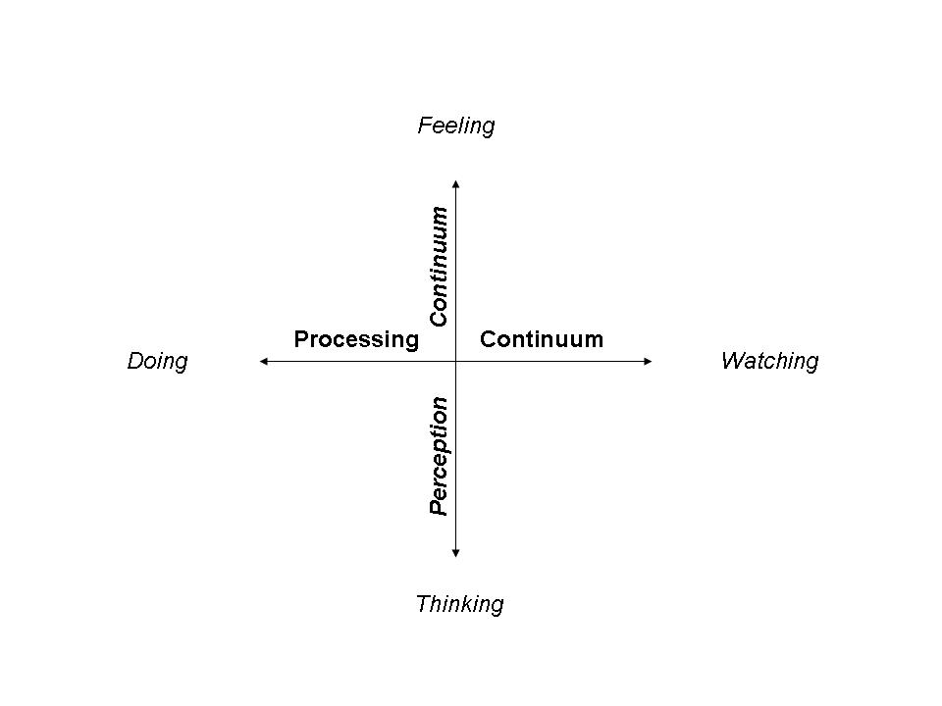](http://www.nwlink.com/~donclark/hrd/styles/continuum_1.jpg)

* Processing Continuum: Our approach to a task, such as preferring to learn by doing or watching.
* Perception Continuum: Our emotional response, such as preferring to learn by thinking or feeling.

**The Learning Cycle**

This matrix provides a learning cycle that involves four processes that must be present for learning to occur. Kolb called this *Experiential Learning* since experience is the source of learning and development (1984). Each ends of the continuums (modes) provide a step in the learning process:

[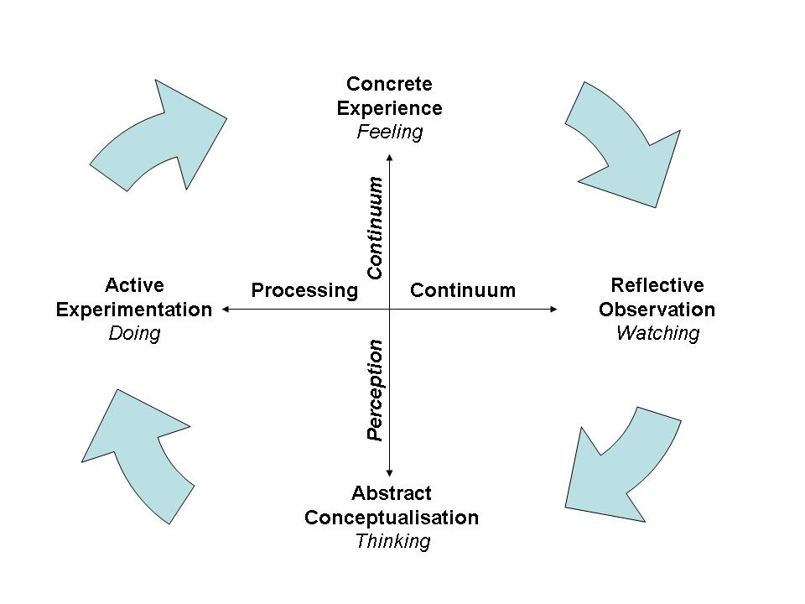](http://www.nwlink.com/~donclark/hrd/styles/learning_cycle_2.jpg) 

Convergers

Accommodators

Assimilators

Divergers

**CONCRETE EXPERIENCE (CE)** (Feeling**)**: Learning from specific experiences and relating to people. Sensitive to other's feelings.A receptive, experience based approach to learning that relies for a large part on judgements based on feelings. CE individuals tend to be empathetic and people oriented. They are not primarily interested in theory; instead they like to treat each case as unique and learn best from specific examples. In their learning they are more oriented towards peers than to authority and they learn best from discussion and feedback with fellow CE learners.

**REFLECTIVE OBSERVATION (RO)** (watching): Observing before making a judgment by viewing the environment from different perspectives. Looks for the meaning of things. A tentative, impartial and reflective approach to learning. They rely on careful observation of others and/or like to develop observations about their own experience. They like lecture format learning so they can be impartial objective observers. They are Introverts. They like to do Self-reflection exercises, journals, brainstorming etc:

**ABSTRACT CONCEPTUALISATION (AC)** (thinking)**:** An analytical, conceptual approach to learning: logical thinking, rational evaluation. These learners are oriented to things rather than to people. They learn best from authority-directed learning situations that emphasize theory. They don’t benefit from unstructured discovery type learning approaches. They learn through logical analysis of ideas and acting on intellectual understanding of a situation.

**ACTIVE EXPERIMENTATION (AE)** (doing)**:** An active, doing approach to learning that relies heavily on experimentation. These learners learn best when they can engage in projects, homework, small group discussion. They don’t like lectures, and tend to be extroverts. Ability to get things done by influencing people and events through action. Includes risk-taking. They like to do Simulations, case studies, homework etc:

Depending upon the situation or environment, the learners may enter the learning cycle at any point and will best learn the new task if they practice all four modes. Effective learning is seen when a person progresses through a cycle of four stages: of (1) having a concrete experience followed by (2) observation of and reflection on that experience which leads to (3) the formation of abstract concepts (analysis) and generalizations (conclusions) which are then (4) used to test hypothesis in future situations, resulting in new experiences.

Hartman (1995) took Kolb's learning styles and gave examples of how one might teach

to each them:

1. for the concrete experiencer: offer labs, field work, observations or videos

2. for the reflective observer: use logs, journals or brainstorming

3. for the abstract conceptualizer: lectures, papers and analogies work well

4. for the active experimenter: offer simulations, case studies and homework

**Learning Styles Descriptions**

Knowing a person's (and your own) learning style enables learning to be orientated according to the preferred method. That said, everyone responds to and needs the stimulus of all types of learning styles to one extent or another - it's a matter of using emphasis that fits best with the given situation and a person's learning style preferences.

Here are brief descriptions of the four Kolb learning styles or **Types of Learners:**

* **Diverging (feeling and watching - CE/RO)**

These people are able to look at things from different perspectives. They are sensitive. They prefer to watch rather than do, tending to gather information and use imagination to solve problems. They are best at viewing concrete situations at several different viewpoints.

Kolb called this style 'diverging' because these people perform better in situations that require ideas-generation, for example, brainstorming. People with a diverging learning style have broad cultural interests and like to gather information. They are interested in people, tend to be imaginative and emotional, and tend to be strong in the arts. People with the diverging style prefer to work in groups, to listen with an open mind and to receive personal feedback.

* **Assimilating (watching and thinking - AC/RO)**

The Assimilating learning preference is for a concise, logical approach. Ideas and concepts are more important than people. These people require good clear explanation rather than practical opportunity. They excel at understanding wide-ranging information and organizing it in a clear logical format.People with an assimilating learning style are less focused on people and more interested in ideas and abstract concepts.  People with this style are more attracted to logically sound theories than approaches based on practical value.This learning style is important for effectiveness in information and science careers. In formal learning situations, people with this style prefer readings, lectures, exploring analytical models, and having time to think things through.

* **Converging (doing and thinking - AC/AE)**

People with a converging learning style can solve problems and will use their learning to find solutions to practical issues. They prefer technical tasks, and are less concerned with people and interpersonal aspects. People with a converging learning style are best at finding practical uses for ideas and theories. They can solve problems and make decisions by finding solutions to questions and problems.People with a converging learning style are more attracted to technical tasks and problems than social or interpersonal issues. A converging learning style enables specialist and technology abilities. People with a converging style like to experiment with new ideas, to simulate, and to work with practical applications.

* **Accommodating (doing and feeling - CE/AE)**

The Accommodating learning style is 'hands-on', and relies on intuition rather than logic. These people use other people's analysis, and prefer to take a practical, experiential approach. They are attracted to new challenges and experiences, and to carrying out plans. They commonly act on 'gut' instinct rather than logical analysis. People with an accommodating learning style will tend to rely on others for information than carry out their own analysis. This learning style is prevalent within the general population.

**Educational Implications**

Both Kolb's (1984) learning stages and cycle could be used by teachers to critically evaluate the learning provision typically available to students, and to develop more appropriate learning opportunities.

Educators should ensure that activities are designed and carried out in ways that offer each learner the chance to engage in the manner that suits them best. Also, individuals can be helped to learn more effectively by the identification of their lesser preferred learning styles and the strengthening of these through the application of the experiential learning cycle.

Ideally, activities and material should be developed in ways that draw on abilities from each stage of the experiential learning cycle and take the students through the whole process in sequence

**VAK Learning Style (Visual, Auditory, Kinesthetic Learning Style)**

The VAK learning style uses the three main sensory receivers: Visual, Auditory, and Kinesthetic (movement) to determine the dominant learning style. It is sometimes known as VAKT (Visual, Auditory, Kinesthetic, & Tactile). It is based on modalities—channels by which human expression can take place and is composed of a combination of perception and memory. The model is also extended to [VARK (Visual-Auditory-Reading-Kinesthetic) or VACT (Visual-Auditory-Kinesthetic-Tactile)](http://www.businessballs.com/howardgardnermultipleintelligences.htm#vark learning styles model). The original VAK concepts were first developed by psychologists and teaching specialists for children such as Fernald, Keller, Orton, Gillintissori, starting in 1920’s.VAKtheory is now a favorite of the accelerated learning community because its principles and benefits extended to all types of learning and development far beyond its applications.

VAK is derived from the accelerated learning world and seems to be about the most popular model nowadays due to its simplicity. While the research has shown a connection with modalities and learning styles (University of Pennsylvania, 2009), the research has [so far been unable to prove](http://www.nwlink.com/~donclark/hrd/styles.html) the using one's learning style provides the best means for learning a task or subject. This is probably because it is more of a preference, rather than a style.

Learners use all three modalities to receive and learn new information and experiences. However, according to the VAK or modality theory, one or two of these receiving styles is normally dominant. This dominant style defines the best way for a person to learn new information by filtering what is to be learned. This style may not always to be the same for some tasks. The learner may prefer one style of learning for one task, and a combination of others for a different task.

**Recognizing and Implementing the VAK Styles:**

|  |  |
| --- | --- |
| **Learning Style** | **Description** |
| Visual | seeing and reading |
| Auditory | listening and speaking |
| Kinesthetic | touching and doing |

**Auditory Learning Styles (***learn through listening***)** involves the transfer of information through listening, to spoken word, of self or others, of sounds and noises. Auditory learners often talk to themselves. They also may move their lips and read out loud. They may have difficulty with reading and writing tasks. They often do better talking to a colleague or a tape recorder and hearing what was said. To integrate this style into the learning environment:

* Begin new material with a brief explanation of what is coming. Conclude with a summary of what has been covered. This is the old adage of “tell them what they are going to lean, teach them, and tell them what they have learned.”
* Use the Socratic method of lecturing by questioning learners to draw as much information from them as possible and then fill in the gaps with you own expertise.
* Include auditory activities, such as brainstorming, buzz groups, or Jeopardy. Leave plenty of time to debrief activities. This allows them to make connections of what they leaned and how it applies to their situation.
* Have the learners verbalize the questions.
* Develop an internal dialogue between yourself and the learners.

**Visual Learning Style (***learn through seeing)*involves the use of seen or observed things including pictures, diagrams, demonstrations, displays, handouts, films, flip-chart etc. Visual learners have two sub-channels—linguistic and spatial. Learners who are visual-linguistic like to learn through written language, such as reading and writing tasks. They remember what has been written down, even if they do not read it more than once. They like to write down directions and pay better attention to lectures if they watch them. Learners who are visual-spatial usually have difficulty with the written language and do better with charts, demonstrations, videos, and other visual materials. They easily visualize faces and places by using their imagination and seldom get lost in new surroundings. To integrate this style into the learning environment:

* Use graphs, charts, illustrations, or other visual aids.
* Include outlines, concept maps, agendas, handouts, etc. for reading and taking notes.
* Include plenty of content in handouts to reread after the learning session.
* Leave white space in handouts for note-taking.
* Invite questions to help them stay alert in auditory environments.
* Post flip charts to show what will come and what has been presented.
* Emphasize key points to cue when to takes notes.
* Eliminate potential distractions.
* Supplement textual information with illustrations whenever possible.
* Have them draw pictures in the margins.
* Have the learners envision the topic or have them act out the subject matter.

The word ‘kinesthetic’ describes the sense of using muscular movement or physical sense. (Kinesthesia the word derived from Greek word ‘kineo’= move, ‘aesthesis’=sensation) **Kinesthetic learning style (***learn through moving, doing, and touching***)** therefore describes a learning style which involves the stimulation of nerves in the body muscles, joints and tendons. This related to the touching, feeling, holding, doing sensations or hand-on experiences. Kinesthetic learners do best while touching and moving. It also has two sub-channels: kinesthetic (movement) and tactile (touch). They tend to lose concentration if there is little or no external stimulation or movement. When listening to lectures they may want to take notes for the sake of moving their hands. When reading, they like to scan the material first, and then focus in on the details (get the big picture first). They typically use color high lighters and take notes by drawing pictures, diagrams, or doodling. To integrate this style into the learning environment:

* Use activities that get the learners up and moving.
* Play music, when appropriate, during activities.
* Use colored markers to emphasize key points on flip charts or white boards.
* Give frequent stretch breaks (brain breaks).
* Provide toys such as Koosh balls and Play-Dough to give them something to do with their hands.
* To highlight a point, provide gum, candy, scents, etc. which provides a cross link of scent (aroma) to the topic at hand (scent can be a powerful cue).
* Provide high lighters, colored pens and/or pencils.
* Guide learners through a visualization of complex tasks.
* Have them transfer information from the text to another medium such as a keyboard or a tablet
  1. **Learning curves and Learning Plateaus**

**Learning Curves :** It is thegraphical representation of how learning takes place in a particular situation and it is a record of learner’s improvement. In this graph, on X axis, Time interval /Practice and on Y axis, Amount of learning is plotted. There are different types of learning curves based on a) The nature of the learner, b) The nature of the task, c) The learning conditions, d) The time available.

**Straight line Curve** is the graph which shows a constant or uniform rate of progress in learning

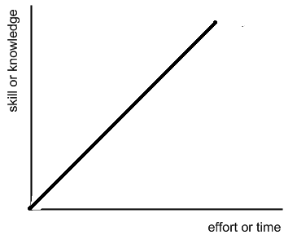

**Convex Curve** is negatively accelerated curve which shows rapid initial improvement in learning that slows down with time. Convex curves are seen when the task is simple or the learner has previous practice on a similar task.

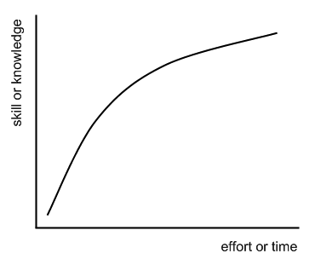

**Concave Curve** is positively accelerated curve that shows slow initial improvement in learning that increases with time ultimately leading to the mastery over the learning material. It is seen when the task is new or difficult and the learner has no previous experience with similar task

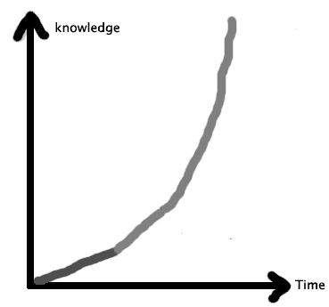

**Mixed Curve/ Concave – Convex / S – Curve:** this graph is the combination of a concave and convex curve depending on rapid or slow initial success followed by a reverse condition in learning**.**

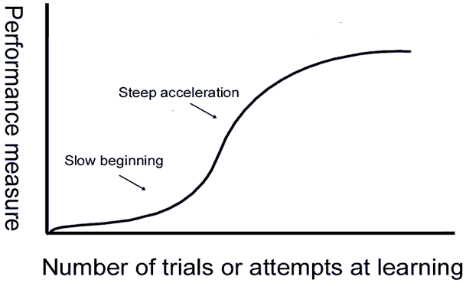

By analyzing the pattern of learning curves we can understand the period of slow progress or rapid progress, period of spurts, period of no apparent progress and the period of decline in the learning process.

The Learning Curves helps the teacher:

* To acquaint with the individual differences in learning among his students.
* To improve the method of teaching.
* To select appropriate teaching aids.
* To maintain a proper account of the regular progress of his students.
* To compare the progress of the students in the class.
* To understand the emotional life and personality characteristics of the learner.
* Help the students to acquaint themselves with their own progress and provides opportunity for self-appraisal.

**Learning Plateau** is the stationary stage where apparently no progress in learning is recorded. When such a stage is reached, a learning curve takes the form of a straight line and become parallel to the X axis, thus it denotes a period of no progress in a learning curve. “A long flat stretch in the learning curve, a long period of almost no improvement, is called a plateau, provided it is followed by more improvement” – Woodworth and Marquis.

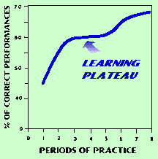

**Causes of Learning Plateau**

1. Poor or faulty method of learning.
2. Physical as well as mental fatigue.
3. Lack of proper motivation or loss of interest.
4. Too much difficulty and complexity of the task.
5. Conflict of previous learning with new learning.
6. Transition from a lower level to higher level.
7. Poor and unfavorable environment and working condition.
8. Mental or physical illness of the learner.
9. Distraction or lack of proper attention.

10. Satisfaction of the learner with moderate achievement.

11. Applying a new method.

The methods to eliminate of Plateaus are:

* Adopt efficient methods of teaching
* Acquaint children with the goals of the work
* Arrange learning experiences according to the increasing level of difficulty
* Avoid introducing new material in a hurried manner
* Use appropriate audio visual aids
* Provide incentives to arouse and maintain motivation
* Eliminate the distracting factors
* Help children to select appropriate method of his learning
* Encourage the learner to stop the task for a short while & start again.
  1. **Transfer of Learning: Types of Transfer, Teaching for positive transfer**

The process of carrying over habits of thinking, knowledge, skills and attitudes from one learning situation to another is called transfer of learning or transfer of training. It implies the application of knowledge to the study of various subjects and activities in various fields.

Theories of transfer of training:

1. Theory of formal discipline: The view that mind is composed of a number of independent faculties like memory, attention, imagination, reasoning etc. and these faculties can be made strong by vigorous exercise.

2. Theory of identical elements: According to thorndike, transfer takes place from one situation to another to the extent that there are identical elements in the two situations.

3. Theory of Generalization: According to Charles H. Judd, the development of special skills, the mastery of specific facts etc. have little transfer value unless the skills, facts, habits are systematized and related to other situations in which they can be utilized.

4. Theory of transposition: Gestalt psychologists explain transfer as a process of adaptation and reorganization of experience, it is a restructuring of cognitive field.

5. Theory of ideals: According to Prof. Bagley the presentation of ideals has more transfer value than isolated instructions.

**Types of transfer**

1. Positive Transfer: Learning of one task facilitates the learning of a second task.

2. Negative transfer: If learning a particular task interferes with another task and thus hindrance to its learning the transfer is said to negative.

3. Zero transfer: Zero transfer occurs if the first task neither facilities nor interferes with the learning of the second task.

Factors like intelligence, attitude, study habits, methods of teaching, learning material etc. affect transfer of training.

In order to facilitate transfer in teaching.

1. Handle subject matter in close relation to its application.

2. Provide opportunities to apply learning in meaningful situation created in laboratories, workshops, playground and school parliaments.

3. Develop power of insight and imagination. Skills, attitudes, ideas and techniques have great transfer value and this value has to be facilitated by proper method of teaching.

4. Provide practice in transfer

5. Concentrate on the process of learning as well as on product

************************************************************