**Reflective Writing**

Reflective writing requires that you think deeply and write about a learning experience. This involves writing about:

1. **What** happened (**positive** and **negative**).
2. **Why** it happened, **what** it means, **how** **successful** it was.
3. **What** you (personally) **learned** from the experience.

**How to reflect**

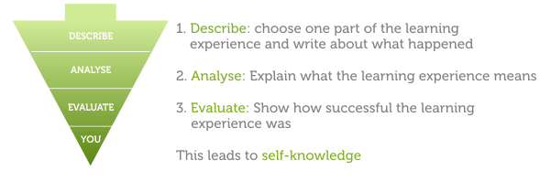

## Types of reflective writing assignments

1. **Journal:** requires you to write weekly entries throughout a semester. May require you to base your reflection on course content.
2. **Learning diary:** similar to a journal, but may require group participation. The diary then becomes a place for you to communicate in writing with other group members.
3. **Log book:** often used in disciplines based on experimental work, such as science. You note down or ‘log’ what you have done. A log gives you an accurate record of a process and helps you reflect on past actions and make better decisions for future actions.
4. **Reflective note:** often used in law. A reflective note encourages you to think about your personal reaction to a legal issue raised in a course.
5. **Essay diary:** can take the form of an annotated bibliography (where you examine sources of evidence you might include in your essay) and a critique (where you reflect on your own writing and research processes).
6. **Peer review:** usually involves students showing their work to their peers for feedback.
7. **Self-assessment:** requires you to to comment on your own work.

**REFLECTIVE JOURNAL**

**Reflective Journal writing has been recognized by educators as an effective strategy and a formal tool to promote reflective thinking and learning.  Writing about what we do and what we think and what we have learnt disciplines us to become more thoughtful, reflective and analytic.**  While writing in a journal we not only record what happened or what was observed, but also develop new understanding, and insights and thereby new hypothesis and new perspectives of the phenomena.  Our writing needs to demonstrate active and reflective engagement in the experiences and ideas we encounter.  Reflective journals enable us to create a record of reflective thought and meaning we are making while engaging in learning process.

**Reflective journals** are notebooks or pieces of paper that students use when writing about and reflecting on their own thoughts. The act of reflecting on thoughts, ideas, feelings, and their own learning encourages the development of metacognitive skills by helping students self-evaluate and sort what they know from what they don't know.

**Reflective journal** provides a platform for reflecting on experiences pursuing personal as well as professional development of learners. It is a space where they can record and reflect upon their experiences which can then be used to track the progress they've made, and to notice the gaps in their knowledge and skills.  It acts as an invaluable means of expression, communication and enlightenment.

**REFLECTION**

     Reflection is defined as the action of critically exploring what you are doing, why you decided to do it, and what its effects have been ----Mertler

**Reflection helps students to develop higher order thinking skills and decision making capabilities by prompting them to:**

1.     Relate n­ew knowledge to their prior understanding

2.     Think in both abstract and concrete terms

3.     Apply specific strategy to novel tasks

4.     Understands their own thinking and learning strategies

5.     Activate efficient decision managing capacity in their learning episodes

6.     Exhibit professionalism in their practices

**The pedagogical potential of this technique includes**

* It reflects the personal reflective background of the learner in the context of the experience
* It develops student responsibility for learning
* It provides active engagement in reflective process
* It is student centered approach
* It helps to shape the learning organisations as learners see fit
* It acts as learners personal curriculum in a written form

**There are many models for reflection.**

**Gibb’s model of reflective cycle (Gibb, 1988) is one among them.**

**Gibbs' reflective cycle**

* **Gibbs - Reflective Cycle model (1988)**

The Gibbs' reflective cycle, inspired partly by [Kolb's learning cycle](http://www.businessballs.com/kolblearningstyles.htm), enables us to focus especially on our own and others' feelings, views and perceptions. In common terms people call this "Standing/walking in someone else's shoes". This relates strongly to ideas about [empathy](http://www.businessballs.com/empathy).

The process is essentially a cycle or loop, containing the following elements:

1. **Description** - What happened?
2. **Feelings** - What were you thinking and feeling?
3. **Evaluation** - What was good and bad about the experience?
4. **Analysis** - What sense can you make of the situation?
5. **Conclusion** - What else could you have done?
6. **Action Plan**- If it arose again what would you do?

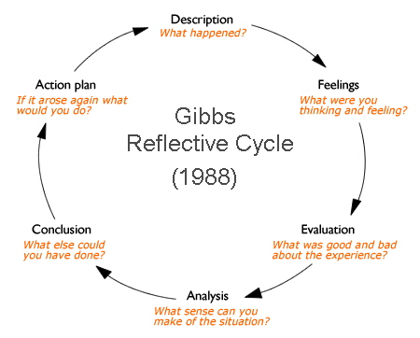

The Gibbs model encourages the use of critical reflection, and especially offers a good starting point for people first using Reflective Practice, in converting new learning and knowledge into action and change.

* **Description**

"What happened? Don't make judgments yet or try to draw conclusions; simply describe."

* **Feelings**

"What were your reactions and feelings? Again don't move on to analysing these yet."

* **Evaluation**

"What was good or bad about the experience? Make value judgments."

* **Analysis**

"What sense can you make of the situation? Bring in ideas from outside the experience to help you."

"What was really going on?"

"Were different people's experiences similar or different in important ways?"

* **Conclusions**"What can be concluded, in a general sense, from these experiences and the analyses you have undertaken?"

"What can be concluded about your own specific, unique, personal situation or way of working?"

* **Action plans**

"What are you going to do differently in this type of situation next time?"

"What steps are you going to take on the basis of what you have learnt?"

The process requires that we look beneath the surface of events and experiences, to achieve deeper levels of reflection and learning.

Detailed below:

1. **Context**

What has happened?-Briefly describe the event as objectively, accurately and concisely as you can.

Who was involved?

Where did it happen?

Do you intend to focus on the structure, process or outcomes of care?

1. **Thoughts**

What were your thoughts...

...at the time?

...afterwards?

1. **Feelings**

What were your feelings or emotions, both positive and negative...

...at the time ?

...afterwards ?

1. **Evaluation**

How well did things go?

Were things satisfactorily resolved?

1. **Analyse**

What were the factors that affected the outcome?

What helped and what hindered?

Can you explain the event?

Why did it happen?

How did it happen?

1. **Reframe**

What might have been some alternative actions or approaches?

What might you have done differently (even when things went well)?

Could negative events be avoided?

Could positive events be made more effective?

1. **Future action**

What will you do if you encounter this kind of situation again?

What will you do in the future to increase the likelihood of similar positive outcomes and minimise the likelihood of similar negative outcomes?

What do you need to learn?

How might you learn this?

**SCOPE OF REFLECTIVE JOURNALS**

1. It respects the right of individuals to exercise self direction and thereby, enhances their ability to exercise control over their own learning and their own actions.
2. Reflective writing is a way of learning and helps to evaluate their own learning performance as a learner
3. By engaging in Reflective journaling learners are taking an active role in learning and recognizing our personal responsibility for lifelong learning.
4. Journal writing is a helpful device in providing educators with a window to make critical judgment of their student’s learning.
5. Reflective learning journals facilitate critical reflection
6. It assists learners in conceptualizing and re-conceptualizing abstractions through re-configurating, re-framing and relating it to practice.
7. Thinking about our learning and writing things down help to clarify our thoughts and emotions
8. Use of learning journal, facilitate metacognitive abilities which leads to self inquiry, self managing learning process and self esteem.