**1.2 Approaches-Teacher centered vs Learner centered, Inductive and Deductive, Analytic and synthetic , Process and Product, Inquiry-Discovery**

Effective teachers draw on a wide range of approaches to teaching and learning to cater for the different needs of their students**.**

**Teacher-centered approach**

Teacher centred approaches are more traditional in nature, focussing on the teacher as instructor. They are sometimes referred to as direct instruction, deductive teaching or expository teaching, and are typified by the lecture type presentation. In these methods of teaching, the teacher controls what is to be taught and how students are presented with the information that they are to learn.

In teacher-centered learning, teachers play important roles in the learning process. Teachers are information providers or evaluator to monitor students to get the right answers, yet students are viewed as learners who passively receive information. In teacher-centered approach, students put all of their focus on the teacher. Teachers talk, and the students exclusively listen. During activities, students work alone, and collaboration is discouraged. As teachers become the most dominant source of information, in teacher-centered learning, questions raised by students, are answered directly by teachers without students’ involvement. In designing the class activities, teachers control every single learning experience. Several advantages of having teacher-centered learning are it is suitable for large classes, it takes shorter time to do the class activities, learning materials can be well prepared, teachers may feel less nervous, embarrassed or tongue-tied,

**Pros**

* When education is teacher-centered, the classroom remains orderly. Students are quiet, and you retain full control of the classroom and its activities.
* Because students learn on their own, they learn independence and make their own decisions.
* Because you direct all classroom activities, you don’t have to worry that students will miss an important topic.

**Cons**

* When students work alone, they don’t learn to collaborate with other students, and their communication skills may suffer.
* Teacher-centered instruction can be boring for students. Their minds may wander, and they may miss important facts.
* Teacher-centered instruction doesn’t allow students to express themselves, ask questions, and direct their own learning.

**Student-centered instruction**

Student centred approaches (sometimes referred to as discovery learning, inductive learning, or inquiry learning) place a much stronger emphasis on the learner’s role in the learning process. When you are using student- centred approaches to teaching, you still set the learning agenda but you have much less direct control over what and how students learn.When a classroom operates with student-centered instruction, students and instructors share the focus. Instead of listening to the teacher exclusively, students and teachers interact equally. Group work is encouraged, and students learn to collaborate and communicate with one another. Student-centered learning becomes a pioneer of development of learning approach. In this approach, students activities are important indicators in learning process and quality of learning product. This approach links with flexible learning, experiential learning, and self-directed learning. Therefore, a student- centered classroom is a place where teachers consider the needs of the students, as a group and as individuals, and encourage them to participate in the learning process all the time. The teachers’ roles are more that of facilitators than instructors. The students are active participants in the learning process, and teachers help to guide the students, manage their activities, and direct their learning

**Pros**

* Students learn important communicative and collaborative skills through group work.
* Students learn to direct their own learning, ask questions, and complete tasks independently.
* Students are more interested in learning activities when they can interact with one another and participate actively.

**Cons**

* Because students are talking, classrooms may often be noisy or chaotic.
* Teachers may have to attempt to manage all students’ activities at once, which can be difficult when students are working on different stages of the same project.
* Because the teacher doesn’t always deliver instruction to all students at once, some students may miss important facts.
* Some students prefer to work alone, so group work can become problematic.

**Teacher centered vs Learner centered**

|  |  |  |
| --- | --- | --- |
| **Domain** | **Teacher-centered** | **Learner-centered** |
| **Knowledge** | Transmitted by teacher | Constructed by students |
| **Student participation** | Passive | Active |
| **Role of teacher** | Leader/authority | Facilitator/learning partner |
| **Role of Assessment** | Few tests/assignments—mainly for grading | Many tests/assignments —for ongoing feedback |
| **Emphasis** | Learning correct answers | Developing deeper understanding |
| **Academic culture** | Individualistic and competitive | Collaborative and supportive |

**Inductive and Deductive**

Two very distinct and opposing instructional approaches are inductive and deductive. Both approaches can offer certain advantages, but the biggest difference is the role of the teacher. In a deductive classroom, the teacher conducts lessons by introducing and explaining concepts to students, and then expecting students to complete tasks to practice the concepts; this approach is very teacher-centred. Conversely, inductive instruction is a much more student-centred approach and makes use of a strategy known as ‘noticing’.

**A deductive approach** to instruction is a more teacher-centered approach. This means that the teacher gives the students a new concept, explains it, and then has the students practice using the concept. For example, when performing experiments in the lab we begin with a generalized law or principle and go over to testing it in a particular instant. We know acids turn blue litmus red so we test whether the given particular substance is an acid by dipping blue litmus in it. Thus it proceeds from general to specific.

**PHYSICS**: By using the properties of semi-conductors (general), we make several instruments like diodes and transistors ,the light emitting diode (LED) the photo diode. As it proceeds from general to specific thus this is an example of deductive method.

**Advantages of the Deductive** Method Coverage of a wider scope of subject matter – because our instruction is direct by starting the rule or the principle at the beginning of the class, we cover more subject matter over a period of time No bother on the part of the teacher to lead learners to the formulation of generalization or rule – we ourselves give the generalization at the beginning of the lesson

**Disadvantages of the Deductive Method** It is not supportive of thee principle that learning is an active process. There is less involvement on the part of the learners. Lesson appears uninteresting at first. We begin our lesson with the abstract, with what the learners do not know so at the outset our lesson will look irrelevant and uninteresting.

**Inductive Approach :** In contrast with the deductive method, inductive instruction makes use of student “noticing”. Instead of explaining a given concept and following this explanation with examples, the teacher presents students with many examples showing how the concept is used. The intent is for students to “notice”, by way of the examples, how the concept works.

**Chemistry** : Iron conducts heat, Copper conducts heat, Silver conducts heat. Iron, Copper and Silver are examples of metals so we can say metals conduct heat. . Thus it proceeds from specific to general and so is an example of inductive method.

**Physics** : when we rub hands, heat is generated, when we rub metals heat is generated, when we rub two pieces of rock heat is generated. So we can say when two bodies are rubbed against each other heat is produced and this is due to friction. Thus it proceeds from specific to general and so is an example of inductive method.

**Advantages of the Inductive method** The learners are more engaged in the teaching – learning process. With our facilitating skills, the learners formulate the generalization or rule. Learning becomes more interesting at the outset because we begin with the experience of our students. We begin with what they know. It helps the development of our learners’ higher-order thinking skills(HOTS). To see patterns and analyze the same in order to arrive at generalization requires analytical thinking.

**Disadvantages of the Inductive method** It requires more time and so less subject matter will be covered. We need much to lead our students to the formulation of generalization. It demands expert facilitating skills on the part of the teacher. We’ve got to ask the right questions, organize answers and comments to pave the way to the derivation of generalization.

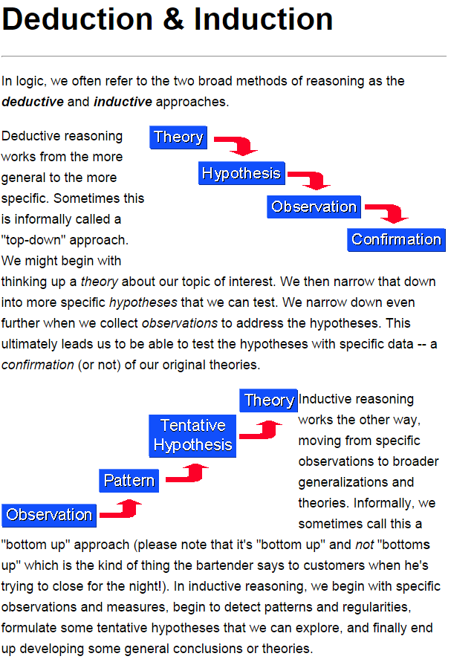

**Inductive Versus Deductive Approach**

|  |  |  |
| --- | --- | --- |
|  | **Inductive Approach** | **Deductive Approach** |
| 1. | Proceeds from the particular to the general; from the concrete to the abstract. | Proceeds from the general to the particular; from the abstract to the concrete |
| 2. | It takes care of the needs and interests of children. It is a developmental process. | The child is provide with information of facts, principles & theories. |
| 3. | It encourages "discovery" and stimulates thinking. | It establishes linkage with real life observations and knowledge already gained. |
| 4. | The generalization or rule is  formulated by the child therefore he remembers it with ease | The rule is first learn and then  derived by the child. So, helshe is  likely to forget it |
| 5. | The "how" and "why" of the rule/  generalization are made clear  through reasoning | The process is accepted by the child  without much reasoning. |
| 6. | It starts from observation and direct experiences and ends in developing a rule in the abstract form. | It starts with a rule and provides for practice and applications. |
| 7. | It encourages child participation and group work. | It demands individual learning and treats a child as a passive recipient. |

**Analytic and Synthetic Approach**

|  |  |  |
| --- | --- | --- |
|  | **Analytic Approach** | **Synthetic Approach** |
| 1. | It proceeds from the conclusion to the hypothesis. | It proceeds from the hypothesis to the conclusion. |
| 2. | It involves breaking up the conclusion into simpler steps and setting up relationships with what is given or known. It applies intuition and inductive reasoning. | It involves writing out the steps in the proof in proper sequence using accepted deductive reasoning. |
| 3. | It is a method of discovery. The solution or proof is arrived at through systematic reasoning. | It is a method of presenting facts already discovered in a logical format. |
| 4. | It takes care of psychological considerations, self-learning, active participation of students, organized thinking and reasoning power. It builds up a scientific attitude, originality and creativity among the students. | It does not care for psychological principles. It is a logical method and encourages memorization of steps in proof. |
| 5. | The teacher acts as a guide and plans situations for discovery learning by students. | The teacher acts as a superior and explains the rationale of the proof. |

**COMPARISON OF ANALYTIC AND SYNTHETIC METHODS**

|  |  |
| --- | --- |
| **ANALYTIC METHOD** | **SYNTHETIC METHOD** |
| ***Meaning:***  Analysis means breaking up into components | ***Meaning:***  Synthesis means combining the elements to get something new. |
| ***Leads from:***    Unknown to known    Conclusion to hypothesis    Abstract to concrete    Complex to simple | ***Leads from:***    Known to unknown    Hypothesis to conclusion    Concrete to abstract    Simple to complex |
| ***Method:***    A method of discovery and thought    A psychological method | ***Method:***    A method for the presentation of discovered facts.    A logical method |
| ***Time:***  Lengthy, laborious and time consuming | ***Time:***  Short, concise and elegant. |
| ***Sequence:***  Valid reasons to justify every step in the sequence. | ***Sequence:***  No justification for every step in the sequence. |
| ***Learning:***  Encourages meaningful learning. | ***Learning:***  Encourages rote learning |
| Easy to rediscover | Once forgotten not easy to recall |
| ***Encourages:***  Encourages originality of thinking and reasoning | ***Encourages:***  Encourages memory work |
| ***Learning:***  Informal and disorganized | ***Learning:***  Formal, systematic ad orderly |
| ***Thinking:***  Process of thinking | ***Thinking:***  Product of thinking |
| ***Participation:***  Active participation of the learner | ***Participation:***  Learner is a passive listener |

Though both analytic and synthetic method seems to oppose each other, they complement and support each other. Analysis leads to synthesis and synthesis makes the purpose of analysis clear and complete. The teacher while teaching can use analytic methods and can encourage the student to present them in the synthetic method. i.e. Analysis forms the beginning and synthesis follow up work.

**Process and Product**

**Product Approach** : School science programs are traditionally designed to give children lots of information, have them memorize that information, and then ask them to recall the information on written tests. That approach may be a significant reason for students’ less-than-enthusiastic response to science, because that type of instruction does not allow for the active involvement of students in their own learning, nor does it allow children opportunities to think creatively about what they are learning.

**A process approach** to science is one in which children do something with the concepts and generalizations they learn. It implies that students can manipulate, decide, solve, predict, and structure the knowledge of science in ways that are meaningful to them. A Process Approach is to develop student competencies to apply a scientific mode of thought to problems. The scientist gains information about the world in certain ways: observing, classifying, making hypotheses, and experimenting. Science--A Process Approach attempts to develop in the students the intellectual and investigative skills of the scientist, and hopefully these skills will provide a generalized method of defining and solving problems which can be applied in other subject areas as well.

**Inquiry-Discovery**

Inquiry is a process by which children actively investigate their world through questioning and seeking answers to their questions. This process is characterized by actions such as probing, searching, exploring and investigating (Martinello and Cook 2000). Inquiry as a way of learning about the world should be taught in the context of real-life scientiﬁc problems involving real science knowledge (Pugliese 1973). These problems should be relevant to the students. The students should initiate study of these problems as they probe, search, explore and investigate problems and questions of interest to them.

Students can also be taught to utilize inquiry in order to add to the body of science knowledge that is understood. Students must be taught to reason from what they know and apply this reasoning in order to investigate phenomena observed in the world around them. Most importantly, students learn ﬁrst hand through their own inquiry experiences the processes used by scientists to add to the current body of accepted science knowledge. Upon using Science as Inquiry strategies, teachers involve students in inquiry-based activities but do not predetermine science concepts for students to ‘discover’. Instead, teachers involve students in investigations such as (a) challenging the validity of currently accepted science concepts,(b) going beyond their present understanding of currently accepted science concepts and (c)investigating differing explanations for speciﬁc science phenomena (Schwab 1962)

Teaching science by inquiry involves teaching students the science processes and skills used by scientists to learn about the world and helping the students apply these skills involved with learning science concepts. Students are helped to learn and apply these processes through conducting problem-centred investigations designed for learning speciﬁc science concepts. The teachers help students generate questions to guide these investigations. This inquiry approach is often referred to as ‘guided discovery’. Teachers ‘guide students’ inquiry’ until the students ‘discover’ speciﬁc science concepts predetermined by the teachers. Pratt and Hackett (1998) suggest that, by learning science by inquiry, students develop deeper understandings of science concepts and also develop critical thinking skills. However, it is important to stress that learning science concepts by inquiry is much more time consuming than learning concepts by traditional methods.

**Inquiry-Discovery**

**In Discovery Approach** some cues in the form of a learning material is presented by the teacher to the students and using Inductive thinking, the students are expected to discover the concept or the generalization/rule. Therefore the teaching learning process is partially controlled by the teacher and students also involved to a great extent.

**In Inquiry approach** the students are given a problem or a discrepant event. The students will ask the teacher questions to collect the data and they through interaction find out a satisfactory solution to a given problem or explanation to the given discrepant event. In this approach the teaching learning process is totally controlled by the students.