**INTERDEPENDENCE AND INTERACTIONS**

Living things interact with each other and with non-living things in order to survive. The interaction between living things and non-living things lead to balance in an ecosystem. Interaction between living things and non-living things is important as it maintains:

a. balance in the environment (the number and types of living things within the environment remain the same)

b. balance in the oxygen and carbon dioxide content within the environment remain the same.

**INTERACTIONS AMONG LIVING ORGANISMS**

There are broadly 3 types of species interactions.

1. Positive interaction- both species interacting are benefitted .ex: mutualism and commensalism.
2. Negative interaction- at least one species is harmed .eg:amensalism, competition, parasitism and predation.
3. Passive interaction - animals show protective resemblance to other animals, surroundings and environment.eg: mimicry and camouflage.

**POSITIVE INTERACTIONS**

1. ***Mutualism****-****Both the organisms mutually benefit from each other.***

***Ex: 1:*** the crocodile lies with its mouth open. The plover flies into its mouth and feeds on bits of decaying meat stuck in the crocodile’s teeth. The crocodile does not eat the plover. Instead, he appreciates the dental work. The plover eats a meal and the crocodile gets his teeth cleaned.

***Ex: 2:*** Some species of ants "farm" aphids, protecting them on the plants they eat, eating the honeydew the aphids release from the terminations of their alimentary canals.

1. ***Commensalism****-****One organism is benefitted and the other is unaffected.***

***Ex:1:*** Epiphytic plants (which grow on other plants but are not parasitic) gain an enormous ecological benefit from living on larger plants, because they gain access to a substrate upon which to grow relatively high in the canopy. The host trees, however, are not affected in any significant way by this relationship, even in cases when they are supporting what appears to be a large population of epiphytes.

***Ex:2:*** By attaching itself to a shark, a remora is carried along on the shark's power. This allows the remora to “travel” to different areas without having to expend its own energy to swim. The shark is completely unaffected by the remora's presence

.

**NEGATIVE INTERACTIONS**

1. ***Amensalism****-****One organism is harmed and the other is unaffected.***

***Ex:1:*** Some higher plants secrete substances that inhibit the growth of—or kill outright—nearby competing plants. An example is the black walnut (Juglansnigra), which secretes juglone, a substance that destroys many herbaceous plants within its root zone.

***Ex:2:***The production of **penicillin** by *Penicilliumnotatum*. This antibiotic compound inhibits the growth of many species of bacteria by interfering with the normal formation of peptidoglycan in the cell wall.

1. ***Competition-Phenomenon in which organisms competing for the same resources which are insufficient for their combined needs.***

**Interspecific competition**, is a form of **competition** in which individuals of different species **compete** for the same resource in an ecosystem (e.g. food or living space).

The other form of **competition** is intraspecific **competition**, which involves organisms of the same species.

***3. Predation****-* ***One organism is harmed, but the other is benefitted.***

***Ex.1.***lion (predator ) kills and eats deer (prey)

***Ex.2.***insectivorous plant (predator) traps and eats small insects.

***4. Parasitism*** *-* ***One organism is harmed, but the other is benefitted.***

***Ex.1.***Ticks (ectoparasite ) found on surface of animals body,feeds on its blood.

***Ex.2.***Tapeworms (endoparasite) found in human intestine causes several diseases in human.

**PASSIVE INTERACTIONS**

1. ***Mimicry-Protective resemblance in which animal mimic another animal to avoid predation.***

***Ex.1.*** CORAL SNAKE, a toxic species is mimicked by a SCARLET KING SNAKE, more palatable one to deceive predators, conferring some survival advantage. The most precise mimics are favored by natural selection when their model becomes increasingly rare.

***Ex.2.***The Viceroy butterfly's major defense against predators is purported to be mimicry , with the Monarch butterfly toxic species to avoid predation.

1. ***Camouflage - Protective resemblance with surroundings. Their body shape and colour blend with the environment.***

***Ex.1.***Moths is particularly at risk of being spotted in daylight, so many have colours and patterns to match the places they rest in. This is why so many moths are patterned in greys and browns, which are hard to see in shadows and blend with dry leaves and the bark of branches.

***Ex.2.***Smooth green snakes rely on an environment matching their green scales for camouflage to protect themselves from predators.

**ECOSYSTEM**

Ecology is the scientific study of interactions among and between organisms and their physical environment. Interactions within the biosphere produce a web of interdependence between organisms and the environment in which they live.

**Structure and function:**

Structure of an ecosystem is basically a description of the species of organism. An ecosystem has abiotic and biotic factors.

**Functional components of ecosystems include;**

***Food chain***

A sequence of organisms through which the food and is contained energy passes with each member becoming food of the later member. Each level of food chain is a trophic level. Two types of food chain are, grazing food chain & detritus food chain.Food chain is important to maintain the ecological balance i.e.:- if there is uncontrolled hunting of tigers it will result in increase in number of bears which will then destroy the vegetation balance and food chain gets disturbed.

***Food web***

It is the network of food chains which are interconnected at various trophic levels so as to form a number of feeding connections.

***Ecological pyramids***

Graphical representation of different trophic levels. In a pyramid, base always represents first trophic level and successive levels are made toward the apex.

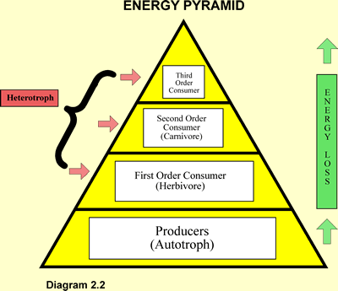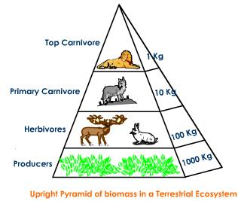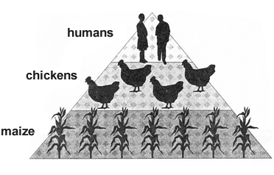

***Energy flow***

There is unidirectional flow of energy. The energy captured by autotrophs does not revert back to solar input but passes to herbivores, and then to carnivores. Due to one flow of energy, system would collapse if primary source of energy (sun) were cut off. At each trophic level there occurs progressive decrease in energy. This is accounted largely by energy loss as heat in metabolic reactions coupled with unutilized energy.

**ROLE OF HUMAN BEINGS IN MAINTAINING BALANCE OF NATURE**

Human beings have a very close relationship with the ecosystem.  Human beings are a part of the ecosystem that depends on living and non-living things for survival. Human beings interact with the ecosystem to obtain needs and to lead comfortable lives.  We obtain our needs in many ways. At the same time, we also disturb the balance of nature.  Human activities bring about an imbalance and decline in the ecosystem.

Human activities that destroy the balance of nature are   forestry / logging, industry, housing, fishing, agriculture, construction, mining, illegal hunting etc.  
The large scale exploration of forests for agriculture, industry, settlement and infrastructure construction has resulted in the loss of wide forest tracts. Improperly planned conversion of forest areas have resulted in the destruction of habitats. Loss of natural habitats has threatened plants and animals with extinction. Human beings need a stable and productive ecosystem to ensure our survival. All our needs can only be obtained continuously, and over a long period of time, if the ecosystem is stable and productive. Before starting on a project, we should carefully plan the project with full responsibility, so as toavoid adversely disturbing any member of the ecosystem, including ourselves.

**ENVIRONMENTAL ISSUES**

Human activities cause pollution and have raised the following environmental issues:

* **The Greenhouse Effect**- Atmosphere around the Earth act as a window glass pane that allows solar radiations to enter earth’s surface. It does not allow long wave radiation(IR) emitted by Earth to escape in space. This IR radiation are absorbed by greenhouse or radioactively active gases(CO2, CH4,N2O,CFC).So the atmosphere radiate part of this energy back to earth called greenhouse flux. These greenhouse gases keep atmosphere warm and fit for living called Greenhouse effect.
* **The Thinning Of The Ozone Layer-** In the stratosphere , the second layer of atmosphere, ozone is present in small quantities as a protective shield for earth. Ozone strongly absorbs UV from sun which is injurious to life on earth.CFCs, CH4,N2O (ozone destroying substances) escape into stratosphere and cause destruction of O3 layers. Most damaging effect of CFCs is production of free radicals in active chlorine –Cl, ClO radicals in presence of ultra violet radiation. These radicals cause thinning of ozone layer. Thinning of ozone layer is maximum in spring season and is called ozone hole. This inhibits photosynthesis in phytoplankton, hence affecting the food chain and damages nucleic acids in living organisms.
* **Acid Rain**- It is a mixture of deposited material , both dry and wet ,coming from atmosphere containing more than normal amounts of nitric and sulphuric acids. It affects the aquatic environment , forests, soil, buildings and public health.

**CONSERVATION AND PRESERVATION OF LIVING ORGANISMS**

Conservation is the systematic and wise use of the Earth's resources. The aim is to ensure that the Earth's natural resources such as forest and seas are not destroyed and can still be used in the future. Preservation is an effort to ensure that the Earth's resources are maintained in good condition. Conservation includes preservation, maintenance, sustainable utilization, restoration and enhancement of natural environment. It means taking action to avoid species decline, extinction and permanent detrimental change to environment.Human beings need a stable and productive ecosystem to ensure our survival. Loss of natural habitats has threatened plants and animals with extinction. Hence all living organisms are mutually interdependent and interrelated.

To ensure a balanced ecosystem for a healthy living the following measures should be taken, which include:

* Create forest reserves, forest gardens and botanical gardens.
* Replant the cut-off trees.
* Construct breeding centres.
* Reinforce laws related to ecological balance.
* Provide awareness campaigns.