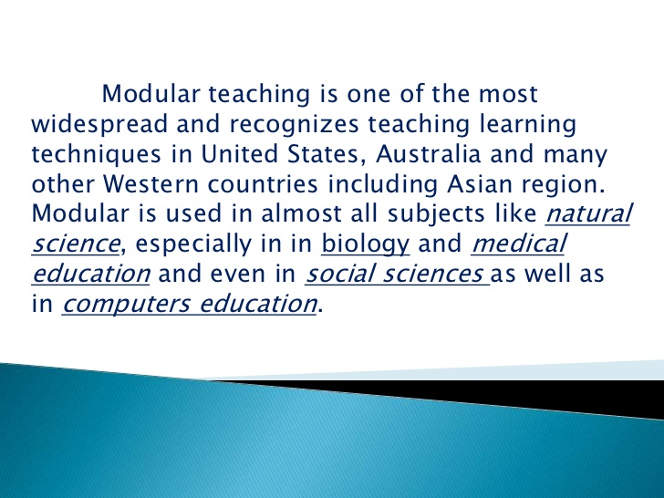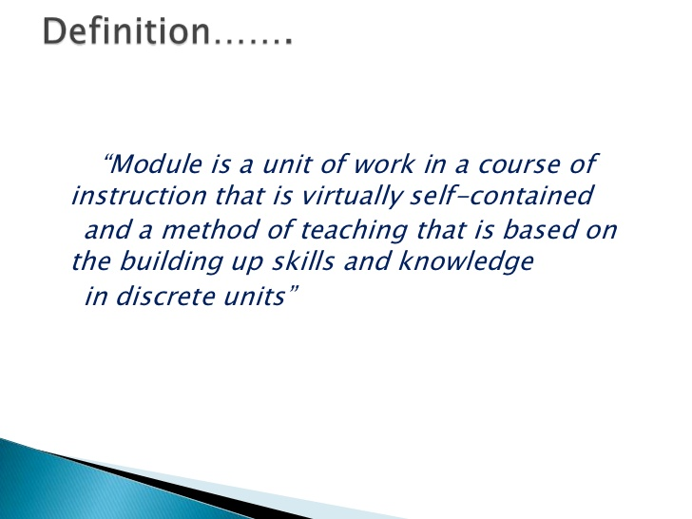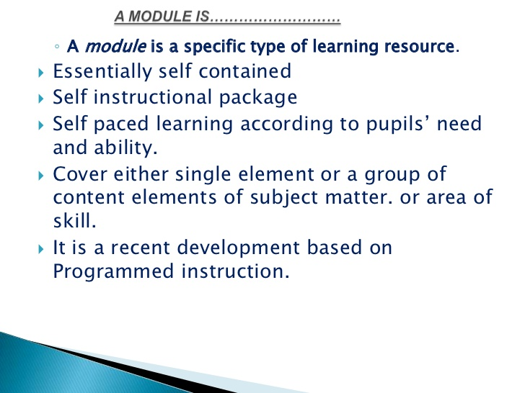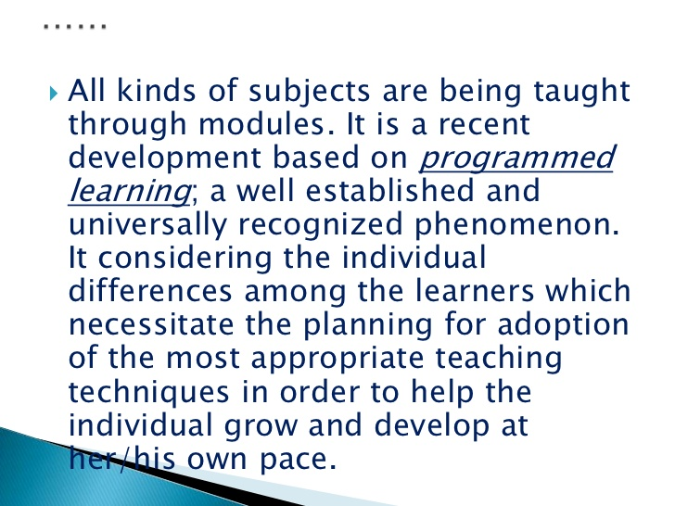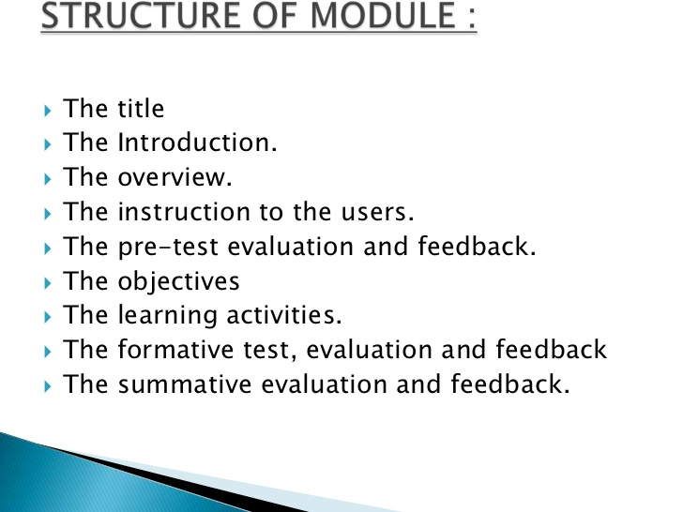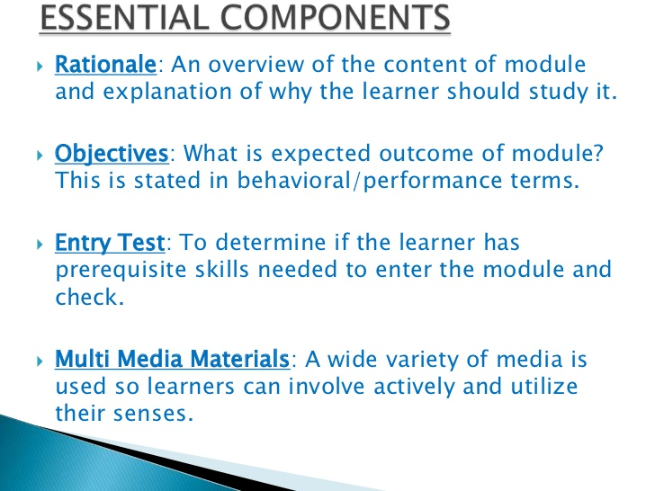EXPLORATION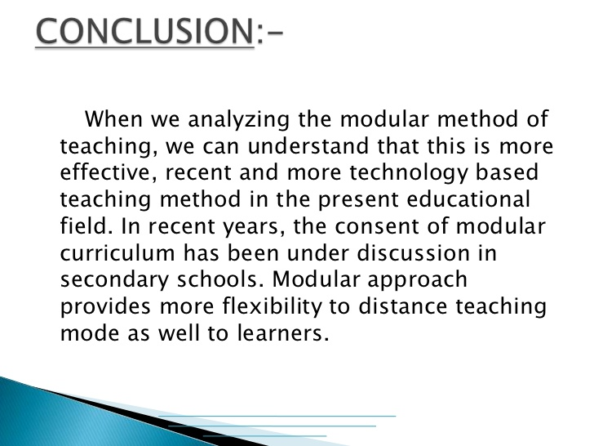S IN SOCIAL STUDIES 11
Ministry code: EPSS 11

View the complete Learning Standards for this course here: Explorations in Social Studies 11
Explorations in Social Studies 11 is a course that looks at life in Canada from several angles: Government and Politics, Society and Identity, Autonomy and International Development and Human Geography. Events that have led up to Canada’s move from a colony of Britain to an independent country are a major focus of this course. The impact of these events on the citizens of Canada, those emigrating to Canada, and the Aboriginal people who occupied the land before contact will also be studied.
Projects in Explorations in Social Studies 11 allow students to further explore areas of interest.

MODULE 1: Government and Politics
Section 1: Formation of Government
- Lesson 1: Formation of Government
- Formation of Government Quiz & Project
Section 2: The Political Spectrum
- Lesson 2: The Political Spectrum
- The Political Spectrum Quiz & Project
Section 3: The Canadian Constitution
- Lesson 3: The Canadian Constitution
- The Canadian Constitution Quiz & Assignment
Section 4: Effecting Change
- Lesson 4: Effecting Change
- Effecting Change Quiz & Assignment
Government and Politics Module Test

MODULE 2: Society and Identity
Section 1: The Great Depression
- Lesson 5: The Great Depression
- The Great Depression Quiz & Project
Section 2: Nationalism and Regionalism
- Lesson 6: Nationalism and Regionalism
- Nationalism and Regionalism Quiz and Assignment
Section 3: Aboriginal People in Canada
- Lesson 7: Aboriginal People in Canada
- Aboriginal People in Canada Quiz & Project
Section 4: Canadian Culture
- Lesson 8: Canadian Culture
- Canadian Culture Assignment
Section 5: Women in Canada
- Lesson 9: Women in Canada
- Women in Canada Quiz
Section 6: Social Policies
- Lesson 10: Social Policies
- Social Policies Quiz
Society and Identity Module Test

MODULE 3: Autonomy and International Development
Section 1: World War I
- Lesson 11: World War I
- World War 1 Quiz & Assignment
Section 2: World War II
- Lesson 12: World War II
- World War II Quiz & Assignment
Section 3: Canadian Autonomy
- Lesson 13: Canadian Autonomy
- Canadian Autonomy Quiz & Assignment
Section 4: Canada and the World
- Lesson 14: Canada and the World
- Canada and the World Quiz & Essay
Identity and International Development Module Test

MODULE 4: Human Geography
Section 1: Environmental Challenges
- Lesson 15: Environmental Challenges
- Environmental Challenges Quiz
Section 2: Population
- Lesson 16: Population
- Population Quiz
Section 3: Standard of Living
- Lesson 17: Standard of Living
- Standard of Living Quiz & Assignment
Human Geography Module Test

ASSESSMENT
- First Assignment 10%
- Unit 1 18%
- Unit 2 18%
- Unit 3 19%
- Unit 4 10%
- Tests 25%
Required Resources: a computer with internet access and headphones/speakers.

