DECISION MAKING

Decision making is the process of making choices by setting goals, gathering information, and assessing alternative occupations.
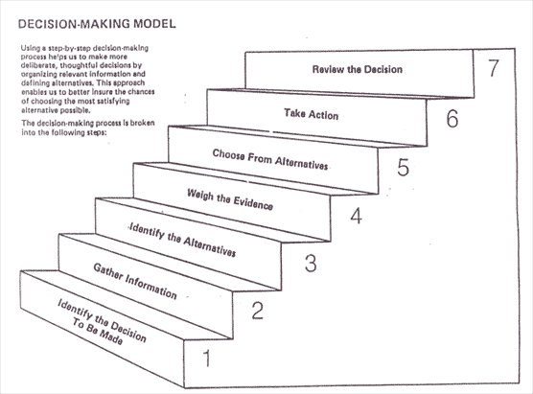
There are seven steps in effective decision making.

Step 1: Identify the decision to be made.
You realize that a decision must be made. You then go through an internal process of trying to define clearly the nature of the decision you must make. This first step is a very important one.

Step 2: Gather relevant information.
Most decisions require collecting pertinent information. The real trick in this step is to know what information is needed, the best sources of this information, and how to go about getting it. Some information must be sought from within yourself through a process of self-assessment; other information must be sought from outside yourself-from books, people, and a variety of other sources. This step, therefore, involves both internal and external “work”.

Step 3: Identify alternatives.
Through the process of collecting information you will probably identify several possible paths of action, or alternatives. You may also use your imagination and information to construct new alternatives. In this step of the decision-making process, you will list all possible and desirable alternatives.

Step 4: Weigh evidence.
In this step, you draw on your information and emotions to imagine what it would be like if you carried out each of the alternatives to the end. You must evaluate whether the need identified in Step 1 would be helped or solved through the use of each alternative. In going through this difficult internal process, you begin to favor certain alternatives which appear to have higher potential for reaching your goal. Eventually you are able to place the alternatives in priority order, based upon your own value system.

Step 5: Choose among alternatives.
Once you have weighed all the evidence, you are ready to select the alternative which seems to be best suited to you. You may even choose a combination of alternatives. Your choice in Step 5 may very likely be the same or similar to the alternative you placed at the top of your list at the end of Step 4.

Step 6: Take action.
You now take some positive action which begins to implement the alternative you chose in Step 5.

Step 7: Review decision and consequences.
In the last step you experience the results of your decision and evaluate whether or not it has “solved” the need you identified in Step 1. If it has, you may stay with this decision for some period of time. If the decision has not resolved the identified need, you may repeat certain steps of the process in order to make a new decision. You may, for example, gather more detailed or somewhat different information or discover additional alternatives on which to base your decision

