Module VI
Memory

“Memory is the process of maintaining information over time.” (Matlin, 2005)

“Memory is the means by which we draw on our past experiences in order to use this information in the present’ (Sternberg, 1999).
Memory is the term given to the structures and processes involved in the storage and subsequent retrieval of information. Memory is essential to all our lives. Without a memory of the past we cannot operate in the present or think about the future. We would not be able to remember what we did yesterday, what we have done today or what we plan to do tomorrow. Without memory we could not learn anything.

Models of memory

Multi Store Model of Memory
Atkinson and Shiffrin (1968) suggest that memory is made up of a series of stores (see below).
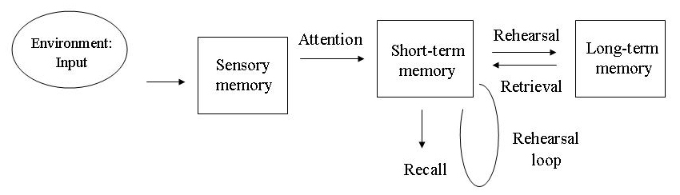
The multi store model (Atkinson, & Shiffrin 1968) describes memory in terms of information flowing through a system. Accordingly, it can be described as an information processing model (like a computer) with an input, process and output. Information is detected by the sense organs and enters the sensory memory. If attended to this information enters the short term memory.

Information from the STM is transferred to the long-term memory only if that information is rehearsed. Rehearsal was initially described by Atkinson and Shiffrin as maintenance rehearsal, but Shiffrin later suggested that rehearsal could be elaborative (Raaijmakers, & Shiffrin, 2003).
If rehearsal does not occur, then information is forgotten, lost from short term memory through the processes of displacement or decay.

Sensory Memory
• Duration: ¼ to ½ second
• Capacity: all sensory experience (v. larger capacity)
• Encoding: sense specific (e.g. different stores for each sense)

Short Term Memory
• Duration: 0-18 seconds
• Capacity: 7 +/- 2 items
• Encoding: mainly auditory

Long Term Memory
• Duration: Unlimited
• Capacity: Unlimited
• Encoding: Mainly Semantic (but can be visual and auditory)

Advantages
Many memory studies provide evidence to support the distinction between STM and LTM (in terms of encoding, duration and capacity). The model can account for primacy & recency effects.
The model is influential as it has generated a lot of research into memory.
The model is supported by studies of amnesiacs: For example the HM case study. HM is still alive but has marked problems in long-term memory after brain surgery. He has remembered little of personal (death of mother and father) or public events ( Watergate , Vietnam War) that have occurred over the last 45 years. However his short-term memory remains intact.

Weaknesses
The model is oversimplified, in particular when it suggests that both short-term and long-term memory each operate in a single, uniform fashion. We now know is this not the case.
It has now become apparent that both short-term and long-term memory are more complicated that previously thought. For example, the Working Model of Memory proposed by Baddeley and Hitch (1974) showed that short term memory is more than just one simple unitary store and comprises different components (e.g. central executive, visuo-spatial etc.).
In the case of long-term memory, it is unlikely that different kinds of knowledge, such as remembering how to play a computer game, the rules of subtraction and remembering what we did yesterday are all stored within a single, long-term memory store. Indeed different types of long-term memory have been identified, namely episodic (memories of events), procedural (knowledge of how to do things) and semantic (general knowledge).
The model suggests rehearsal helps to transfer information into LTM but this is not essential. Why are we able to recall information which we did not rehearse (e.g. swimming) yet unable to recall information which we have rehearsed (e.g. reading your notes while revising). Therefore, the role of rehearsal as a means of transferring from STM to LTM is much less important than Atkinson and Shiffrin (1968) claimed in their model.
However, the models main emphasis was on structure and tends to neglect the process elements of memory (e.g. it only focuses on attention and rehearsal).
Memory processes
Memory is involved in processing vast amounts of information. This information takes many different forms, e.g. images, sounds or meaning. For psychologists the term memory covers three important aspects of information processing:
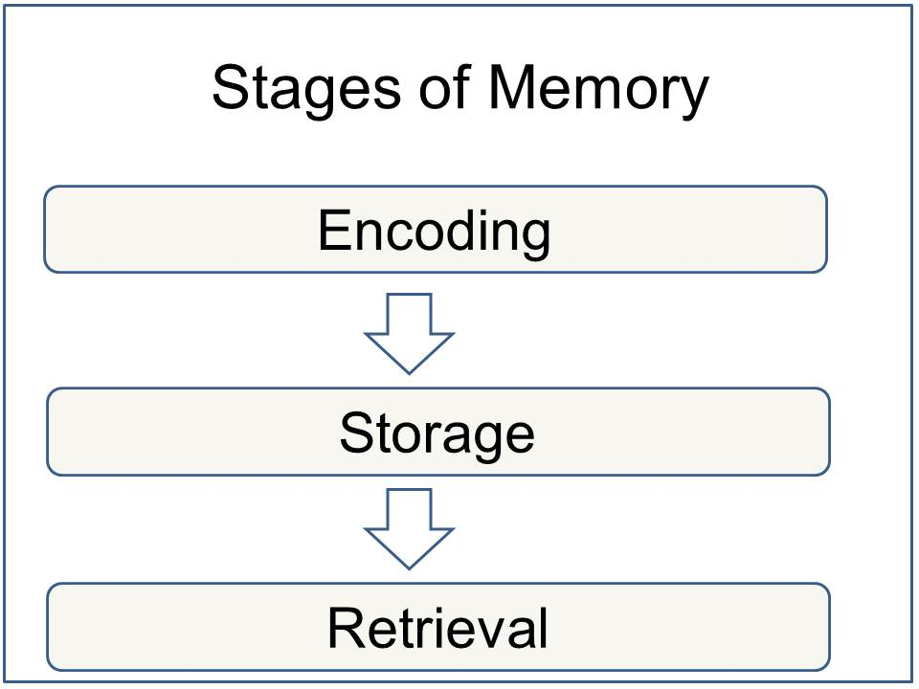

1. Memory Encoding
When information comes into our memory system (from sensory input), it needs to be changed into a form that the system can handle with, so that it can be stored. Think of this as similar to changing your money into a different currency when you travel from one country to another. For example, a word which is seen (in a book) may be stored if it is changed (encoded) into a sound or a meaning (i.e. semantic processing).
There are three main ways in which information can be encoded (changed):
1. Visual (picture)
2. Acoustic (sound)
3. Semantic (meaning)
For example, how do you remember a telephone number you have looked up in the phone book? If you can see it then you are using visual coding, but if you are repeating it to yourself you are using acoustic coding (by sound).
Evidence suggests that this is the principle coding system in short term memory (STM) is acoustic coding. When a person is presented with a list of numbers and letters, they will try to hold them in STM by rehearsing them (verbally). Rehearsal is a verbal process regardless of whether the list of items is presented acoustically (someone reads them out), or visually (on a sheet of paper).
The principle encoding system in long term memory (LTM) appears to be semantic coding (by meaning). However, information in LTM can also be coded both visually and acoustically.

2. Memory Storage
This concerns the nature of memory stores, i.e. where the information is stored, how long the memory lasts for (duration), how much can be stored at any time (capacity) and what kind of information is held. The way we store information affects the way we retrieve it. There has been a significant amount of research regarding the differences between Short Term Memory (STM ) and Long Term Memory (LTM).
Information can only be stored for a brief duration in STM (0-30 seconds), but LTM can last a lifetime.

3. Memory Retrieval
This refers to getting information out storage. If we can’t remember something, it may be because we are unable to retrieve it. When we are asked to retrieve something from memory, the differences between STM and LTM become very clear.
STM is stored and retrieved sequentially. For example, if a group of participants are given a list of words to remember, and then asked to recall the fourth word on the list, participants go through the list in the order they heard it in order to retrieve the information.
LTM is stored and retrieved by association. This is why you can remember what you went upstairs for if you go back to the room where you first thought about it.
Organizing information can help aid retrieval. You can organize information in sequences (such as alphabetically, by size or by time). Imagine a patient being discharged from hospital whose treatment involved taking various pills at various times, changing their dressing and doing exercises. If the doctor gives these instructions in the order which they must be carried out throughout the day (i.e. in sequence of time), this will help the patient remember them.

The Constructive Nature of Memory
Memory is essential to everyday life. We often reflect on our past to understand current experience or predict future events. For example, in choosing a birthday gift for a friend, we may look to past birthdays for help in deciding what gift would elicit the greatest joy for the friend this year. In this way, memory is not merely retrospective, but also intrinsically prospective. To be maximally adaptive for such future use, memories do not simply reflect individual records of directly experienced events, but also include representations built by combining knowledge across many experiences. This constructive nature of memory allows us to extract new knowledge beyond our direct experience. Such derived knowledge increases the predictive power of our memories, but may depend on our ability to fully attend to our environment.

TYPES OF MEMORY
While experts have varying definitions for short-term memory, it is generally described as the recollection of things that happened immediately up to a few days. It is generally believed that five to nine items can be stored in active short-term memory and can be readily recalled. Patients who suffer from short-term memory loss can't remember who walked into the room five minutes before, but can remember their childhood friend from 50 years ago.
Implicit memory is sometimes referred to as unconscious memory or automatic memory. Implicit memory uses past experiences to remember things without thinking about them. Musicians and professional athletes are said to have superior ability to form procedural memories.
Procedural memory, which is a subset of implicit memory, is a part of the long-term memory responsible for knowing how to do things, also known as motor skills. You don't have to look into your memory to recall how to walk each time you take a step.
Some examples of procedural memory:
- Playing piano
- Ice skating
- Playing tennis
- Swimming
- Climbing stairs
While implicit memory requires little if any effort to recall, explicit memory — sometimes referred to as declarative memory — requires a more concerted effort to bring the surface. Declarative memory involves both semantic and episodic memory.
While most people can tick off the days of the week from the time they are in grade school — which is implicit memory — it takes explicit memory to remember that your mother's birthday is next Wednesday.
Semantic memory is not connected to personal experience. Semantic memory includes things that are common knowledge, such as the names of states, the sounds of letters, the capitals of countries and other basic facts that are not in question. Some examples of semantic memory include:
- Knowledge that the sky is blue
- Knowing how to use a knife and fork
- Remembering what dog is
- Recalling that President Kennedy was assassinated on Nov. 22, 1963
Episodic memory is a person's unique recollections of a specific event or an episode. People are usually able to associate particular details with an episodic memory, such as how they felt, the time and place, and other particulars. It is not clear as to why some memories of events in our lives are committed to memory, while others don't get recorded, but researchers believe that emotions play a critical role in what we remember.
Some examples of episodic memory:
- Where you were and the people you were with when you found out about the Challenger space shuttle disaster
- Your beach vacation last summer
- The first time you traveled by plane
- Your first day at a new job
- The restaurant you went to on your first date with your spouse
AUTOBIOGRAPHICAL MEMORY
It is a memory system consisting of episodes recollected from an individual's life, based on a combination of episodic (personal experiences and specific objects, people and events experienced at particular time and place) and semantic (general knowledge and facts about the world) memory.
Conway and Pleydell-Pearce (2000) proposed that autobiographical memory is constructed within a self-memory system (SMS), a conceptual model composed of an autobiographical knowledge base and the working self.
The autobiographical knowledge base contains knowledge of the self, used to provide information on what the self is, what the self was, and what the self can be. This information is categorized into three broad areas: lifetime periods, general events, and event-specific knowledge.
Working self
The working self, often referred to as just the ‘self’, is a set of active personal goals or self-images organized into goal hierarchies. These personal goals and self-images work together to modify cognition and the resulting behaviour so an individual can operate effectively in the world.
The working self is similar to working memory: it acts as a central control process, controlling access to the autobiographical knowledge base. The working self manipulates the cues used to activate the knowledge structure of the autobiographical knowledge base and in this way can control both the encoding and recalling of specific autobiographical memories.
The relationship between the working self and the autobiographical knowledge base is reciprocal. While the working self can control the accessibility of autobiographical knowledge, the autobiographical knowledge base constrains the goals and self-images of the working self within who the individual actually is and what they can do.

Types of autobiographical memories:
There are four main categories for the types of autobiographical memories:

- Biographical or Personal: These autobiographical memories often contain biographical information pertaining to who you are, such as where one was born or the names of one's parents.
- Copies vs. Reconstructions: Autobiographical memories have different levels of authenticity. Copies are vivid autobiographical memories of an experience with a considerable amount of visual and sensory-perceptual detail. Reconstructions are autobiographical memories that are not reflections of raw experiences, but are rebuilt to incorporate new information or interpretations made in hind-sight.
- Specific vs. Generic: Autobiographical memories vary as to the level of detail. Specific autobiographical memories contain a detailed memory of a certain event (event-specific knowledge); generic autobiographical memories are vague and hold little detail other than the type of event that occurred. Repisodic autobiographical memories can also be categorized into generic memories, where one memory of an event is representative of a series of similar events.
- Field vs. Observer: Autobiographical memories can be experienced from different perspectives. Field memories are memories recollected in the original perspective, from a first-person point of view. Observer memories are memories recollected from a perspective outside ourselves, a third-person point of view. Typically, older memories are recollected through an observer perspective, and observer memories are more often reconstructions while field memories are more vivid like copies.
Autobiographical memories can also be differentiated into Remember vs. Know categories. The source of a remembered memory is attributed to personal experience. The source of a known memory is attributed to an external source, not personal memory. This can often lead to source-monitoring error, wherein a person may believe that a memory is theirs when the information actually came from an external source.

Functions
Autobiographical memory serves three broad functions:
- directive
- social and
- self-representative.
A fourth function, adaptive, was proposed by Williams, Conway and Cohen (2008).
The directive function of autobiographical memory uses past experiences as a reference for solving current problems and a guide for our actions in the present and the future. Memories of personal experiences and the rewards and losses associated with them can be used to create successful models, or schemas, of behaviour. which can be applied over many scenarios. In instances where a problem cannot be solved by a generic schema, a more specific memory of an event can be accessed in autobiographical memory to give some idea of how to confront the new challenge.
The social function of autobiographical memory develops and maintains social bonds by providing material for people to converse about. Sharing personal memories with others is a way to facilitate social interaction. Disclosing personal experiences can increase the intimacy level between people and reminiscing of shared past events strengthens pre-existing bonds. The importance of this function can easily be seen in individuals with impaired episodic or autobiographical memory, where their social relationships suffer greatly as a result.
Autobiographical memory performs a self-representative function by using personal memories to create and maintain a coherent self-identity over time. This self-continuity is the most commonly referred to self-representative function of autobiographical memory. A stable self-identity allows for evaluation of past experiences, known as life reflection, which leads to self-insight and often self-growth.
Finally, autobiographical memory serves an adaptive function. Recalling positive personal experiences can be used to maintain desirable moods or alter undesirable moods. This internal regulation of mood through autobiographical memory recall can be used to cope with negative situation and impart an emotional resilience. The effects of mood on memory are explained in better detail under the Emotion section.

Working Memory

Every day we have occasion to keep particular pieces of critical information briefly in mind, storing them until the opportunity to use them arrives. Here are some examples: remembering a phone number between the time of hearing it and dialing it (“1 646 766-6358”); holding driving directions in mind until you get to the landmarks you’ve been told to watch for (“take the first left, continue for one mile, past the school, bear right, left at the four-way intersection, then it’s the third building on the left— you can pull into the driveway”). Sometimes a problem offers multiple possible solutions, such as when you must look ahead along various possible sequences of moves in a chess game, and sometimes, as when you must untangle the structure of a complex sentence like this one, it is straightforward but nonetheless requires holding bits of information in mind until you can put it all together. In situations like these, not only do we need to keep certain bits of information accessible in mind, but also we need to perform cognitive operations on them, mulling them over, manipulating or transforming them. These short-term mental storage and manipulation operations are collectively called working memory. Think of working memory as involving a mental blackboard—that is, as a workspace that provides a temporary holding store so that relevant information is highly accessible and available for inspection and computation. When cognitive tasks are accomplished, the information can be easily erased, and the process can begin again with other information.

BADDELEY'S MODEL OF WORKING MEMORY

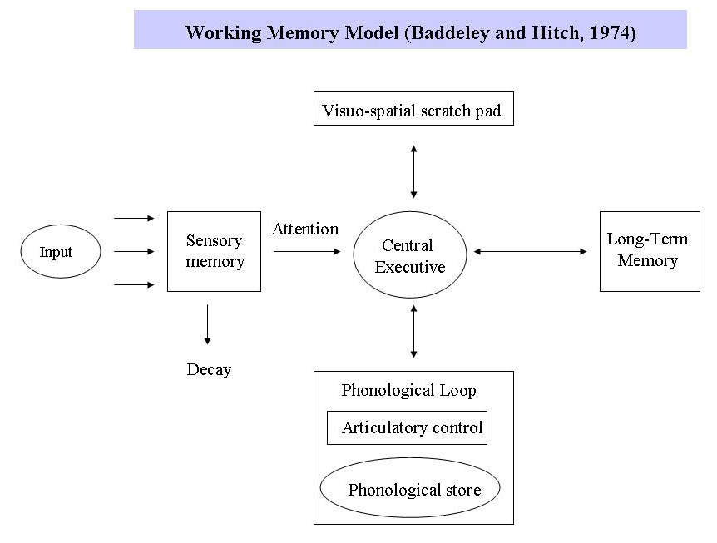
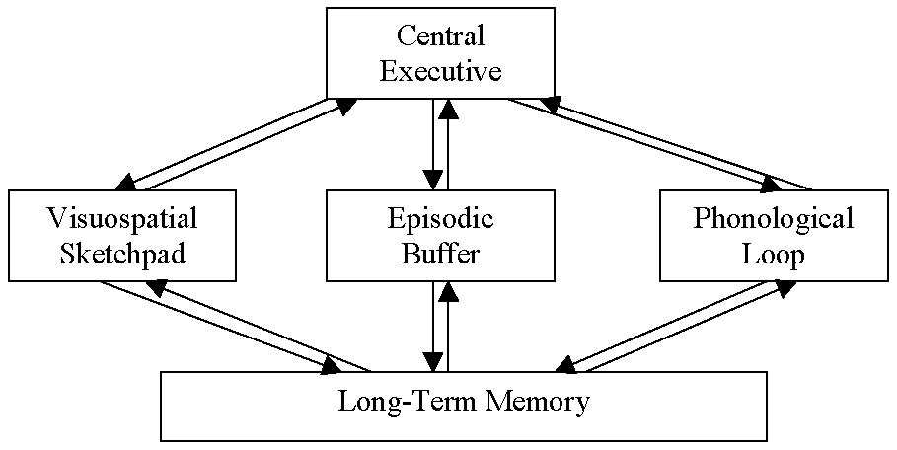
In 1974 Baddeley and Hitch proposed a "working memory model" that replaced the general concept of short-term memory with an active maintenance of information in the short-term storage. In this model, working memory consists of three basic stores: the central executive, the phonological loop and the visuo-spatial sketchpad. In 2000 this model was expanded with the multimodal episodic buffer (Baddeley's model of working memory).^{[12]}
The central executive essentially acts as an attention sensory store. It channels information to the three component processes:
- the phonological loop,
- the visuo-spatial sketchpad, and
- the episodic buffer.
The phonological loop stores auditory information by silently rehearsing sounds or words in a continuous loop: the articulatory process (for example the repetition of a telephone number over and over again). A short list of data is easier to remember.
The visuo-spatial sketchpad stores visual and spatial information. It is engaged when performing spatial tasks (such as judging distances) or visual ones (such as counting the windows on a house or imagining images).
The episodic buffer is dedicated to linking information across domains to form integrated units of visual, spatial, and verbal information and chronological ordering (e.g., the memory of a story or a movie scene). The episodic buffer is also assumed to have links to long-term memory and semantical meaning.
The working memory model explains many practical observations, such as why it is easier to do two different tasks (one verbal and one visual) than two similar tasks (e.g., two visual), and the aforementioned word-length effect. However, the concept of a central executive as noted here has been criticised as inadequate and vague . Working memory is also the premise for what allows us to do everyday activities involving thought. It is the section of memory where we carry out thought processes and use them to learn and reason about topics.
Memory Distortions
Memories aren’t exact records of events. Instead, memories are reconstructed in many different ways after events happen, which means they can be distorted by several factors. These factors include schemas, source amnesia, the misinformation effect, the hindsight bias, the overconfidence effect, and confabulation.

Schemas
A schema is a mental model of an object or event that includes knowledge as well as beliefs and expectations. Schemas can distort memory.
Example: Suppose a high school junior visits her sister’s college dorm room for the first time. She’s never been to a dorm before, but she’s seen dorms in movies, read about them, and heard her friends talking about them. When she describes the room to another friend after the visit, she comments on how many clothes her sister had and how many huge books were on her sister’s desk. In reality, the books were hidden under the bed, not out in the open. The clothes were something she actually saw, while the books were part of her dorm-room schema.

Source Amnesia
Another reason for distorted memories is that people often don’t accurately remember the origin of information.
Example: After witnessing a car crash on the freeway, Sam later tells friends many details about what he saw. It turns out, however, that there is no way he could have actually seen some of the details he described and that he is, in fact, just reporting details he heard on TV about the accident. He isn’t deliberately lying. He just may not be able to remember where all the different pieces of information came from.
This inaccurate recall of the origin of information is called source amnesia, source misattribution, or source monitoring error.

The Misinformation Effect
The misinformation effect occurs when people’s recollections of events are distorted by information given to them after the event occurred. The psychologist Elizabeth Loftus did influential research on the misinformation effect that showed that memory reconstructions can affect eyewitness testimony.
Example: A bank robber enters a crowded bank in the middle of the day, brandishing a gun. He shoots out the security cameras and terrifies everyone. He is taking money from a teller when one of two security guards approaches the robber, draws his own weapon, and shoots. Suddenly, another shot is fired from a different direction and the security guard falls to the ground, shot. Some of the customers see that the other security guard, who was approaching the robber from the other side, mistakenly shot his partner. Later, police ask the witnesses when the robber shot the guard, and they report that he shot after the guard fired on him. Even though they saw one guard shoot the other, they are swayed by the misinformation given by the police.
- Stop or Yield
In one of Loftus’s early experiments, she showed research subjects a film of a simulated automobile accident at an intersection with a stop sign. Afterward, she told half the subjects that there was a yield sign at the intersection. When asked later to describe the accident, those who had received the misleading suggestion tended to claim with certainty that there was a yield sign at the intersection, while those subjects who received no misleading suggestions had a more accurate recollection.

The Hindsight Bias
The hindsight bias is the tendency to interpret the past in a way that fits the present. For example, if Laura’s boyfriend cheats on her, she may recall the boyfriend as always having seemed promiscuous, even if this is not true.

The Overconfidence Effect
The overconfidence effect is the tendency people have to overestimate their ability to recall events correctly.

Mnemonics
Mnemonics are strategies for improving memory. Different kinds of mnemonics include acronyms, acrostics, the narrative method, and rhymes.
- Acronyms
Acronyms are words made out of the first letters of several words. For example, to remember the colors of the spectrum, people often use the name ROY G. BIV, which gives the first letters of the colors red, orange, yellow, green, blue, indigo, and violet in the right order.
- Acrostics
Acrostics are sentences or phrases in which each word begins with a letter that acts as a memory cue. For example, the rather strange phrase Roses on yachts grow better in vinegar also helps to remember the colors of the spectrum.
- Narrative methods
Narrative methods involve making up a story to remember a list of words. For example, people could remember the colors of the rainbow in the right order by making up a short story such as this:Red Smith stood next to an orange construction cone and flagged down a yellow cab. He told the cabbie he was feeling very green and asked to be taken to a hospital. The cabbie took him to a hospital, where a nurse in a blue coat guided him to a room with indigo walls. He smelled a violet in a vase and passed out.

- Rhymes
Rhymes are also good mnemonics. For example, the familiar rhyme that begins, “Thirty days has September . . .” is a mnemonic for remembering the number of days in each month.

Visual Imagery
Some well-known memory improvement methods involve using visual imagery to memorize or recall lists.

Method of Loci
When using the method of loci, people might picture themselves walking through a familiar place. They imagine each item on their list in a particular place as they walk along. Later, when they need to remember their list, they mentally do the walk again, noting the items they imagined along the path.

The Link Method
To use the link method, people associate items on a list with each other. For example, if a man wants to remember to buy bread, juice, and carrots at the store, he might try visualizing the peculiar image of himself eating a juice-and-bread mush using carrots as chopsticks.

Peg Word Method
When using the peg word method, people first remember a rhyme that associates numbers with words: one is a bun, two is a shoe, three is a tree, four is a door, five is a hive, six is sticks, seven is heaven, eight is a gate, nine is swine, ten is a hen. They then visualize each item on their list being associated with a bun, a shoe, a tree, and so on. When they need to remember the list, they first think of a bun, then see what image it’s associated with. Then they think of a shoe, and so forth.
Reference
- Memory http://www.sparknotes.com/psychology/psych101/memory/section7.rhtml

