**Kolb - Learning Styles**

by [Saul McLeod](http://www.simplypsychology.org/saul-mcleod.html) [twitter icon](https://twitter.com/simplypsych) published 2010, updated 2013

David Kolb published his learning styles model in 1984 from which he developed his learning style inventory.

Kolb's experiential learning theory works on two levels: a four stage cycle of learning and four separate learning styles.  Much of Kolb’s theory is concerned with the learner’s internal cognitive processes.

Kolb states that learning involves the acquisition of abstract concepts that can be applied flexibly in a range of situations.  In Kolb’s theory, the impetus for the development of new concepts is provided by new experiences.

“Learning is the process whereby knowledge is created through the transformation of experience” (Kolb, 1984, p. 38).

**The Experiential Learning Cycle**

Kolb's experiential learning style theory is typically represented by a four stage learning cycle in which the learner 'touches all the bases':

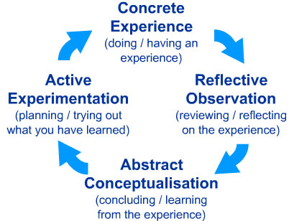

**1.** **Concrete Experience** - (a new experience of situation is encountered, or a reinterpretation of existing experience).

**2.** **Reflective Observation** (of the new experience. Of particular importance are any inconsistencies between experience and understanding).

**3.** **Abstract Conceptualization** (Reflection gives rise to a new idea, or a modification of an existing abstract concept).

**4.** **Active Experimentation** (the learner applies them to the world around them to see what results).

Effective learning is seen when a person progresses through a cycle of four stages: of (1) having a concrete experience followed by (2) observation of and reflection on that experience which leads to (3) the formation of abstract concepts (analysis) and generalizations (conclusions) which are then (4) used to test hypothesis in future situations, resulting in new experiences.

Kolb (1974) views learning as an integrated process with each stage being mutually supportive of and feeding into the next. It is possible to enter the cycle at any stage and follow it through its logical sequence.

However, effective learning only occurs when a learner is able to execute all four stages of the model. Therefore, no one stage of the cycle is an effective as a learning procedure on its own.

**Learning Styles**

Kolb's learning theory (1974) sets out four distinct learning styles, which are based on a four-stage learning cycle (see above).

Kolb explains that different people naturally prefer a certain single different learning style. Various factors influence a person's preferred style.  For example, social environment, educational experiences, or the basic cognitive structure of the individual.

Whatever influences the choice of style, the learning style preference itself is actually the product of two pairs of variables, or two separate 'choices' that we make, which Kolb presented as lines of axis, each with 'conflicting' modes at either end:

A typical presentation of Kolb's two continuums is that the east-west axis is called the **Processing Continuum**(how we approach a task), and the north-south axis is called the **Perception Continuum**(our emotional response, or how we think or feel about it).

Kolb believed that we cannot perform both variables on a single axis at the same time (e.g. think and feel).

Our learning style is a product of these two choice decisions.

It's often easier to see the construction of Kolb's learning styles in terms of a two-by-two matrix. Each learning style represents a combination of two preferred styles. The diagram also highlights Kolb's terminology for the four learning styles; diverging, assimilating, and converging, accommodating:

|  |  |  |
| --- | --- | --- |
|  | Doing (Active Experimentation - AE) | Watching (Reflective Observation - RO) |
| Feeling (Concrete Experience - CE) | **Accommodating (CE/AE)** | **Diverging (CE/RO)** |
| Thinking (Abstract Conceptualization - AC) | **Converging (AC/AE)** | **Assimilating (AC/RO)** |

**Learning Styles Descriptions**

Knowing a person's (and your own) learning style enables learning to be orientated according to the preferred method. That said, everyone responds to and needs the stimulus of all types of learning styles to one extent or another - it's a matter of using emphasis that fits best with the given situation and a person's learning style preferences.

Here are brief descriptions of the four Kolb learning styles:

**Diverging (feeling and watching - CE/RO)**

These people are able to look at things from different perspectives. They are sensitive. They prefer to watch rather than do, tending to gather information and use imagination to solve problems. They are best at viewing concrete situations at several different viewpoints.

Kolb called this style 'diverging' because these people perform better in situations that require ideas-generation, for example, brainstorming. People with a diverging learning style have broad cultural interests and like to gather information. They are interested in people, tend to be imaginative and emotional, and tend to be strong in the arts. People with the diverging style prefer to work in groups, to listen with an open mind and to receive personal feedback.

**Assimilating (watching and thinking - AC/RO)**

The Assimilating learning preference is for a concise, logical approach. Ideas and concepts are more important than people. These people require good clear explanation rather than practical opportunity. They excel at understanding wide-ranging information and organizing it in a clear logical format.

People with an assimilating learning style are less focused on people and more interested in ideas and abstract concepts.  People with this style are more attracted to logically sound theories than approaches based on practical value.

This learning style is important for effectiveness in information and science careers. In formal learning situations, people with this style prefer readings, lectures, exploring analytical models, and having time to think things through.

**Converging (doing and thinking - AC/AE)**

People with a converging learning style can solve problems and will use their learning to find solutions to practical issues. They prefer technical tasks, and are less concerned with people and interpersonal aspects. People with a converging learning style are best at finding practical uses for ideas and theories. They can solve problems and make decisions by finding solutions to questions and problems.

People with a converging learning style are more attracted to technical tasks and problems than social or interpersonal issues. A converging learning style enables specialist and technology abilities. People with a converging style like to experiment with new ideas, to simulate, and to work with practical applications.

**Accommodating (doing and feeling - CE/AE)**

The Accommodating learning style is 'hands-on', and relies on intuition rather than logic. These people use other people's analysis, and prefer to take a practical, experiential approach. They are attracted to new challenges and experiences, and to carrying out plans.

They commonly act on 'gut' instinct rather than logical analysis. People with an accommodating learning style will tend to rely on others for information than carry out their own analysis. This learning style is prevalent within the general population.

**Educational Implications**

Both Kolb's (1984) learning stages and cycle could be used by teachers to critically evaluate the learning provision typically available to students, and to develop more appropriate learning opportunities.

Educators should ensure that activities are designed and carried out in ways that offer each learner the chance to engage in the manner that suits them best. Also, individuals can be helped to learn more effectively by the identification of their lesser preferred learning styles and the strengthening of these through the application of the experiential learning cycle.

Ideally, activities and material should be developed in ways that draw on abilities from each stage of the experiential learning cycle and take the students through the whole process in sequence

**Kolb's Learning Styles and Experiential Learning Model**

Note: While you can start at any of the major themes listed to the left of this screen, you should read the [Introduction](http://www.nwlink.com/~donclark/hrd/styles.html) to get a background of learning styles.

While [VAK](http://www.nwlink.com/~donclark/hrd/styles/vakt.html) may have popularized learning styles, David Kolb, Professor of Organizational Behavior at Case Western Reserve University, is credited with launching the learning styles movement in the early seventies and is perhaps one of the most influential learning models developed.

Learning is the process whereby knowledge is created through the transformation of experience. Knowledge results from the combination of grasping experience and transforming it. - Kolb (1984, 41)

Kolb proposes that experiential learning has six main characteristics:

* Learning is best conceived as a process, not in terms of outcomes.
* Learning is a continuous process grounded in experience.
* Learning requires the resolution of conflicts between dialectically opposed modes of adaptation to the world (learning is by its very nature full of tension).
* Learning is a holistic process of adaptation to the world.
* Learning involves transactions between the person and the environment.
* Learning is the process of creating knowledge that is the result of the transaction between social knowledge and personal knowledge.

Kolb's learning theory sets out four distinct learning styles, which are based on a four-stage learning cycle. In this respect, Kolb's model differs from others since it offers both a way to understand individual learning styles, which he named the "Learning Styles Inventory" (LSI), and also an explanation of a cycle of *experiential learning* that applies to all learners.

**Basis of Kolb's Experiential Learning Model**

**Note**: “Experiential” means relating to or resulting from experience while “experimental” means relating to or based on experiment. Kolb uses the term “experiential” as his theory is based more on reflection of experiences. While others use “experimental” when referencing experimental-inquiry techniques that requires learners to test hypothesis (experiment) about content knowledge.

Kolb's learning model is based on two continuums that form a quadrant:

[[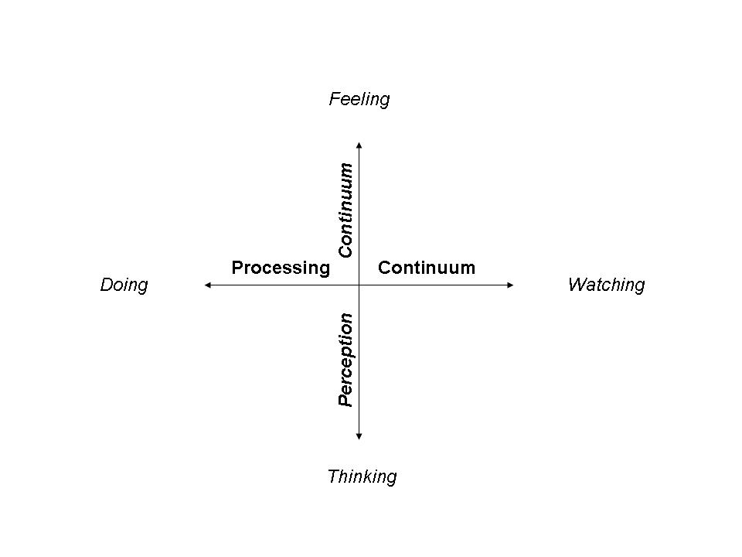](http://www.nwlink.com/~donclark/hrd/styles/continuum_1.jpg)](http://www.nwlink.com/~donclark/hrd/styles/continuum_1.jpg)  
For a larger picture, click on the image

* Processing Continuum: Our approach to a task, such as preferring to learn by doing or watching.
* Perception Continuum: Our emotional response, such as preferring to learn by thinking or feeling.

**The Learning Cycle**

This matrix provides a learning cycle that involves four processes that must be present for learning to occur. Note that this part of Kolb's model is more useful in that rather than trying to pinpoint a learning style, he provides a model learning program.

Kolb called this *Experiential Learning* since experience is the source of learning and development (1984). Each ends of the continuums (modes) provide a step in the learning process:

[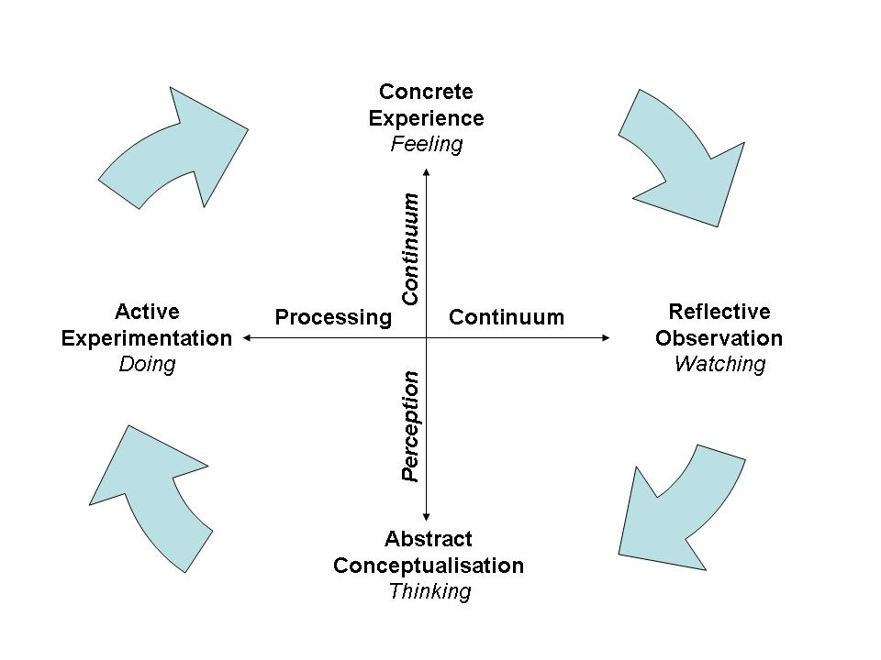](http://www.nwlink.com/~donclark/hrd/styles/learning_cycle_2.jpg)   
For a larger picture, click on the image

* Concrete experience (feeling): Learning from specific experiences and relating to people. Sensitive to other's feelings.
* Reflective observation (watching): Observing before making a judgment by viewing the environment from different perspectives. Looks for the meaning of things.
* Abstract conceptualization (thinking): Logical analysis of ideas and acting on intellectual understanding of a situation.
* Active experimentation (doing): Ability to get things done by influencing people and events through action. Includes risk-taking.

Depending upon the situation or environment, the learners may enter the learning cycle at any point and will best learn the new task if they practice all four modes.

Listed below are some examples:

* **Learning to ride a bicycle:**
  + Reflective observation - Thinking about riding and watching another person ride a bike.
  + Abstract conceptualization - Understanding the theory and having a clear grasp of the biking concept.
  + Concrete experience - Receiving practical tips and techniques from a biking expert.
  + Active experimentation - Leaping on the bike and have a go at it.
* **Learning a software program:**
  + Active experimentation - Jumping in and doing it.
  + Reflective observation - Thinking about what you just performed.
  + Abstract conceptualization - Reading the manual to get a clearer grasp on what was performed.
  + Concrete experience - Using the help feature to get some expert tips.
* **Learning to coach:**
  + Concrete experience - Having a coach guide you in coaching someone else.
  + Active experimentation - Using your people skills with what you have learned to achieve your own coaching style.
  + Reflective observation - Observing how other people coach.
  + Abstract conceptualization - Reading articles to find out the pros and cons of different methods.
* **Learning algebra:**
  + Abstract conceptualization - Listening to explanations on what it is.
  + Concrete experience - Going step-by-step through an equation.
  + Active experimentation - Practicing.
  + Reflective observation - Recording your thoughts about algebraic equations in a learning log.

Kolb views the learning process as a context of people moving between the modes of concrete experience (CE) and abstract conceptualization (AC), and reflective observation (RO) and active experimentation (AE). Thus, the effectiveness of learning relies on the ability to balance these modes, which Kolb sees as opposite activities that best promote learning.

In addition, Kolb (1999) claims that concrete experience and abstract conceptualization reflect right-brain and left-brain thinking respectively.

**Kolb's Learning Styles**

Kolb theorized that the four combinations of perceiving and processing determine one of four learning styles of how people prefer to learn. Kolb believes that learning styles are not fixed personality traits, but relatively stable patterns of behavior that is based on their background and experiences. Thus, they can be thought of more as learning preferences, rather than styles.

[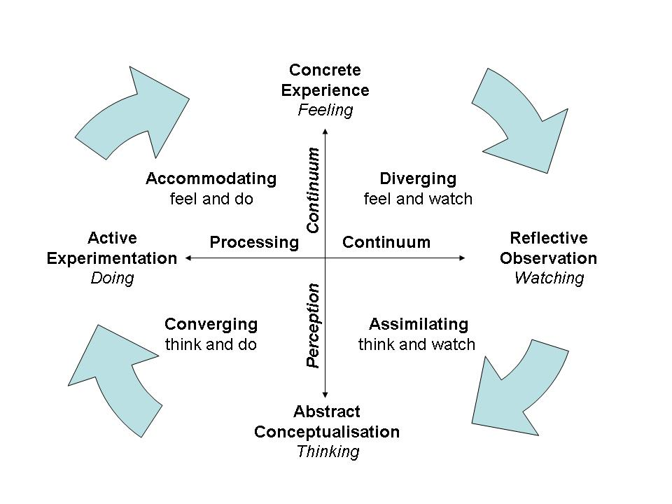](http://www.nwlink.com/~donclark/hrd/styles/learning_styles.jpg)   
For a larger picture, click on the image

* **Diverging** (concrete, reflective) - Emphasizes the innovative and imaginative approach to doing things. Views concrete situations from many perspectives and adapts by observation rather than by action. Interested in people and tends to be feeling-oriented. Likes such activities as cooperative groups and brainstorming.
* **Assimilating** (abstract, reflective) - Pulls a number of different observations and thoughts into an integrated whole. Likes to reason inductively and create models and theories. Likes to design projects and experiments.
* **Converging** (abstract, active)- Emphasizes the practical application of ideas and solving problems. Likes decision-making, problem-solving, and the practical application of ideas. Prefers technical problems over interpersonal issues.
* **Accommodating** (concrete, active) - Uses trial and error rather than thought and reflection. Good at adapting to changing circumstances; solves problems in an intuitive, trial-and-error manner, such as discovery learning. Also tends to be at ease with people

**Visual, Auditory, and Kinesthetic Learning Styles (VAK)**

The VAK learning style uses the three main sensory receivers: Visual, Auditory, and Kinesthetic (movement) to determine the dominant learning style. It is sometimes known as VAKT (Visual, Auditory, Kinesthetic, & Tactile). It is based on *modalities—*channels by which human expression can take place and is composed of a combination of perception and memory.

VAK is derived from the accelerated learning world and seems to be about the most popular model nowadays due to its simplicity. While the research has shown a connection with modalities and learning styles (University of Pennsylvania, 2009), the research has [so far been unable to prove](http://www.nwlink.com/~donclark/hrd/styles.html) the using one's learning style provides the best means for learning a task or subject. This is probably because it is more of a*preference*, rather than a *style*.

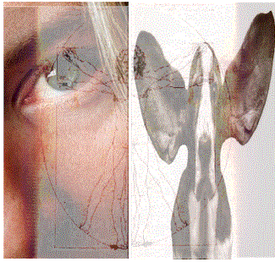

Learners use all three modalities to receive and learn new information and experiences. However, according to the VAK or modality theory, one or two of these receiving styles is normally dominant. This dominant style defines the best way for a person to learn new information by filtering what is to be learned. This style may not always to be the same for some tasks. The learner may prefer one style of learning for one task, and a combination of others for a different task.

Classically, our learning style is forced upon us through life like this: In grades kindergarten to third, new information is presented to us kinesthetically; grades 4 to 8 are visually presented; while grades 9 to college and on into the business environment, information is presented to us mostly through auditory means, such as lectures.

According to the VAK theorists, we need to present information using all three styles. This allows all learners the opportunity to become involved, no matter what their preferred style may be.

While there is some evidence for modality specific strengths and weaknesses (Rourke, et al. 2002), what has has not been established is matching the instructional style to individual learning strength improves their learning abilities. For example, one study (Constantinidou and Baker, 2002), found that visual presentation through the use of pictures was advantageous for all adults, irrespective of a high or low learning-style preference for visual images. Indeed, it was especially advantageous for those with a strong preference for verbal processing.

**Hints for Recognizing and Implementing the Three VAK Styles**

**Auditory learners** often talk to themselves. They also may move their lips and read out loud. They may have difficulty with reading and writing tasks. They often do better talking to a colleague or a tape recorder and hearing what was said. To integrate this style into the learning environment:

* Begin new material with a brief explanation of what is coming. Conclude with a summary of what has been covered. This is the old adage of “tell them what they are going to lean, teach them, and tell them what they have learned.”
* Use the Socratic method of lecturing by questioning learners to draw as much information from them as possible and then fill in the gaps with you own expertise.
* Include auditory activities, such as brainstorming, buzz groups, or Jeopardy. Leave plenty of time to debrief activities. This allows them to make connections of what they leaned and how it applies to their situation.
* Have the learners verbalize the questions.
* Develop an internal dialogue between yourself and the learners.

**Visual learners** have two sub-channels—*linguistic* and *spatial*. Learners who are*visual-linguistic* like to learn through written language, such as reading and writing tasks. They remember what has been written down, even if they do not read it more than once. They like to write down directions and pay better attention to lectures if they watch them. Learners who are *visual-spatial* usually have difficulty with the written language and do better with charts, demonstrations, videos, and other visual materials. They easily visualize faces and places by using their imagination and seldom get lost in new surroundings. To integrate this style into the learning environment:

* Use graphs, charts, illustrations, or other visual aids.
* Include outlines, concept maps, agendas, handouts, etc. for reading and taking notes.
* Include plenty of content in handouts to reread after the learning session.
* Leave white space in handouts for note-taking.
* Invite questions to help them stay alert in auditory environments.
* Post flip charts to show what will come and what has been presented.
* Emphasize key points to cue when to takes notes.
* Eliminate potential distractions.
* Supplement textual information with illustrations whenever possible.
* Have them draw pictures in the margins.
* Have the learners envision the topic or have them act out the subject matter.

**Kinesthetic learners** do best while touching and moving. It also has two sub-channels: kinesthetic (movement) and tactile (touch). They tend to lose concentration if there is little or no external stimulation or movement. When listening to lectures they may want to take notes for the sake of moving their hands. When reading, they like to scan the material first, and then focus in on the details (get the big picture first). They typically use color high lighters and take notes by drawing pictures, diagrams, or doodling. To integrate this style into the learning environment:

* Use activities that get the learners up and moving.
* Play music, when appropriate, during activities.
* Use colored markers to emphasize key points on flip charts or white boards.
* Give frequent stretch breaks (brain breaks).
* Provide toys such as Koosh balls and Play-Dough to give them something to do with their hands.
* To highlight a point, provide gum, candy, scents, etc. which provides a cross link of scent (aroma) to the topic at hand (scent can be a powerful cue).
* Provide high lighters, colored pens and/or pencils.
* Guide learners through a visualization of complex tasks.
* Have them transfer information from the text to another medium such as a keyboard or a tablet
* free VAK learning styles test
* vak - visual, auditory, kinesthetic - learning styles model and free self-test
* The VAK learning styles model and related VAK learning styles tests offer a relatively simple methodology. Therefore it is important to remember that these concepts and tools are **aids** to understanding **overall** personality, preferences and strengths - which is always a mixture in each individual person.
* As with any methodology or tool, use VAK and other learning styles ideas with care and interpretation according to the needs of the situation. They are guide as to the mixture of preferences, strengths and learning styles in an individual, not a basis for deciding on one exclusive preference or approach to the exclusion of everything else.
* On this point, the [Kolb Learning Styles](http://www.businessballs.com/kolblearningstyles.htm) page offers additional [notes on the use of Learning Styles in young people's education](http://www.businessballs.com/kolblearningstyles.htm#note-learning-styles-education).
* In addition to the VAK materials and tests below, further VAK (and VARK and VACT) explanation is on the page dealing with [Multiple Intelligences and VAK](http://www.businessballs.com/howardgardnermultipleintelligences.htm).
* vak learning styles
* The **Visual-Auditory-Kinesthetic** learning styles model or 'inventory', usually abbreviated to VAK, provides a simple way to explain and understand your own learning style (and learning styles of others).
* **'Learning style' should be interpreted to mean an individual mixture of styles.** Everyone has a mixture of strengths and preferences. No-one has exclusively one single style or preference. Please bear this in mind when using these ideas.
* Alternatively the model is referred to as Visual-Auditory-Physical, or Visual-Auditory-Tactile/Kinesthetic (or Kinaesthetic). The model is also extended by some people to [VARK (Visual-Auditory-Reading-Kinesthetic) or VACT (Visual-Auditory-Kinesthetic-Tactile)](http://www.businessballs.com/howardgardnermultipleintelligences.htm#vark learning styles model), and you can decide yourself about the usefulness of such adaptations.
* The original VAK concepts were first developed by psychologists and teaching (of children) specialists such as Fernald, Keller, Orton, Gillingham, Stillman and Montessori, starting in the 1920's. VAK theory is now a favourite of the accelerated learning community because its principles and benefits extend to all types of learning and development, far beyond its early applications. See also [Kolb's learning styles model](http://www.businessballs.com/kolblearningstyles.htm), and [Gardner's Multiple Intelligences model](http://www.businessballs.com/howardgardnermultipleintelligences.htm), in which section you'll find[more information about VAK, VARK and VACT learning styles theories](http://www.businessballs.com/howardgardnermultipleintelligences.htm" \l "vak visual auditory kinesthetic learning styles inventory theory model). [Katherine Benziger's methodology](http://www.businessballs.com/benzigerpersonalityassessment.htm) is also useful and relevant, as is the various material on the [Personality Styles](http://www.businessballs.com/personalitystylesmodels.htm) section. These models provide additional perspectives of the way we each think and relate to the world, and where are natural strengths lie. The Visual-Auditory-Kinesthetic learning styles model does not overlay [Gardner's multiple intelligences](http://www.businessballs.com/howardgardnermultipleintelligences.htm), or [Kolb's theory](http://www.businessballs.com/kolblearningstyles.htm), rather the VAK model provides a different perspective for understanding and explaining a person's preferred or dominant thinking and learning style, and strengths. Gardner's theory is one way of looking at thinking styles; Kolb is another way; VAK is another. The more perspectives you have, the better you see and understand your own personality and learning styles, and the learning styles of employees, colleagues and staff.
* vak learning styles

|  |  |
| --- | --- |
| **learning style** | **description** |
| **Visual** | seeing and reading |
| **Auditory** | listening and speaking |
| **Kinesthetic** | touching and doing |

* N.B. Kinesthetic style is also referred to as 'Physical', or 'Tactile', or 'Touchy-Feely'.
* According to the VAK model, most people possess a dominant or preferred learning style, however some people have a mixed and evenly balanced blend of the three styles.
* As already mentioned, it is also helpful to look at [Kolb's learning styles model](http://www.businessballs.com/kolblearningstyles.htm) and [Gardner's Multiple Intelligences model](http://www.businessballs.com/howardgardnermultipleintelligences.htm).

* visual-auditory-kinesthetic learning styles
* The VAK learning styles model provides a very easy and quick reference inventory by which to assess people's preferred learning styles, and then most importantly, to **design learning methods and experiences that match people's preferences**:
* **Visual** learning style involves the use of seen or observed things, including pictures, diagrams, demonstrations, displays, handouts, films, flip-chart, etc.
* **Auditory** learning style involves the transfer of information through listening: to the spoken word, of self or others, of sounds and noises.
* **Kinesthetic** learning involves physical experience - touching, feeling, holding, doing, practical hands-on experiences.
* The word 'kinesthetic' describes the sense of using muscular movement - physical sense in other words. Kinesthesia and kinesthesis are root words, derived from the Greek **kineo, meaning move**, and **aisthesis, meaning sensation**. Kinesthetic therefore describes a learning style which involves the stimulation of nerves in the body's muscles, joints and tendons. This relates to the colloquial expression '**touchy-feely**' ('kineo-aisthesis' = 'move-sensation').
* The VAK Visual-Auditory-Kinesthetic model and the free test below provides a free quick easy way to assess your own or other people's preferred learning styles. Please note the test below is a simple indicator of preferred learning styles - it's bloody good for free, but it's not meant for rigorous scientific research. This VAK assessment tool is a good basic guide to personal learning styles, but it's is not a scientifically validated instrument - otherwise it would probably not be free.
* vak (visual-auditory-kinesthetic) learning style indicators and free self-test
* Here is a free VAK learning style indicator, which can be used as a questionnaire or 'test' to assess your own preferred learning style or styles, or the VAK learning styles of your people. Score each statement and then add the totals for each column to indicate learning style dominance and mix. Your learning style is also a reflection of the type of person you are - how you perceive things and the way that you relate to the world. This questionnaire helps you to improve your understanding of yourself and your strengths. **There are no right or wrong answers**. (See also the [free quick VAK test - short version](http://www.businessballs.com/howardgardnermultipleintelligences.htm" \l "vak learning styles free quick test))
* You can use various scoring systems to suit your purposes:
* **Method 1** - Simplest and quickest - select one from each line and add the total selections for each column. The totals will indicate your relative learning style preference and mix.
* **Method 2** - More subtle measurement - takes longer, but probably worth it - score each option either 1, 2 or 3 points. Clearer indication will be produced if no options in a single line are scored the same, but it's up to you. You get out what you put in. Decide whether to allow equal scores or not, and most importantly then apply the rule for the whole of the questionnaire.
* **Method 3** - Re-structure the matrix into a multiple choice-style questionnaire - takes longer, but is more likely to avoid 'leading' or influencing the person being assessed because the format is less transparent. Each of the 30 questions would be structured as per this example, and could either ask for a single selection or to score each option 1, 2, or 3:
* Q1 When operating new equipment for the first time I prefer to..
* a) read the instructions   
  b) listen or ask for an explanation   
  c) have a go and learn by 'trial and error'
* (A scoring grid would need to be created so as to enable calculation of totals for all a's b's and c's.)
* [Free VAK learning styles test - multiple-choice questionnaire (MSWord doc)](http://www.businessballs.com/freematerialsinword/vaklearningstylesquestionnaireselftest.doc" \t "_blank)
* [Free VAK learning styles test - multiple-choice questionnaire (PDF)](http://www.businessballs.com/freepdfmaterials/vak_learning_styles_questionnaire.pdf" \t "_blank)
* **Method 4**- As method 3, but mix up the order of the options within each question, so as to reduce the transparency of the options and which style they relate to - this takes even longer and is a pain in the backside to score because 'a, b, c' would no longer correlate to 'V, A, K', so you'd need quite a clever scoring grid to achieve this, and a reasonably serious project to justify the effort.

* vak learning style indicators (free self-test questionnaire)

|  |  |  |  |  |  |  |  |
| --- | --- | --- | --- | --- | --- | --- | --- |
|  |  | **visual** | | **auditory** | | **kinesthetic /physical** | |
| 1 | when operating new equipment for the first time I prefer to | read the instructions |  | listen to or ask for an explanation |  | have a go and learn by 'trial and error' |  |
| 2 | when seeking travel directions I.. | look at a map |  | ask for spoken directions |  | follow my nose or maybe use a compass |  |
| 3 | when cooking a new dish I.. | follow a recipe |  | call a friend for explanation |  | follow my instinct, tasting as I cook |  |
| 4 | to teach someone something I.. | write instructions |  | explain verbally |  | demonstrate and let them have a go |  |
| 5 | I tend to say.. | "I see what you mean" |  | "I hear what you are saying" |  | "I know how you feel" |  |
| 6 | I tend to say.. | "show me" |  | "tell me" |  | "let me try" |  |
| 7 | I tend to say.. | "watch how I do it" |  | "listen to me explain" |  | "you have a go" |  |
| 8 | complaining about faulty goods I tend to.. | write a letter |  | phone |  | go back to the store, or send the faulty item to the head office |  |
| 9 | I prefer these leisure activities | museums or galleries |  | music or conversation |  | physical activities or making things |  |
| 10 | when shopping generally I tend to.. | look and decide |  | discuss with shop staff |  | try on, handle or test |  |
| 11 | choosing a holiday I.. | read the brochures |  | listen to recommendations |  | imagine the experience |  |
| 12 | choosing a new car I.. | read the reviews |  | discuss with friends |  | test-drive what you fancy |  |
| 13 | learning a new skill | I watch what the teacher is doing |  | I talk through with the teacher exactly what I am supposed to do |  | I like to give it a try and work it out as I go along by doing it |  |
| 14 | choosing from a restaurant menu.. | I imagine what the food will look like |  | I talk through the options in my head |  | I imagine what the food will taste like |  |
| 15 | when listening to a band | I sing along to the lyrics (in my head or out loud!) |  | I listen to the lyrics and the beats |  | I move in time with the music |  |
| 16 | when concentrating I.. | focus on the words or pictures in front of me |  | discuss the problem and possible solutions in my head |  | move around a lot, fiddle with pens and pencils and touch unrelated things |  |
| 17 | I remember things best by.. | writing notes or keeping printed details |  | saying them aloud or repeating words and key points in my head |  | doing and practising the activity, or imagining it being done |  |
| 18 | my first memory is of | looking at something |  | being spoken to |  | doing something |  |
| 19 | when anxious, I.. | visualise the worst-case scenarios |  | talk over in my head what worries me most |  | can't sit still, fiddle and move around constantly |  |
| 20 | I feel especially connected to others because of | how they look |  | what they say to me |  | how they make me feel |  |
| 21 | when I revise for an exam, I.. | write lots of revision notes (using lots of colours!) |  | I talk over my notes, to myself or to other people |  | imagine making the movement or creating the formula |  |
| 22 | when explaining something to someone, I tend to.. | show them what I mean |  | explain to them in different ways until they understand |  | encourage them to try and talk them through the idea as they try |  |
| 23 | my main interests are | photography or watching films or people-watching |  | listening to music or listening to the radio or talking to friends |  | physical /sports activities or fine wines, fine foods or dancing |  |
| 24 | most of my free time is spent.. | watching television |  | talking to friends |  | doing physical activity or making things |  |
| 25 | when I first contact a new person.. | I arrange a face to face meeting |  | I talk to them on the telephone |  | I try to get together to share an activity |  |
| 26 | I first notice how people.. | look and dress |  | sound and speak |  | stand and move |  |
| 27 | if I am very angry.. | I keep replaying in my mind what it is that has upset me |  | I shout lots and tell people how I feel |  | I stomp about, slam doors and throw things |  |
| 28 | I find it easiest to remember | faces |  | names |  | things I have done |  |
| 29 | I think I can tell someone is lying because.. | they avoid looking at you |  | their voice changes |  | the vibes I get from them |  |
| 30 | When I'm meeting with an old friend.. | I say "it's great to see you!" |  | I say "it's great to hear your voice!" |  | I give them a hug or a handshake |  |
|  | **totals** | **visual** |  | **auditory** |  | **kinesthetic/physical** |  |

* However you calculate the totals, ensure you use the chosen method consistently throughout the questionnaire. The total scores for each style indicate your relative preferred learning style or styles. There are no right or wrong answers. Some people have very strong preferences, even to the extent that they have little or no preference in one or two of the styles. Other people have more evenly balanced preferences, with no particularly strong style. The point is simply to try to understand as much as you can about yourself and your strengths (your p