**Micro teaching- Characteristics and Phases**

**Definitions**

Allen,D.W (1966): Micro-teaching is a scaled down teaching encounter in class size and class time.

Allen,D.W. and Eve,A.W. (1968): Micro-teaching is defined as a system of controlled practice that makes it possible to concentrate on specified teaching behavior and to practices teaching under controlled conditions.

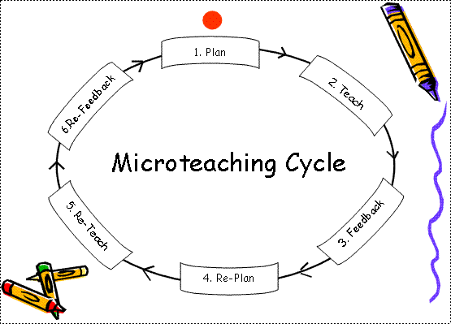

The **steps in a microteaching session** are:

1. PLANNING:

This involves selection of the skill to be practiced, awareness of components of the skill, selection of a suitable concept, writing of micro lesson with specific objectives.

2. TEACHING:

The following setting is suggested for the micro teaching technique.

Time: 5 minutes

Students: peer group-5 or so in number

Supervisors: 1or 2

If possible, use of CCTV facility could be made to enable the teacher trainee to get a first hand look at his weaknesses.

3. FEEDBACK:

This is a vital aspect of the micro teaching cycle. To be effective it must be clearly related to the model of the teaching skill used. Appraisal guides add to the comments of the supervisor and fellow students, they focus the feedback on to specific

behaviours and can be used for the analysis session or be just given to the teacher trainee with a written comment or rating of his/her skill performance.

4. REPLAN:

Keeping in mind the feedback received from the supervisor the teacher trainee replans his/her micro lesson writing another micro lesson plan or editing the existing one.

5. RETEACH:

The teacher trainee re teaches, incorporating the suggested changes with the same students or another group of 5 students. Supervisor checks to see whether there is any improvement in skill attainment.

6. RE-FEED BACK:

The supervisor assesses the lesson again pointing out the improvements and lapses.

**Characteristics of Microteaching**

1) Duration of teaching as well as number of students are less.

2) Content is divided into smaller units.

3) Only one teaching skill is considered at a time.

4) Provision of immediate feedback.

5) In micro teaching cycle, there is facility of replanning, re-teaching and re-evaluation.

6) It puts the teacher under the microscope

7) All the faults of the teacher are observed.

8) The problem of discipline can also be controlled.

**Phases of Microteaching**

**Knowledge Acquisition Phase** : In this phase the teacher trainee learns about the skill and its components through discussion, illustrations and demonstration of the skill given by the expert. He learns about the purpose of the skill and the condition under which it proves useful in the teaching learning process. His/Her analysis of the skill into components leading to various types of behaviours which is to be practised. The teacher trainee tries to gain a lot about the skill from the demonstration given by the expert . He discusses and clarifies each and every aspect of the skill.

**Skill Acquisition Phase** : On the basis of the demonstration presented by the expert, the teacher trainee plans a micro-lesson, lesson for practising the demonstrated skill. He practices the teaching skill through the Micro-teaching cycle and continues his efforts till he attains mastery level. The feed-back component of micro-teaching contributes significantly towards the mastery level acquisition of the skill. On the basis of the performance of teacher trainee in teaching, the feed back is provided for the purpose of change in behaviour of the teacher trainee in the desired direction.

**Transfer Phase of Micro-teaching** : After attaining mastery level and command over each of the skills, the teacher trainee integrates all these skills and transfer to actual classroom teaching is done during this transfer phase.