Module 2
FACTORS FOR CURRICULUM CONSTRUCTION
"Mar and Society are conceived as interrelated. It is this concept which re-enforces the belief that the curriculum of the schools should be developed in relation to the nature of the community and that education is not preparation for living but life itself. It is this concept which stresses the continuity of education and the belief that education goes on throughout life"*. The curriculum is the very pivot cantering round which the entire edifice of education is constructed. It is the focal point of a modern education system and the success as well as failure in achieving the proposed goal depends largely upon the proper curriculum construction and as such greater emphasis should be placed upon curriculum, and the essence of education should be in conformity with certain well thought out theories. However, it is to be adjusted and modified in relation to specific needs of a particular country. For the improvement of the quality of education, educationists have to take into consideration the proper selection of objectives, proper selection of the curriculum, suitable methods of teaching and evaluation. includes all wider experiences of children and it should have the potentiality to achieve the best and should be well conceived to bring out latent faculties of children in accordance with their respective age groups, understanding, and above all psychological aspiration and needs. The schools being an integral part of the educational activity should create conditions for such development. Supporting the same statement Joodlad says I "A curriculum consists of all these learning intended for students. There must be plans specifying and justifying what they are to do and hopefully learn"!.
From the ancient period to modem times, different factors have been influencing our education system. These factors may be conveniently grouped as philosophical, psychological, social, economical and environmental etc. The present chapter is an attempt to present a comprehensive idea, how these factors have been influencing our educational system.
The philosophical aspects :
The various philosophical thoughts that influence curriculum are Idealism, Realism, Existentialism, Pragmatism, Essentialism and Deconstructionism. ... Basically, philosophy of education does influence, and to a greater extent determines our educational decisions and alternative .The spirit and nature of the government of a particular state as well as the cultural and historical background is to be taken into consideration for the educational system of the country,
The form of government - democratic, communistic or dictatorial - largely influences the shape of educational system prevailing in the country - a fact which must be taken in into consideration/the present discussion. While attempting to evaluate the principles of curriculum construction the democratic values of the country should take precedence over all other considerations. "In this context, special emphasis has to be laid on the development of values such as a scientific temper of mind, tolerance, respect for the culture of other national groups etc., which will enable us to adopt democracy not only as a form of Government, but also as a way of life.... A healthy development of democratic trends will help softer the impact of this division into social, economic and cultural groups"1. A communist country like U.S.s.R. has a different ideological and philosophical background. In U.S.S.R. greater emphasis has been placed on the demands of the national economy. It stresses greater importance on labour discipline as a matter of vital necessity by which the country is trying to raise the standard of living. Commurist China has two broad objectives of its education i.e., political education and education for national reconstruction. The schools place primary importance on Education and National Development, Report on EducationCommission 1964-66, National Council of Educational Research and Trainirg 1971
Cultural factor :
"... the basic biological equipment of man seems to be comparatively invariant and may therefore be expected to give certain common elements to education every where and at all times. Human civilization has characteristics of neighbour-hood, region, nation and more extended cultural areas, which lend unique qualities to every educational programme, however, persistent and parvasive may be the universal elements entering it
Education in democratic India must be rooted in the cultural heritages of the land in terms of both the past and present with the basic objective to make a greater future. Our school education will remain unsuccessful if it absolutely ignores the need of the present society or remains tied to the
past. It is not possible for us to ignore the role of cultural aspect in educational system. Only culture binds the individual and society together and education helps culture to flourish.
Religious aspects s
In the ancient age, education was dominated by religion. During that period religious education was treated as the touchstone for religious knowledge. The Vedas constituted the texts for higher education in ancient India. Religion was a predominant factor in every sphere of life and it could be said that ancient India was built upon a solid relagious rather than polotical and social ground.
Dr. R® K. Mukherjee said : "Learning in India through the ages had been prized and pursued not for its own sake, if we may so put it, but for the sake and as a part of religion.
Tie result is that it is religion that creates literature in India and wields it as an instrument for its own purposes, a vehicle of its expression"!. Thus ancient Indian education was influenced by religion. The Buddhist system of education had not also departed from the established order. The basic philosophy of Buddhist religion formed an essential part of academic discipline. In the Qoran is also mentioned that "education" was compulsory for all Moslems. The Maktab was the institution for primary education and this institution was attached to a mosque. The basic objective was to instruct boys in the fundamental aspects of the Qoran which a mohammedan was expected to know forperformances of religious rites.
Caste system :
In ancient India, the Vedic system of education had: taken into consideration the caste system as a part and parcel of education. Birth and occupations were the main factors on the basis of which was determined what type of education would suit the incuhm&nt and naturally various social groups (caste) sprang up and they tenaciously clung to their respective vocational training from generation to generation. During ancient times there were four main castes - Brahman,Kshatriya, Vaishya and Sudra. The Brahman mainly enjoyed the exclusive right to acquire vedic and spiritual knowledge, but some Kshatriyas, like janaka, also became learned philosophers. But Vaishyas and Sudras lay
low in social status. The Vaishyas, the great agricultural and trading grcup, was divided into functional groups as chariot makers, blacksmiths, carpenters etc. and these people were assumed
as new castes generally devoid of the privilege of acquiring higher and spiritual knowledge. Socially despised due to caste preindices they were hardly allowed to receive higher education whatsoever.
A system of education was bound to be affected by the above mentioned caste system. The brahmin by virtue of his social superiority had been given priority to acquire higher education but at the same time Kshatriya and the Vaisya were also eligible for studentship. Besides religious education, the Kshatriya had other subjects to study. Those were politics, military arts, Archury etc. including the use of elephants, horses, chariots, weapons, Ithihasa besides Purana, Itivritta, Akhyayika, Udaharana, Dharmasastra and Arthasastra etc. The knowledge of the Vedaswas also essential for them. The education of the Vaishyas was concerned with agriculture and trade, lb become a specialist in agriculture, a Vaishya had to know sewing, quality of fields, measures and weights,
were to know the value of gems, corals, metals, pearls, thread, perfumes e-c. Besides these, they had to know commercial geography, arithmetic and some foreign languages. The Sndra's education was restricted to animal husbandry, hand work and handicrafts, music, dancing, instrument playing
etc. From the above discussion, it is clear that caste system had a great role in our ancient Indian education system.
Geographical factor :
To discuss the geographical factor, the economic nature of the country, its regions, climate, natural resources, production etc. should not be ignored.
a) The economic nature of the country and its geographical location - If the country is agricultural, its education system should place emphasis on agricultural education because the economics of the country is essentially based on the natural resources of that country. As an example - India is still a predominantly agricultural country. A large part of Indian population still depends on agriculture for earning livilihood. Naturally the educational policy should have agricultural bias. In the same manner an industrialised country demands a different types of education which would help the country to develop more engineers and technological experts.If the country possesses extensive mineral resources, the education system will place an emphasis on mining education in order to develop the economy of the country. A coastal country will teach how to utilise the sea resources properly. The naval training and fishing industry should be given priority to harmonise with the geographical factors
Climate :
The climate of a country has great influence on educational provisionsJ The factors such as the structure of the school system, the school buildings and equipments, the means and transport used by the pupil; all these factors are determined by the climate of the country. In a -temperate climate, the pupils get easy incentive to acquire their lessons but the learners in the tropical countries by its peculiar climatic conditions feel themselves exhausted and in suck cases, a greater emphasis should be placed upon co-curricu;ar activities to make the process of learning less
mechanical« It car not be denied that climate has a great role to play
in our physical and mental life. So these factors should be considered in our education system
Economic factor (Production and vocation)
a) Production (Agriculture and Industry)
An agricultural country like India where agriculture is the main source of economic development, the curriculum should always' put greater emphasis on agricultural education. It was clearly mentioned by the Radha Krishnan Commission (1947), that as India was a predominately agricultural country, Indian education system should have agricultural bias. In the same manner, Mudaliar Commission (1952) also suggested agriculture as a course in secondary education. Also the Commission pointed out that students should study the allied subjects like Horticulture and Animal Husbandry. An Inlustrial Country like England gives emphasis on technical and industrial education, because the economy of that country is based on Industrial production.
Vocational aspects i
Curriculum planner should try to establish a closer relationsh_p between education and economic development, which are to large extent inter-dependent. An agricultural country will depend largely on how effectively students of secondary stage can participate in an agricultural society.
Vocational efficiency is closely related to economic prosperity of the country. Education system also influences our vocation. From the instances of ancient Indian educational system, it is clear that education was.'* broadly based on vocation. Vocational efficiency should be closely related to our
education of the present days too. Education Commission1964-66 also pointed out, "%e would also like to stress the need to pay due to the relationship between enrolment and manpower requirements. If India is to achieve its targets of economic growth it must have an adequate supply of educated specialists for each category of job to be performed".
From the above discussion, it is clear that education has a direct influence on vocation and vice versa.
Rapid development of science :
As science is developing rapidly, education can not remainmindifferent to these changes because it has some social purpose. People are bound to change their habits, practices and attitudes due to this development. Also science helps to improve the physical and social environment. Education is an instrument which helps to utilise science Education and National Development, Report on Education
Commission 1964-66, National Council of Educational Research
and Training 1971 in our social progress. Science is a blessing for human
beings, because - "The growth of population may not cause any anxiety to the economic planner in future since in addition to the preparation of synthetic food, mineral fertilisers and chemical warfare on crop pests have considerably increased food production and with further experiment and investigation there will be increased harvests and consequent increase in livestock produce. Electronic machines are being devised which have already started solving complicated mathematical problems and there is no doubt that further efforts will be made to speed up the tempo of the calculating machines which will help men in carrying out the most complicated technical processes. There are numerous engineering and scientific projects which, when completed, may change the face of the planet and its climate"*.
Psychological aspects :
Psychological aspects is an important factor for curriculum construction because psychology explains how human development is related to learning. Curriculum attempts to provide the "what" of learning the psychology is concerned with the "why" and "when" of learning. Psychology has a powerful influence upon the formulation of educational objectives, the construction of school curriculum and organization of teaching-learning procedures. It also helps us to know the relationship between maturational level and learning readiness.
Students' needs and teaching techniques should be considered for curriculum construction so that learners may achieve their objectives.
Also Individual differences should be considered for effective education. Hence, for curriculum construction we have to consider individual differences. Present education system of cur country is meant for the pupils who possess better I.Q. Generally, in an ordinary community, people have I.Q.
ranging from 85 to 115 and these people are known as normal people. Cyril Burt pointed out that 86 per cent of the total population of a community come under the average group. Out ofthe remaining 14 per cent about seven per cent are above the average an3 an equal number below the average .
In a democratic state like India, the school should provide different types of curriculum to meet the needs of different categories of students according to their I.Q.
To achieve the national objectives, the Government of India proposed a uniform structure and curriculum for all states of India. This is stated clearly in the resolution on the National policy of Education, 1968
Curriculum planning
Perspectives of Environmental Education in Schools
Inputs from Experts and Practitioners
A comprehensive consultation strategy was evolved by the NCERT keeping in view the
paramount urgency of introducing Environmental Education (EE) as a compulsory
subject in schools. The experts, environmentalists, educationists and organisations
working in the field of environment and EE were approached to give their comments and
suggestions on the seven specific issues identified as being critical to development of syllabus for EE.
An issue wise analysis of comments and suggestions received is given below:
1. Scope and dimensions of Environmental Education at elementary, secondary and higher secondary levels of school education
EE has generally been visualised as a multi-disciplinary area of study. The scope is broad
based and encompasses physical, chemical, biological, social, cultural and human
dimensions of study. All the dimensions are closely interrelated and influence one
another. The themes, which emerge prominently, include interdependence of man and
nature, ecologically and socially sustainable development, pollution and the problems it
creates and the preservation and conservation of natural resources. The other themes that
find a prominent place are population, human health, impact of science and technology,
industrialisation, culture, ethics, agriculture and economics.
The main focus of EE is to expose students to the actual world they live in. They have to
be acquainted with the environment related issues and problems. They must also be able
to look at the environmental problems and concerns, analyse, evaluate, draw inferences
and equip themselves to resolve them. To achieve this, the curriculum could be based on
the three common aspects:
• Learning about the environment
• Learning through the environment _ implying a systematic exploration through a
variety of activities
• Learning for the environment by developing a genuine concern for and sensitivity
towards its protection and preservation
In order to realise the above, the objectives of EE need to focus not only on knowledge
but more importantly on generating awareness, developing attitudes, values and skills,
and promoting participation and action among children at all levels of school education.
By implication, learning opportunities would
not remain limited to the classroom alone but extend much beyond it.
On the issue of viewing EE as a compulsory subject with reference to the different stages
of school education, i.e., elementary, secondary and higher secondary, the common
consensus on the scope and dimension at each stage, as it emerged, is as follows:
• Elementary - Coverage be related to the child's surroundings, health and hygiene
along with suitable field activities and observations.
• Secondary - Moderate exposure to various environmental concepts, plant and
animal life, their interaction with the environment, pollution and other problems
be given.
• Higher secondary - Greater exposure to all the topics covered at the previous
levels be given and, in addition, some other topics could also be included.
Integration of topics, not only at the elementary level but also at the secondary and higher
secondary levels could also be done. To facilitate this process, the basic inputs and ideas
about the environment along with concrete examples could be given through components
in the physical sciences and life sciences.
In addition to the above approaches, another view could be that of a mixed approach.
The underlying philosophy in determining the scope and dimensions of the syllabus could
also be highlighted in a variety of ways. Gandhiji's concept of correlation in three
spheres, i.e., self, society and nature, focuses on the inner man. The holistic framework
focusing on `man in nature' and education correlated to life and the total environment is
to be thought of. At the same time, nature having its own value, regardless of its value to
human beings, is important too.
The main purpose of EE is to acquaint and sensitise the young minds to the
environmental problems and concerns, to inculcate in them healthy personal and social
attitudes and behaviour towards environment. This will enable them to initiate work for
its sustainability individually and collectively taking together peers and community.
2. Significant elements of the content and process including projects and activities for EE
EE as an interdisciplinary subject has not only to lay emphasis on content but also on the
development of awareness, attitudes and skills, leading to action. The content and process
in cluding projects and activities are to be geared towards creating a sustainable world.
Themes: There is a nationwide commonality of perception regarding the major concerns
and issues of EE. These include:
• Concept and meaning of environment
• Components of environment
• Natural resources
• Pollution and related problems
• Current environmental concerns and interdependence between man
and nature
• Energy management
• Toxicology
• Health hazards
• Agriculture and environment
• Ecology/ecosystem
• Bio-technology and environment
• Sustainable development
• Population and development and the quality of life
• Environmental policies and legal provisions
3.The topics suggested for inclusion in the syllabi are as given below.
• Natural resources (flora, fauna, air, water, land, minerals)
• Biological diversity
• Marine life
• Inter-dependence of man and environment
• Environmental degradation
• Environmental problems and hazards
• Environmental pollution _ air, water, soil, noise
• Waste management
• Disaster management
• Protection of human health conditions and quality of life
• Conservation of energy, soil, wildlife, forests, water
• Renewable resources
• Eco-friendly and indigenous technologies
• Water resources managment
• Sustainable development
• Sustainable agriculture
• Environmentally sound management of biotechnology
• Environmental policies and programmes
• Environmental information resources
• Acts, laws and regulations
4. Role of government and non-governmental agencies.
Pollution in its various aspects emerges as a very important concern and a critical area of
attention. Equally prominent are the local indigenous methods and traditional practices to
bring solutions and changes in the local context.
In order to make the content of EE relevant to the students' life, it should reflect local
environmental concerns, problems and local specific needs and be responsive to local
specific challenges.
EE is not merely the transfer of knowledge, it is an approach to learning by providing
direct exposure to the environment, using active, hands-on discovery method with
emphasis on learning by doing, exploring and problem solving.
Process : While planning and designing activities, the immediate environmental needs of
the area like water conservation, plantation, pollution control, waste management,
sanitation and organic agriculture, could be the main focus of the projects and activities
to be undertaken by the learners. The children experience the feeling of concern for the
environment leading to environmental consciousness and positive action. Some of the
common field based projects and activities suggested are:
• Segregation of waste
• Vermi composting
• Safe dumping
• Testing of water quality
• Safe sewage disposal
• Rainwater harvesting
• Tree plantation and maintenance of school gardens
• Protection of plants of medicinal and economic value
• Management of water bodies
• Pollution growth and environmental quality
• Food adulteration
5. In addition, some of the local environmental challenges, issues and concerns could be identified and prioritised.
The significant elements of the content and process of EE need to be worked out by
schools individually on the basis of their local situations and requirements. Some
activities could become part of the daily routine and some others can be undertaken on
specific occasions, such as special orientation work camps or field visits. The teachers,
learners and community could work together for climate building leading towards better
and healthy environment. Transactional modalities have to be essentially activity
oriented, project based and participatory in nature.
3. Modalities of introducing EE without increasing curriculum load
Regarding the introduction of EE at different stages of school, two separate approaches
have emerged. The first one is about an integrated approach where teaching of
environmental concerns and challenges becomes a part of science, social science,
mathematics and other subjects. The second approach refers to EE as an interdisciplinary
area and as a compulsory subject. This model lends a more definite shape and structure to
the subject.
The implementation of EE so far has been through the infusion model. Some
environment related activities or paragraphs are added to the chapters concerned with EE,
but the results do not respond to the urgency of the situation. The holistic perspective is
missing.
The prime requirement of a greater focus on EE demands for it a separate subject
approach. However, the need for such an approach would require a symphony of separate
subject and existing areas of study and would make EE an interdisciplinary subject. It
should follow the principle of from immediate to remote, i.e., from local to global.
Introduction of EE as a compulsory subject would require reformulation of curriculum in
other subject areas also. It would be necessary to avoid repetition, excess information,
load of incomprehension and increase in curriculum load.
In addition, EE could also create opportunities for the learners to think, plan and act, and
share responsibilities. Such opportunities be provided in the daily schedule of the school
as well as in the activities organised specially for EE. It should be based on familiar
examples of living entities such as common trees and animals from the learner's
immediate environment. It needs to be made interesting and value-added with no
homework for students to carry.
At the primary level, maximum use of school and home surroundings as well as other
settings needs to be emphasised in order to promote awareness and appreciation about the
local environment. At the upper primary level, children's participation in simple projects
related to different environmental issues and problems has to find an important place. At
the secondary level, children need to be introduced to real life situations and
opportunities for community based environmental action. The schools may set up ecoclubs, health clubs, eco-corners and conduct cleanliness drives, nature study camps and
field visits. At the higher secondary level, there is a need to move into real life settings
where environmental problems are a reality and action through extension work in groups
leading to improvement in the environment is to be initiated.
As regards the modalities of introducing EE, the following alternative approaches were
suggested:
• Allowing the state governments to prepare their own syllabi based
on a framework provided by the NCERT with each state ensuring
that the syllabi cater effectively to all the eco-zones of the
concerned state.
• Providing the states with separate syllabi for EE prepared by the
NCERT.
• Formulating a broad framework for EE for schools which would
help them plan their own detailed syllabi and strategies.
A large number of transactional modalities have been suggested which include :
• Narration of events, experiences and stories
• Assignments and projects
• Field trips and visits
• Establishing eco clubs
• Field studies and surveys
• Brain storming and quizzes
• Role play and drama
• Lectures and demonstrations
• Discussions
• Case studies
All the above transactional modalities/strategies need to use an open-ended, problemsolving approach in devising class work so as to promote knowing about, feeling for,
loving and protecting the environment. A graded, action-oriented, value based course in
EE for all classes/levels of schooling is to be formulated without adding to the curriculum
load.
4. EE as an instrument for inculcating healthy personal and social attitudes towards environment and development
Development of healthy personal and social attitudes in learners will go a long way
towards environmental sustenance, building a vigilant society, and promoting sustainable
development, as well as maintaining a standard of health, hygiene and sanitation.
EE is viewed as an effective instrument for creating civic consciousness and inculcating
positive attitudes among learners towards the environment, its protection, preservation
and conservation. These need to be promoted in an effective way through the schoolparent-community involvement. Though habits have a limited influence directly on the
environment, environmental degradation has raised persistent questions concerning
health such as getting pure drinking water, clean air and unadulterated food.
In developing healthy personal and social attitudes and habits among learners there is a
shift in focus at different levels of school education. At the elementary level, the students
need to learn from their environment and thus develop an understanding about it. They
need to be educated about healthy living habits and their relevance to the fitness of body
and mind. At the secondary and higher secondary levels, students need to be introduced
to the problems of the environment they are living in, the social responsibility of the
community in maintaining it and making it healthy. This focus is required since the living
conditions of people have become complex due to rapid technological advancement,
urbanisation and increase in population.
A focus on the social environment would lead to better and healthier relationships. It is
emphasised that proper appreciation of these relationships is very vital to human survival
and development. School projects and activities could be used as an instrument for
developing healthy personal and social attitudes towards environment.
EE is to sensitise the learners by giving a better understanding of the way the
environment functions towards peaceful and harmonious co-existence of all life forms in
nature. Through the experiential learning the students will act as pro-active future citizens
of the country and create a vigilant society for better and healthy environment, thus
leading to a sustainable future.
5. Role of the community in imparting effective EE in schools
School alone cannot develop a comprehensive, healthy, personal and social attitude
towards environment. So, a partnership between the school, family and community needs
to be established and strengthened so as to develop proper attitudes. This would lead to
positive action in learners towards the total environment.
The role of parents is crucial. Parents need to be consulted and involved in the total
curriculum transaction. The basic role of the community is to provide help and support to
schools in planning, organising and conducting projects, schemes and activities involving
both teachers and students. This will enhance the awareness of children about their
surroundings; help them realise the importance of projects as well as promote
conservation efforts. When the child carries out a project with the guidance of her/his
parents, it will develop an emotional bond with the environment as well as with the
society.
A number of important areas identified for interaction between school, community and
other organisations are there to help learners. These include:
• Understanding the local environmental problems and finding out
their solutions;
• Keeping the local environment clean and healthy;
• Using natural resources in a judicious manner;
• Sensitizing the community about environmental concerns; and
• Participating in environmental conservation and protection
activities.
The community can contribute in the following areas:
• Sharing knowledge and information, and participating in actions
related to environmental improvement;
• Sharing basic resources _ material and human;
• Joining hands in cleanliness campaigns, adoption of local parks
and playgrounds, ponds and rivers, gardens and orchards, local
monuments;
• Celebrating festivals, national and international day functions;
• Supporting and participating in nature clubs, fairs, cultural and
social activities;
• Participating in meetings and forums to ensure consideration of
community needs;
• Monitoring of water and air quality, rain water harvesting and
practices for conservation of water; and
• Creating awareness about the legal provisions for environmental
protection.
Active community participation will enable children to realise their social and
environmental responsibilities. To achieve this partnership, it is necessary that different
agencies from the community such as the Panchayat, Municipal Corporation bodies,
NGOs, social workers and scientific and research institutions be involved. The media
could arrange exhibitions, films/video shows, awareness programmes and reading
materials for dissemination among students. The role of women as powerful allies in
conservation programmes as well as that of non-governmental organisations in
implementing projects at the grassroot level is extremely important.
Proactive involvement of the community in the entire process of EE is necessary.
Dynamic networking and cooperation among the various individuals, community,
organisations, and the schools could produce the desired results.
6. Strategies of evaluating EE and its place in public examinations
A variety of quantitative and qualitative techniques have to be evolved for evaluating
students' performance in scholastic and co-scholastic areas.
In order to assess and evaluate learners' knowledge and awareness, attitudes and skills,
continuous and comprehensive evaluation (CCE) is necessary. The objectives of the
evaluation process are to:
• assess the learners' awareness and knowledge at different stages;
• assess behavioural changes in learners focusing on the
development of skills and attitudes and the inculcation of habits
and values;
• diagnose difficulties/weaknesses in learning and, thereby, teaching;
and
• serve as a mechanism for improving the EE delivery system.
EE could be assessed on the basis of field activity notes, project findings, presentations
and reports prepared by students and also through the question-answer type tests. Grading
of children's performance is preferred in assessing the qualitative aspects of the subject.
At the elementary stage, evaluation is to be continuous and comprehensive, based on both
knowledge and activity. The knowledge aspect may be assessed through written tests
whereas the practical aspects could be assessed through other techniques. At the
secondary stage, EE will focus on both the theory and practical aspects. The theory aspect
is to be assessed through external examination while the practical aspect is to be
internally assessed. At the higher secondary stage, both the theory and practical aspects
of EE are to be assessed externally.
There are two alternative views regarding the strategies of evaluation in EE. The
dominant view supports this evaluation to be at par with that in other subject areas
considering EE as a compulsory subject. It recommends its own evaluation system with
weightage given to theory and practical aspects both in school and public examinations.
The other view puts emphasis on internal evaluation. It further underlines that there is no
necessity for conducting any public examination, since the very spirit of the subject
would get lost in this exercise. So, variety of techniques need to be adopted for
continuous and comprehensive evaluation of the cognitive, affective and conative aspects
of the learners at different stages of school education.
7. Implications of EE for Teacher Education
A general need for properly and adequately trained teachers for all the stages of school
education in order to achieve the objectives of the subject does exist as teachers' role is
pivotal in imparting EE. To realise this, the curriculum of teacher education needs to
provide the basic knowledge and conceptual understanding of EE as well as to develop
relevant skills and attitudes in student-teachers and the existing cadre of teachers. This
calls for proper development of skills for competency-based teaching, continuous and
comprehensive evaluation, organising and conducting projects and activities related to
local specific conditions and the daily life of learners.
The basic strategies required for strengthening both pre-service and in-service teacher
education programmes include:
• Reviewing and modifying the existing pre-service and in-service
education programmes in view of the need for making EE their
integral part and providing theoretical and practical inputs
specifically focusing on environment related issues and concerns;
• Familiarising teachers and student-teachers with planning,
organising and conducting of projects, activities and case-studies
in EE and enabling them to generate desired action amongst
learners;
• Providing exposure to different kinds of projects already in
progress in the community;
• Developing skills to establish closer school-community contacts;
and
• Using co-scholastic activities in other subjects as a medium of
teaching EE
5. National Consultations on Environmental Education in Schools
In order to supplement the analysis of individual and institutional consultations it was
decided to organise two face to face National Consultations on Environmental Education
in Schools. The First Consultation on the academic aspects of Environmental Education
(EE) in Schools was organised by NCERT on 13-14 February, 2004 in New Delhi.
Seventy participants comprising eminent scientists, environmentalists, officials of central
and state govt. departments dealing with environment, senior academicians attached to
Departments/Centres of environmental studies, environmental science, environmental
ecology, botany, regional development, geography, marine biology etc. of different
universities, teacher educators, principals of teacher training colleges, prominent Non Governmental Organisations (NGOs) and NCERT faculty took part in deliberations. The
Second Consultation on the Implementation of EE in Schools was held on 13th March,
2004. Seventy-two officials comprising Presidents/Chairpersons of Boards/Councils of
School Education, Directors of State Councils of Educational Research and Training
(SCERTs), Directors of Education in the states, eminent scientists, environmentalists and
NCERT faculty participated. The initial draft prepared by NCERT faculty presented in
the First Consultation was revised as per the suggestions received. This revised version
was presented in the Second Consultation and suggestions for further improvement were
received. Various issues were deliberated upon in these Consultations through plenary
presentation, open house discussion, interaction in groups and consolidation of
recommendations.
The Hon'ble Supreme Court's directive to develop a model syllabus of EE as a
compulsory subject in a graded manner for the entire school stage was welcomed. In the
detailed discussion that followed it was noted that National Curriculum Framework for
School Education (NCERT, 2000) has already made recommendations of far reaching
consequences with regard to EE for different stages of school education. Significant
initiatives undertaken by the state level agencies in revising their curriculum and syllabus
including EE over the years were also highlighted.
Wide ranging suggestions received through consultations include identifying the mission
and objectives of EE, initiating proactive action and reforms in curriculum and syllabus,
pedagogy and classroom transaction, evaluation, teacher education and implementation
strategies.
The viewpoints that emerged from interaction on various issues are highlighted below:
Mission
The implementation of EE in schools needs to be undertaken in a mission mode. The
mission could be stated as:
To prepare young minds to appreciate the importance of environment in a holistic
manner, not only for human survival but for all life forms on Earth, to inculcate a
positive attitude towards environment, and to encourage pro-active action for a
sustainable future.
Objectives
The overall objectives of EE are to develop in the learner:
• an awareness of the environment and its problems;
• basic knowledge and understanding of the environment and its
inter-relationship with man including indigenous tradition and
cultural practices related to the environment;
• habits, values, attitudes and emotions to maintain and promote
`quality environment' for human survival;
• skills to solve environmental problems;
• ability to assess the outcomes of environmental action and
initiatives; and
• a sense of responsibility and urgency to ensure appropriate action
to solve environmental problems.
EE, therefore, aims at cognitive, affective and conative behaviour modification. This is an
action-oriented, project-centred and participatory process leading to development of self confidence, positive attitudes and personal commitment to environmental protection and
its improvement. Furthermore, the process needs to be implemented through an
interdisciplinary approach.
The concept of `man-nature interdependence' highlights the dynamic nature of the
relationship between human beings and environment. This should be the cornerstone of
bringing about an understanding of environment leading to action for sustainable
development.
Curriculum and Syllabus
• EE should be a compulsory subject in the school curriculum.
Accordingly, the syllabus at different levels of school education
needs to be suitably reviewed in order to identify linkages and to
avoid overlapping of contents.
• Though the school syllabi caters to all the three domains of
learning, viz. cognitive, affective and conative, during transaction
due to various reasons only cognitive aspects are generally
focussed on. There is a need to design projects and activities to
activise affective and conative domains of learning.
Pedagogy and Transaction methods
1. Pedagogy will have to be based on local contextuality, the
indigeneous social perception of environment, cultural tradition,
multi-disciplinary approaches and experiential learning strategies.
Pedagogy has to come out of the confines of the school and extend
itself to the active participation of parents, family and the entire
community.
2. In Classes I-II, the entire transaction needs to be woven around the
child's immediate environment, and it must also be built upon the
child's inherent curiosity, observation and the ability to co-relate at
that age.
3. At the higher levels, greater attention has to be given to additional
practical inputs in the form of investigations, project work, coscholastic activities and the like. There is a need to create separate
time slot and space within the total
4. Curricular framework for which details in the form of
projects/activities to be undertaken by students and their gradation
can be worked out. This experience could be evaluated both
qualitatively and quantitatively through appropriate weightage
assigned to each of these inputs.
5. EE is not teaching-learning transaction alone. It has to become a
way of life of all the stakeholders in the school, as also the
community. Therefore, the process needs to permeate the school
system and be reflected both in the physical environment of the
school (e.g., water and sanitation facilities, garbage management,
green school campuses, energy conservation, etc.) and the attitudes
and actions of all those who are part of the school education
system _teachers, parents, administrative staff and the
management.
6. Field activities like camping and trekking provide opportunity for
students to experience nature first-hand, develop life skills and
encourage their spirit of adventure. Nature camps have proved to
be an effective way of introducing children to the wonders of
nature, awakening their concern for it and laying the foundations
of a conservation ethics. Through the exercise of their sensory
faculties, students learn the art of self-discovery. Leadership skill
building and community living are important benefits that a
student derives from such experiences.
7. Creatively planned use of facilities like botanical gardens,
agricultural, fields, ponds, factories, museums, natural history
museums, cultural heritage sites and planetaria can help to create
an interest in environment and reinforce curricular learnings.
Opportunities for such visits must be actively explored and used by
schools at all levels.
8. The transaction modalities of EE would include interactive mode,
demonstration, discovery approach, project based methods, action
oriented practicals, field visits, value clarification and community
based approaches.
Evaluation
1. Evaluation has to focus on cognitive, affective and conative
learning in a balanced manner.
2. EE as a compulsory subject needs to be assessed through
continuous evaluation, group evaluation, peer evaluation,
institution based evaluation and external evaluation through
appropriate grades.
Teacher Education
1. EE has to be a prominent part of the foundation component and
also an elective subject in all pre-service teacher education courses.
2. A detailed design of in-service programmes covering various
aspects of content and methodology, competencies to transact the
subject, to prepare the teaching-learning materials, to evaluate the
learning outcomes need to find place in the agenda of District
Institutes of Educational Training (DIETs), Colleges of Teacher
Education (CTEs), Institutes of Advanced Studies in Education
(IASEs) and State Councils of Educational Research and Training
(SCERTs).
3. Appropriate design of in-service teacher education programmes
through open, distance and online learning modes will have to be
formulated to cover large numbers of teachers located in rural,
tribal and remote areas.
4. The teacher education methodology has to emphasise
competencies to participate in interactive group discussions,
problem solving sessions, contextual transaction of the content,
demonstration-cum-discussion, concept-centred teaching and
experiments, project work, conduct of
co-curricular activities, field study, and the use of information and
communication technology including multimedia. In addition, the
student-teachers need to acquire skills in organising exhibitions on
various environmental issues, undertaking action research on
environmental problems, conducting field and laboratory
observation, undertaking case studies of innovations, disseminating
the success stories and using school-based and community based
approaches.
5. Use of low-cost/no-cost materials available in local environment,
audio-video materials, materials related to information and
communication technology have to be encouraged in schools
depending on the facilities available.
Implementation Strategy
• EE offers an opportunity for community involvement.
Investigative projects and action oriented problem-solving projects
suited to age and ability of the learner need to be undertaken in
partnership with the community. School -community mutuality
needs to be established and strengthened through various modes.
Parent-teacher associations could also play a major role in
actualising the objectives of EE.
• Institutions like DIETs, CTEs, SCERTs, IASEs, University
Education Departments and other Teacher Education Institutions,
have to function as resource centres on EE. State and national level
institutions would assist them in their professional activities and
programmes.
• For effective implementation of EE, the role of media is also
important. Networking with different media agencies,
organisations and institutions has to be established.
• Appropriate training, orientation and awareness generation
programmes for teachers, teacher educators, parents and
educational administrators need to be undertaken simultaneously.
• Formulation of implementation strategies, logistics and support
system for introduction of EE as a compulsory subject in the
school system, needs to be initiated at state and district levels.
• Effective implementation of EE would require development of a
comprehensive support system both within the school and outside
the school system. This would include professional preparation of
teachers, head masters and other functionaries; involvement of
community, NGOs, electronic media and institutions/organisations
dealing with areas and elements of environment.
• The success of implementation of EE would depend on delineation
of the roles and responsibilities of Directorates of School
Education, the State Boards/Councils of School Education,
SCERTs/SIEs, DIETs, CTEs, IASEs, University Education
Departments and other Teacher Education Institutions in
curriculum/syllabus planning, evaluation, monitoring and
networking at the state level.
Recommendations
1. EE as a compulsory subject needs to focus in a graded manner on all the
three domains of learning
i.e., cognitive, affective and conative.
2. In Classes I _ II, the curriculum for EE automatically becomes a part
and parcel of language,
mathematics and the Art of Healthy and Productive Living.
3. The existing syllabus of EE in Standards III to V needs to be reviewed
for bringing in greater
emphasis on students carrying out activities in their local environment
and development of habits
and values.
4. Teachers are required to be empowered and committed to function as
curriculum constructors with
confidence, appropriate resources and training support pre-dominantly
at the primary level.
5. The content of EE in the syllabi of upper primary stage will have to be
suitably reviewed with a
focus on affective and conative components by providing additional
inputs in the form of
investigation, project work, co-scholastic activities and the like.
6. At the secondary stage, the focus of EE as a compulsory subject should
not mainly be on
knowledge and information processing but on acquisition of skills,
development of attitudes and
values and participation in actions through activities, projects, field
interactions and co-curricular
activities.
7. At the higher secondary stage, one full paper of EE for one of the
semesters each year as part of
the foundation course has to be made compulsory for both academic
and vocational streams. At
this stage, the focus needs to be on development of critical thinking
ability, problem solving skills
and participation in pro-active action in community settings.
8. Introduction of EE as a compulsory subject would require reformulation
of curricula in other
subject areas as well, in order to avoid duplication or replication and
increase in curriculum load.
9. The school environment should be both a demonstration and a
manifestation of the EE process.
10. Every child from the upper primary level onwards has to be provided
with the opportunity to
participate in at least one nature/outdoor field visit experience.
11. The content and transaction of EE needs to recognise, acknowledge,
respect and celebrate all
forms of diversity and local contextuality.
12. The content related to environmental issues and concerns needs to
cover the range from the local
to the global in a graded manner.
13. The pedagogy of EE will have to be based on local contextuality,
indigenous knowledge,
experiential learning strategies, multi-disciplinary approaches, project
based methods and action
oriented practicals.
14. EE has to be the concern of all teachers in all subject areas. Every
teacher would have the
capacity to design teaching-learning strategies in EE.
15. Regular and periodic renewal and updating of syllabus of EE is
desirable.
16. Environmental values have to be suitably integrated with the
curriculum, teaching-learning process
and teacher education.
17. At the primary stage no formal evaluation is recommended. At the
secondary and senior
secondary level EE as a compulsory subject could be evaluated both
internally and externally by
awarding grades. Evaluation of affective and conative domains may be
undertaken through group
evaluation, peer evaluation, self-evaluation, institution based
evaluation and periodic achievement
surveys for impact study.
18. The syllabi for both the pre-service and in-service teacher education
programmes require
significant modification and changes. NCERT may prepare curriculum
with EE component for
teacher education courses.
Specific strategies will have to be designed for in-service education of
teachers on the new
approaches of EE.
20. Teacher education programmes of two years duration for secondary
and higher secondary
teachers, as recommended by the National Council for Teacher
Education, need to be considered
for imparting all the requisite competencies, skills, values and
attitudinal changes in the learner.
21. Collaboration has to be established between NCERT, Indian Space
Research Organisation
(ISRO) and State Institutes of Educational Technology (SIETs) for
teacher preparation through
distance mode and production of multi-media materials.
22. Community involvement, particularly that of youth power, is crucial in
the process of
teaching-learning of EE. School - community mutuality needs to be
established and strengthened
through various modes. Parent-teacher associations could also play a
major role in actualising the
objectives of EE.
23. NCERT may develop a master plan for development of materials,
training of key persons and
master trainers in collaboration with national level and state level
agencies/departments.
24. Teacher education institutions at different levels need to function as
resource centres for EE in
states and districts.
25. National electronic media like Doordarshan and Akashvani need to
provide slots during prime
time for generating awareness and building a climate for action to find
solutions to environmental
issues.
26. States will have to develop their own monitoring and networking
mechanisms for implementation

APPROACH TO TEACHING ENVIRONMENTAL EDUCATION IN SCHOOLS
Environmental Goal
The goal of environment action is:
To improve all ecological relationships, including the relationship of humanity with nature and people with each other.
There are, thus, two preliminary objectives:
For each nation, according to its culture, to clarify for itself the meaning of such basic concepts as "quality of life" and "human happiness" in the context of the total environment, with an extension of the clarification and appreciation to other cultures, beyond one’s own national boundaries.
To identify which actions will ensure the preservation and improvement of humanity's potentials and develop social and individual well-being in harmony with the biophysical and man-made environment.
Environmental Education Goal

The goal of environmental education is:

To develop a world population that is aware of, and concerned about, the environment and its associated problems, and which has the knowledge, skills, attitudes, motivations and commitment to work individually and collectively toward solutions of current problems and the prevention of new ones.

❖ Environmental Education Objectives

The objectives of environmental education are:

➢ Awareness: to help individuals and social groups acquire an awareness of and sensitivity to the total environment and its allied problems.
➢ Knowledge: to help individuals and social groups acquire basic understanding of the total environment, its associated problems and humanity's critically responsible presence and role in it.
➢ Attitude: to help individuals and social groups acquire social values, strong feelings of concern for the environment and the motivation for actively participating in its protection and improvement.
➢ Skills: to help individuals and social groups acquire the skills for solving environmental problems.
➢ Evaluation ability: to help individuals and social groups evaluate environmental measures and education programmes in terms of ecological, political, economic, social, aesthetic and educational factors.
➢ Participation: to help individuals and social groups develop a sense of responsibility and urgency regarding environmental problems to ensure appropriate action to solve those problems.

❖ Characteristics of Environmental

➢ Environmental education should be INTEGRATED into the whole system of formal education at all levels.

➢ Environmental education should be INTERDISCIPLINARY in nature.

➢ Environmental education should adopt a HOLISTIC perspective which will examine the ecological, social, cultural and other aspects of particular problems.

➢ Environmental education should be centered on PRACTICAL PROBLEMS related to real life.

❖ Curricular patterns for environmental education

❖ Single-subject approach: where components are drawn from a SINGLE academic discipline

❖ Interdisciplinary approach: where components are drawn from two or more academic disciplines and focused SIMULTANEOUSLY on a single topic.

❖ Multidisciplinary approach: where components are drawn from two or more academic disciplines and focused SEQUENTIALLY on a single topic.

❖ Holistic approach: where there is co-ordination of separate courses such that the diverse fragments of knowledge and understanding are WOVEN together.

Educational strategies for environmental education would be conditioned by the concept to be learnt, the learning situation and the means available for the learner.

Apart from the traditional teaching methodologies currently employed such as lectures (classroom teaching) and discussions, there are several interesting approaches to environmental education that can be effectively used in our schools today. The following illustrates some such techniques.

❖ An inventory of Teaching Competencies for Environmental Education

The environmental education teacher should be able to understand and use the following:

A. Educational technology such as:

➢ instructional modules
➢ inquiry techniques
➢ investigative laboratory activities
➢ individualized instruction techniques
➢ lessons which reflect environmental processes

B. Audio-visual aids:- preparation and use of aids

C. Library resources
D. Educational methodology such as:
• techniques of questioning
• visual aids appropriate to the topic
• activity-oriented teaching
• instructional games
• role playing and simulation
• group dynamics

❖ Community resources - such as individuals, organizations and natural resources
❖ Organize and supervise field trips
❖ Plan and equip a laboratory for environmentally related practicals
❖ Be familiar with various curriculum materials, journals and environmental organization
❖ Mathematical skills
❖ Laboratory procedures and techniques

❖ Environmental education programs are ideal for both the formal and non-formal channels of education because it involves participation by the individuals and the activities could be carried out either individually or in groups with little or no supervision. Environmental activities such as group projects are ideal channels for preparing young citizens to understand and practice responsibility and participate in a collective understanding of life situation which have a direct bearing on their quality of life. This could also provide an excellent opportunity to enhance national unity and racial integration since environmental issues transcend political, geographical and racial barriers. It only helps one to:

❖ understand the complex nature of the environment and how crucial it is to maintain it,
❖ be aware of the physical, biological and social interactions, and acknowledge it as a life science since life depends on the environment.

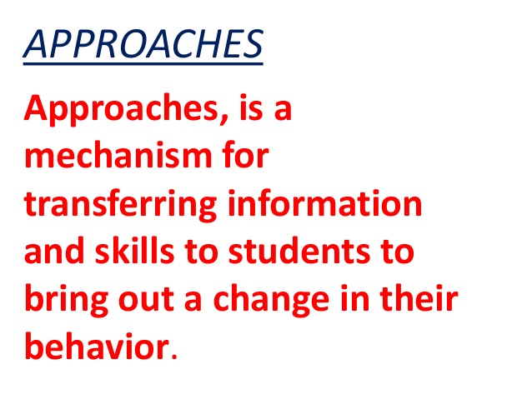

TYPES OF
APPROACHES
Integration ,interdisciplinary, multidisciplinary and holistic approach

INFUSION/integration
-To infuse means to focus in still to integrate a new dimension without changing the innate nature of the subject ... - In the present context, infusion means to focus on EE concepts in curriculum.

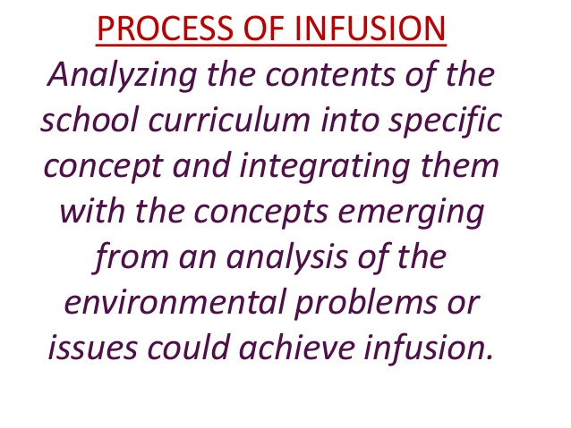

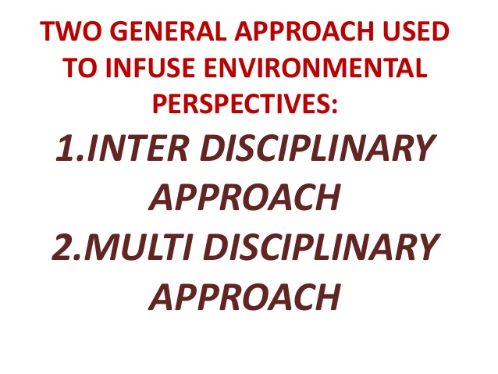
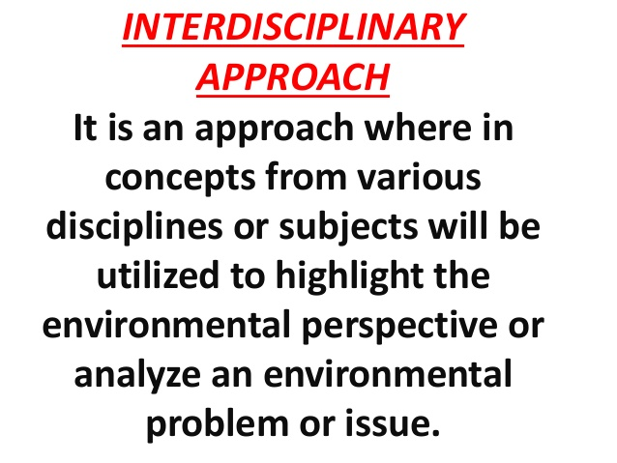
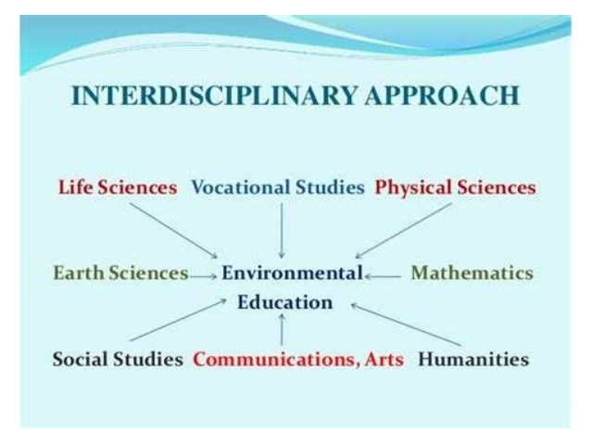
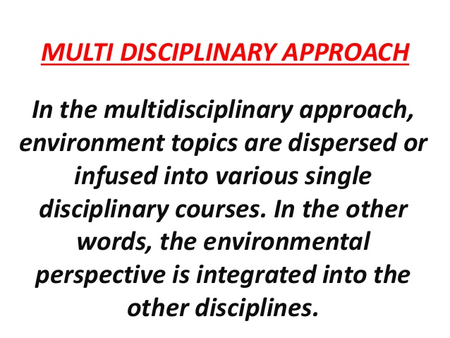
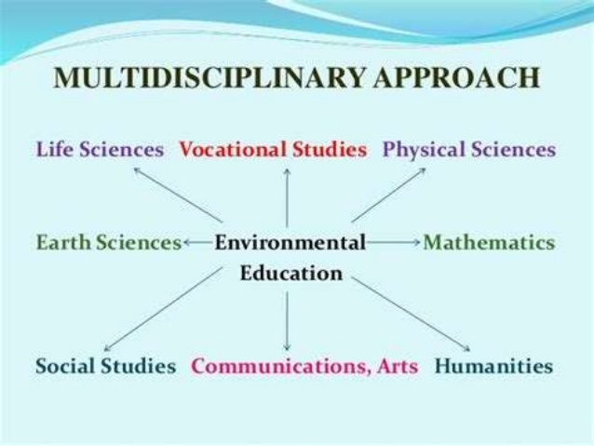
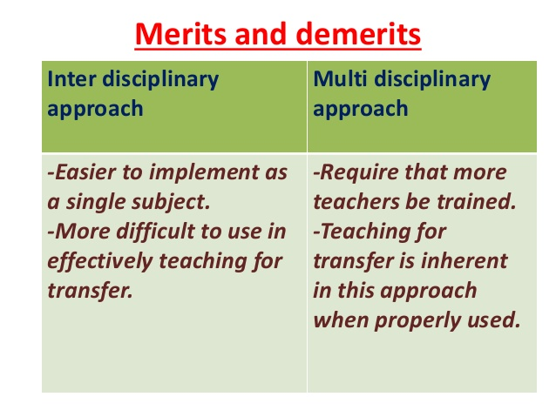
Holistic approach
The alarming environmental problems we are facing will require a more holistic view to education. It implies more of an inter-disciplinary approach and better linkages among the different school subjects, as well as a growing need for more thematic teaching.
At the same time, in order to be able to work with holistic and thematic approaches, the learners need a lot of specified and detailed knowledge provided by traditional subject studies. The challenge is to combine these supposed contradictions and find ways to let our teaching within traditional subjects be influenced by holistic and trans-disciplinary perspectives.
The example The Mission is a good illustration of that. It is a holistic task where the learners use knowledge and insights from many subject areas. The goal is that they, at their own level of understanding, should create a model of a sustainable world. Out of a few initial conditions and the question “What will you bring?” – the learners will explore and combine many knowledge areas and in the end will be able to describe a detailed and rich model of a sustainable world.
The example A Good Life could be used as a shorter version of the same theme. The learners will, through a guided process of group discussions and plenary sessions, explore ethics, values and other basic elements that contribute to “a good life” in a sustainable society.
The eco-footprint is a very useful tool when discussing environmental sustainability and making life style comparisons between nations or individuals. The concept is a complex and advanced tool that calls for solid background knowledge from a number of subject areas. In the example Ecological Footprint we introduce the concepts of eco-footprints, bio capacity and supply and demand for resources. We give the learners a basic understanding of how eco-footprints are calculated and also of how they are influenced by human behaviour.
“The tragedy of the commons” is an explanation of why common resources all over the world have often been depleted because the responsibility of safeguarding them is not tied to the individual. The example The Fish Game allows the learners to gain a deeper understanding of the driving forces and challenges with resource management of commons, and equips them withtools, knowledge and values on how best they could reduce the risks of overexploitation.

Organizing Environmental Education System (Formal and Non-Formal Education)
Some of the major ways to organize environmental education system are as follows: (b) Formal Education (b) Non formal Education.
(a) Formal Education:
Formal education is given in schools, colleges and a university etc., limited to a specific period, and has a well defined and systematic curriculum.
The best approach in any awareness programme is to propagate through children and youth as they quickly take to new ideas and are the future activists. Formal environmental education should begin at the primary school level.
Curriculum should be constructed taking into account the class and age of the students. The content at the primary stage must be easily accessible to the young minds and so the emphasis should be on building up the environmental awareness in the child.
By lower secondary level, the child is conscious about the physical, social and aesthetic aspects of environment. At this stage and beyond, inter-disciplinary approach must be adopted and so the emphasis must be on increasing the knowl­edge about environmental problems, conservation and sustainable development.
The medium of imparting environmental education is not only through books but also through first hand experiences in field activities and eco-development camps etc. The activities in environmental educational system vary from place to place as the environmental conditions and needs vary from place to place.
The National Council of Educational Research and Training (NCERT) have de­veloped a curriculum framework based on which many good text books, charts and other teaching aids have been designed. University Grants Commission (UGC) has the main responsibility of environ­mental education at post graduate level.
Environment is a part of the curriculum of mainly the biology courses in Universities and is taught as environmental engineering in many engineering colleges, polytechnic colleges and most Indian Institutes of Technology (IIT’s).Environmental engineering includes subjects like civil engineering, town and country planning, environment im­provement of urban slums, human settlements, landscaping, industrial design, designing environmental friendly technologies and environmental impact assessment for sustainable development.
Environmental management includes subjects like land use, agriculture, waste management, wildlife management, conservation of natural resources, forestry, national parks, water resources management, biosphere reserves etc. Besides these main subjects there are topics dealing with the health and welfare of human beings, for instance, hygiene, toxicology, occupational health, nutrition, chemical engineering etc.
At post graduate level, environmental education also includes social ecology i.e. human ecology, sociology, psychology, counselling, cost-benefit aspects, environmental ethics etc.
Case studies must be constructed at identified areas as dissertation and field work reports and research must be conducted on specific environmental problems related to the local environment. Environmental legislation is also a part of the curriculum and it includes environmental policies and environmental protection laws etc.
Present situation of formal Environmental Education in India:
There are nearly two hundred departments of environmental studies in the universities and colleges all over India. They offer degree or diploma programmes covering all aspects of environmental sciences and engineering.
There are also diplomas, bachelor’s degree, M.Sc, M.Phil and Ph.D programmes in environ­mental sciences or environmental studies. Besides these, M.E., M.Tech and Ph.D programmes in environmental engineering are offered by Civil Engineering and Chemical Engineering departments.
Post graduate degree programmes in environmental management and courses, which lead to M.Sc in environmental chemistry/biology/geology or environmental toxicology, are also available.
Environmental education at doctoral level is also available in a large number of autonomous Research and Development (R & D) institutions founded by central government, state governments and agen­cies such as CSIR, ICAR and ICMR i.e. formal education in environmental sci­ence or engineering is available in India up to the highest possible level.
What needs to be done is restructuring of environmental studies programmes so as to produce instead of generalists, professionals whose forte is Environmental Botany or Environmental Zoology/Chemistry/Economics/Sociology etc.
These courses should have relatively specific curricula having provisions for training students in specialisations such as forest ecology, Limnology, marine ecology, environmental analysis, pollution studies, environmental toxicology etc.
(b) Non-formal Education:

For a majority of the population that still does not have adequate access to formal education, environmental education and awareness can be acquired by programmes that fall outside the formal education system. Environmental education needs to be a lifelong affair rather than a matter of formal schooling.
This realization has resulted in an increase in non formal education which includes activities outside the framework of the established formal education system. The process of non formal environment education is experience based involving exercises of solving environmental problems.
This gives the students an out-of-school exposure which involves the students in natural processes of enquiring, exploring, conjecturing, comparing, inferring, evaluating and decision making regarding environmental problems in their surroundings. Flexibility of approach is the most fundamental characteristic of non-formal environmental education programmes.
Non formal education includes organisation of extra-curricular activities like eco development camps, posters and essay-writing competitions, exhibitions, seminars, nature camps, nature-club activities, audio visual slides, mobile ex­hibitions etc.
Eco-development camps aim at creating awareness about basic ecological principles and solving environmental problems after identifying the causes of the ecological problems. Tree-plantation, trenching, fencing, seed-banks, cleaning water-bodies, hygiene and promoting the use of non-conventional energy sources are the activities included in these camps.
The Vikram Sarabhai Community Centre, Ahmedabad, involved children in carrying out experiments and surveys, and, the centre for environment educa­tion has evolved a water monitoring kit for secondary school students under the Ganga Pollution Control Programme. Arts and Crafts, folk dances, ballet and street plays are also used to impart informal environmental education by many organisations such as Bal Bhawan Society, Shantiniketan.

Issues related to supervision and assisting in environmental education
The supervisory role is one of the functions of a school operation that has been and continues to be a very challenging aspect of administration in secondary schools. This challenge involves a continuous process of assisting teachers to improve their instructional performance in accordance to the professional code established by the Ministry of Education. Supervision is very important in schools to ensure that the standards set by the Ministry are adhered to and not only the institutional goals but also the national goals are met. If supervision is enhanced then the teachers’ job performance shall be monitored and timely effective corrective measures implemented to ensure improvement of teacher competencies and general professional growth. Instructional problems can be easily detected through observations and appraisals

Educational supervisors are the main administrators at educational institutions. A principal or head teacher is the most common type of educational supervisor. An educational supervisor keeps the school running. Budgets, teaching schedules, supplies, disciplinary actions, teacher and staff evaluations, and communications with the public fall under the purview of educational supervisors. They also have a hand in planning school events and implementing curriculum.
Educational supervisors must also ensure that their schools follow the educational directives set by local governments, state governments and the federal government. It is the responsibility of the educational supervisor to make sure that their school meets testing, budgetary and other standards set by their district or state. They must make sure that every person working a school, including custodial teachers and bookkeepers, are ultimately under the scrutiny of the principal and assistant principal. Supervision is the by overseeing of the performance or operation of a person or group. It is the act of watching over the work or tasks of another person who lack full knowledge of the concept at hand. Supervision does not mean the control of other but guidance in a work in professional or personal context

A supervisor should be concerned with performing the following functions –
1. Planning and Organizing - Supervisor’s basic role is to plan the daily work schedule of the teachers by guiding them the nature of their work and also dividing the work amongst the teachers according to their interests, aptitudes, skills and interests.
2. Provision of working conditions - A supervisor plays an important role in the physical setting of the school and in arranging the physical resources at right place. This involves providing proper sitting place, ventilation, lighting, water facilities
etc. to teachers. His main responsibility is here to provide healthy and hygienic condition to the teachers
. 3. Leadership and Guidance - A supervisor is the leader of teachers under him. He leads the teachers and influences them to work their best. He also guides the teachers by fixing production targets and by providing them instruction and guidelines to achieve those targets.
4. Motivation - A supervisor plays an important role by providing different incentives to teachers to perform better. There are different monetary and non-monetary incentives which can inspire the teachers to work better.
5. Controlling - Controlling is an important function performed by supervisor. This will involve
Recording the actual performance against the time schedule, Checking of progress of work, Finding out deviations if any and making solutions
Supervision has three primary purposes
1. Develop knowledge and skill: a) to receive feedback and reflect on the content and process of your work from more than one perspective b) to develop skills through the exchange of information, observation and practical experience c) to review and discuss individual client issues d) to learn from others’ experiences, approaches, theories, models and techniques
2. Maintain quality standards and ethics: a) to promote the welfare of your clients b) to fulfill requirement for your certification and accreditation
3. Support: a) to enjoy professional and personal support
Educational Supervision as a Challenge
The educational supervisor is responsible for providing adequate support to the trainee for the development of their learning requirements and ensuring that appropriate training opportunities are made available to acquire the necessary competencies. Through a regular appraisal process the educational supervisor should also ensure that the trainee follows a programme which meets the educational objectives as laid down by the training body. Learning outcomes are discussed and agreed with the trainee, as well as the clinical supervisor in charge of that period of training when appropriate. Unlike the clinical supervisor, the educational supervisor may not be in direct clinical interaction with the trainee but should have a good overview of training needs. This does not mean that the same person cannot do both, though it is arguable that it is best to separate the two posts and responsibilities. Educational supervision therefore requires time, dedication and, more importantly, adequate training to qualify for the role. Although it is recommended that educational supervisors should have an understanding of educational theories and practical educational techniques including constructive feedback, communication skills and dealing with difficulties, regrettably this is not the case. It is a matter of fact that all consultants are expected to become qualified educational supervisors with minimal training or interest. Furthermore, even those who are qualified in education find themselves taking on this role with little or no time allocation in their job plans and as an add-on to their clinical commitments. Few would disagree that very little investment has been made in this area. One of the major challenges facing postgraduate education is meeting educational demands through formal training in educational supervision. This admittedly would require time and resources. Until then it may be advisable to limit educational supervision to those qualified to do so and with adequate time allocation.

