Psychosocial Stages
Erikson’s (1959) theory of psychosocial development has eight distinct stages. Like Freud, Erikson assumes that a crisis occurs at each stage of development. For Erikson (1963), these crises are of a psychosocial nature because they involve psychological needs of the individual (i.e. psycho) conflicting with the needs of society (i.e. social).
According to the theory, successful completion of each stage results in a healthy personality and the acquisition of basic virtues. Basic virtues are characteristic strengths which the ego can use to resolve subsequent crises.
Failure to successfully complete a stage can result in a reduced ability to complete further stages and therefore a more unhealthy personality and sense of self. These stages, however, can be resolved successfully at a later time.
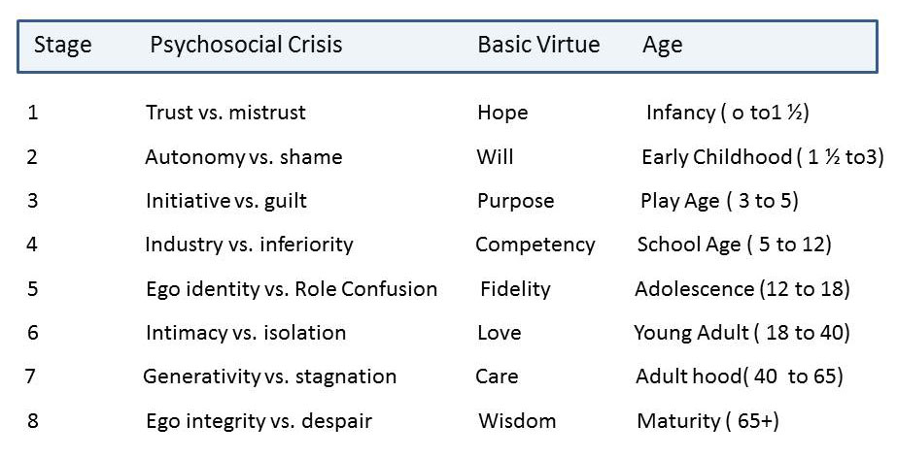

1. Trust vs. Mistrust
Is the world a safe place or is it full of unpredictable events and accidents waiting to happen?
Erikson's first psychosocial crisis occurs during the first year or so of life (like Freud's oral stage of psychosexual development). The crisis is one of trust vs. mistrust.
During this stage the infant is uncertain about the world in which they live. To resolve these feelings of uncertainty the infant looks towards their primary caregiver for stability and consistency of care.
If the care the infant receives is consistent, predictable and reliable, they will develop a sense of trust which will carry with them to other relationships, and they will be able to feel secure even when threatened.
Success in this stage will lead to the virtue of hope. By developing a sense of trust, the infant can have hope that as new crises arise, there is a real possibility that other people will be there are a source of support. Failing to acquire the virtue of hope will lead to the development of fear.
For example, if the care has been harsh or inconsistent, unpredictable and unreliable, then the infant will develop a sense of mistrust and will not have confidence in the world around them or in their abilities to influence events.
This infant will carry the basic sense of mistrust with them to other relationships. It may result in anxiety, heightened insecurities, and an over feeling of mistrust in the world around them.
Consistent with Erikson's views on the importance of trust, research by Bowlby and Ainsworth has outlined how the quality of the early experience of attachment can affect relationships with others in later life.

2. Autonomy vs. Shame and Doubt
The child is developing physically and becoming more mobile. Between the ages of 18 months and three, children begin to assert their independence, by walking away from their mother, picking which toy to play with, and making choices about what they like to wear, to eat, etc.
The child is discovering that he or she has many skills and abilities, such as putting on clothes and shoes, playing with toys, etc. Such skills illustrate the child's growing sense of independence and autonomy. Erikson states it is critical that parents allow their children to explore the limits of their abilities within an encouraging environment which is tolerant of failure.
For example, rather than put on a child's clothes a supportive parent should have the patience to allow the child to try until they succeed or ask for assistance.
So, the parents need to encourage the child to becoming more independent whilst at the same time protecting the child so that constant failure is avoided.
A delicate balance is required from the parent. They must try not to do everything for the child but if the child fails at a particular task they must not criticize the child for failures and accidents (particularly when toilet training). The aim has to be “self control without a loss of self-esteem” (Gross, 1992). Success in this stage will lead to the virtue of will.
If children in this stage are encouraged and supported in their increased independence, they become more confident and secure in their own ability to survive in the world.
If children are criticized, overly controlled, or not given the opportunity to assert themselves, they begin to feel inadequate in their ability to survive, and may then become overly dependent upon others, lack self-esteem, and feel a sense of shame or doubt in their own abilities.

3. Initiative vs. Guilt
Around age three and continuing to age five, children assert themselves more frequently. These are particularly lively, rapid-developing years in a child’s life. According to Bee (1992) it is a “time of vigor of action and of behaviors that the parents may see as aggressive".
During this period the primary feature involves the child regularly interacting with other children at school. Central to this stage is play, as it provides children with the opportunity to explore their interpersonal skills through initiating activities.
Children begin to plan activities, make up games, and initiate activities with others. If given this opportunity, children develop a sense of initiative, and feel secure in their ability to lead others and make decisions.
Conversely, if this tendency is squelched, either through criticism or control, children develop a sense of guilt. They may feel like a nuisance to others and will therefore remain followers, lacking in self-initiative.
The child takes initiatives which the parents will often try to stop in order to protect the child. The child will often overstep the mark in his forcefulness and the danger is that the parents will tend to punish the child and restrict his initiatives too much.
It is at this stage that the child will begin to ask many questions as his thirst for knowledge grows. If the parents treat the child’s questions as trivial, a nuisance or embarrassing or other aspects of their behavior as threatening then the child may have feelings of guilt for “being a nuisance”.
Too much guilt can make the child slow to interact with others and may inhibit their creativity. Some guilt is, of course, necessary, otherwise the child would not know how to exercise self control or have a conscience.
A healthy balance between initiative and guilt is important. Success in this stage will lead to the virtue ofpurpose.

4. Industry (competence) vs. Inferiority
Children are at the stage (aged 5 to 12 yrs) where they will be learning to read and write, to do sums, to do things on their own. Teachers begin to take an important role in the child’s life as they teach the child specific skills.
It is at this stage that the child’s peer group will gain greater significance and will become a major source of the child’s self esteem. The child now feels the need to win approval by demonstrating specific competencies that are valued by society, and begin to develop a sense of pride in their accomplishments.
If children are encouraged and reinforced for their initiative, they begin to feel industrious and feel confident in their ability to achieve goals. If this initiative is not encouraged, if it is restricted by parents or teacher, then the child begins to feel inferior, doubting his own abilities and therefore may not reach his or her potential.
If the child cannot develop the specific skill they feel society is demanding (e.g. being athletic) then they may develop a sense of inferiority. Some failure may be necessary so that the child can develop some modesty. Yet again, a balance between competence and modesty is necessary. Success in this stage will lead to the virtue of competence.

5. Identity vs. Role Confusion
During adolescence (age 12 to 18 yrs), the transition from childhood to adulthood is most important. Children are becoming more independent, and begin to look at the future in terms of career, relationships, families, housing, etc. The individual wants to belong to a society and fit in.
This is a major stage in development where the child has to learn the roles he will occupy as an adult. It is during this stage that the adolescent will re-examine his identity and try to find out exactly who he or she is. Erikson suggests that two identities are involved: the sexual and the occupational.
According to Bee (1992), what should happen at the end of this stage is “a reintegrated sense of self, of what one wants to do or be, and of one’s appropriate sex role”. During this stage the body image of the adolescent changes.
Erikson claims that the adolescent may feel uncomfortable about their body for a while until they can adapt and “grow into” the changes. Success in this stage will lead to the virtue of fidelity.
Fidelity involves being able to commit one's self to others on the basis of accepting others, even when there may be ideological differences.
During this period, they explore possibilities and begin to form their own identity based upon the outcome of their explorations. Failure to establish a sense of identity within society ("I don’t know what I want to be when I grow up") can lead to role confusion. Role confusion involves the individual not being sure about themselves or their place in society.
In response to role confusion or identity crisis an adolescent may begin to experiment with different lifestyles (e.g. work, education or political activities). Also pressuring someone into an identity can result in rebellion in the form of establishing a negative identity, and in addition to this feeling of unhappiness.

6. Intimacy vs. Isolation
Occurring in young adulthood (ages 18 to 40 yrs), we begin to share ourselves more intimately with others. We explore relationships leading toward longer term commitments with someone other than a family member.
Successful completion of this stage can lead to comfortable relationships and a sense of commitment, safety, and care within a relationship. Avoiding intimacy, fearing commitment and relationships can lead to isolation, loneliness, and sometimes depression. Success in this stage will lead to the virtue of love.

7. Generativity vs. Stagnation
During middle adulthood (ages 40 to 65 yrs), we establish our careers, settle down within a relationship, begin our own families and develop a sense of being a part of the bigger picture.
We give back to society through raising our children, being productive at work, and becoming involved in community activities and organizations.
By failing to achieve these objectives, we become stagnant and feel unproductive. Success in this stage will lead to the virtue of care.

8. Ego Integrity vs. Despair
As we grow older (65+ yrs) and become senior citizens, we tend to slow down our productivity, and explore life as a retired person. It is during this time that we contemplate our accomplishments and are able to develop integrity if we see ourselves as leading a successful life.
Erik Erikson believed if we see our lives as unproductive, feel guilt about our past, or feel that we did not accomplish our life goals, we become dissatisfied with life and develop despair, often leading to depression and hopelessness.
Success in this stage will lead to the virtue of wisdom. Wisdom enables a person to look back on their life with a sense of closure and completeness, and also accept death without fear.

Critical Evaluation
Erikson is rather vague about the causes of development. What kinds of experiences must people have in order to successfully resolve various psychosocial conflicts and move from one stage to another? The theory does not have a universal mechanism for crisis resolution.
Indeed, Erikson (1964) acknowledges his theory is more a descriptive overview of human social and emotional development that does not adequately explain how or why this development occurs. For example, Erikson does not explicitly explain how the outcome of one psychosocial stage influences personality at a later stage.
One of the strengths of Erikson's theory is its ability to tie together important psychosocial development across the entire lifespan.
Although support for Erikson's stages of personality development exists (McAdams, 1999), critics of his theory provide evidence suggesting a lack of discrete stages of personality development (McCrae & Costa, 1997).

