Module 4
The Process of Thinking
17. Nature of Higher Level Thinking - Critical and Creative Thinking. Facilitating Critical
and Creative Thinking in Classroom.
18. Information Processing - Concept. Information Processing Framework of Learning
(Sternberg and Kosslyn), Atkinson and Shiffrin Model.
19. Memory - Constructive nature of Memory - Autobiographic, Memory Distortions,
Episodic and Semantic. Working Memory – Baddeley. Strategies to Enhance Memory -
Mnemonics.
20. Forgetting - Types, Causes. Curve of Forgetting. Theories of Forgetting. Interference-
Proactive and Retroactive.
21. Problem Solving - Approaches to the Study of Problem Solving. Decision Making and
Reasoning. Problem Solving- as associative learning - as Insight - as Information
Processing - as Reflective Learning.

NATURE OF HIGHER LEVEL THINKING
Cognitive abilities like thinking, reasoning and problem-solving may be considered to be some of the chief characteristics which distinguish human beings from other species including the higher animals. Good poetry, a highly developed computer or a robot, a beautiful painting, or a magnificent building is all products of the thinking, reasoning abilities of their creators or inventors. Even to understand, appreciate or put these into use, we have to employ our powers of thinking and reasoning. The challenges and problems faced by the individual, or by society, in general, are solved through serious efforts involving thinking and reasoning. The power of thinking may thus be considered to be the essential tool for the welfare and meaningful existence of the individual as well as society.
Thinking
Thinking is an incredibly complex process and the most difficult concept in psychology to define or explain. However, it has not deterred the thinkers, and many different definitions exist. Some of them are given here.
Ross (1951) “Thinking is mental activity in its cognitive aspect or mental activity with regard to psychological objects.”
Garret (1968) “Thinking is behavior which is often implicit and hidden and in which symbols (images, ideas, concepts) are ordinarily employed.”
Nature of Higher Level/ Order Thinking
Higher-order thinking, known as higher order thinking skills (HOTS), is a concept of education reform based on learning. The idea is that some types of learning require more cognitive processing than others, but also have more generalized benefits. for example, skills involving analysis, evaluation and synthesis (creation of new knowledge) are thought to be of a higher order, requiring different learning and teaching methods than the learning of facts and concepts. Higher order thinking involves the learning of complex judgmental skills such as critical thinking and problem solving. Higher order thinking is more difficult to learn or teach but also more valuable because such skills are more likely to be usable in novel situations (i.e., situations other than those in which the skill was learned).
Concept and Nature of Critical Thinking
It is a type of thinking that helps a person in stepping aside from his own personal beliefs, prejudices, and opinions to sort out the facts and discover the truth, even at the expense of his basic belief system. In this way it represents a challenging thought process which leads a person to new avenues of knowledge and understanding. It is in fact a structural approach of thinking to find ways and means for the improvement of thinking process itself. Here one resorts to a set of higher cognitive abilities and skills for the proper interpretation, analysis, evaluation and inference, as well as explanation of the gathered or communicated information resulting in a purposeful, unbiased and self –regulatory judgment.
The National Council for Excellence in Critical Thinkingdefines critical thinking as the“ intellectually disciplined process of actively and skillfully conceptualizing, applying, analyzing, synthesizing, and/or evaluating information gathered from, or generated by, observation, experience, reflection, reasoning, or communication, as a guide to belief and action.”
Thinking is often causal or routine, whereas critical thinking deliberately evaluates the quality of thinking. Ina seminal study on critical thinking and education in 1941, Edward Glaser writes that the ability to think critically involves three things
- An attitude of being disposed to consider in a thoughtful way the problems and subjects that come within the range of ones experiences
- Knowledge of the methods of logical enquiry and reasoning
- Some skill in applying those methods.
Critical thinking calls for a persistent effort to examine any belief or supposed form of knowledge in the light of the evidence that supports it and the further conclusions to which it tends. An ideal critical thinker is habitually inquisitive, well informed, open minded,flexible fair minded in evaluation, free from personal bias and prejudices, honest in seeking relevant information, skilled in the proper use of the abilities like interpretation,analysis,synthesis, evaluation and drawing conclusions and inferences etc., interested in reasoned inquiry, prudent in making judgements, willing to reconsider, clear about issues, orderly in dealing with complex matters, persistent in seeking results which are as precise as the subject.
Critical thinking can occur whenever one judges, decides, or solves a problem. Reading, writing, speaking and listening can all be done critically or uncritically. Critical thinking is crucial to becoming a close reader and a substantive writer. Expressed most generally, critical thinking is a ‘way of taking up theproblems of life. “Irrespective of the sphere of thought, “a well cultivated critical thinker”:
- Raise vital questions and problems, formulating them clearly and precisely
- Gathers and assess relevant information, using abstract ideas to interpret it effectively
- Comes to well-reasoned conclusions and solutions, testing them against relevant criteriaand standards
- Thinks open-mindedly within alternative systems of thought, recognizing and assessing, as need to be, their assumptions, implications and practical consequences and
- Communicates effectively with others in figuring out solutions to complex problems; without unduly influenced by others thinking on the topic
Critical thinking is an important element of all professional fields and academic disciplines. In other words though critical thinking principles are universal, their application to disciplines requires a process of reflective contextualization. Critical thinking is important because it enables one to analyze,evaluate, explain, and restructure our thinking, decreasingthereby the risk of adopting, acting on, or thinking with a false belief.
The nature of critical thinking can be concluded by terming it as “a higher order well- disciplined thought process, which involves the use of cognitive skills like conceptualization, interpretation, analysis, synthesis and evaluation for arriving at an unbiased, valid and reliable judgment of the gathered or communicated information or data as a guide to one’s belief and action.
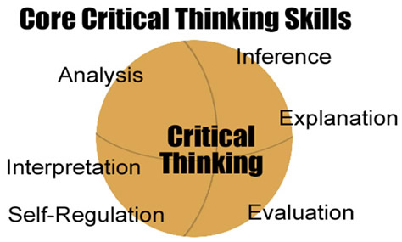
1: Interpretation
What it Means: Having the ability to understand the information you are being presented with and being able to communicate the meaning of that information to others.
2:Analysis
What it Means: Having the ability to connect pieces of information together in order to determine what the intended meaning of information was meant to represent.
3: Inference
What it Means: Having the ability to understand and recognize what elements you will need to determine an accurate conclusion or hypothesis from the information you have at your disposal.
4: Evaluation
What it Means: Being able to evaluate the credibility of statements or descriptions of a person’s experience, judgment or opinion in order to measure the validity of the information being presented
5: Explanation.
What it Means : Having the ability to not only restate information, but add clarity and perspective to the information, so it can be fully understood by anyone you are sharing it with
6: Self-Regulation
What it Means : Having the awareness of your own thinking abilities and the elements that you are using to find results.
Critical Thinking in Classroom
Critical thinking can be presented or emphasized in all classroom areas: lecture, homework, term papers and exams. Some slight extra effort on the part of the instructor will be necessary but the effort will be worthwhile because the results are so valuable for the student.
Teacher’s mission is to use one or more of the following classroom strategies or techniques to teach critical thinking in one or more of the above four course areas. Critical thinking cannot be taught by lecturing. Critical thinking is an active process, while, for most students, listening to lectures is a passive activity. The intellectual skills of critical thinking-analysis, synthesis, reflection, etc.-must be learned by actually performing them. Classroom instruction, homework, termpapers, and exams, therefore, should emphasize active intellectual participation by the student.
1. Lectures
Enhancement of critical thinking can be accomplished during lecture by periodically stopping and asking students searching and thoughtful questions about the material you have just presented and then wait an appropriate time for them to respond. Do not immediately answer such questions you; leave sufficient time for students to think about their answer before they state it. If you constantly answer such questions yourself, students will quickly realize this and not respond. Learn student’s names as quickly as possible and ask the questions of specific students that you call upon by name. If an individual cannot answer a question, help them by simplifying the question and leading them through the thought process: ask what data are needed to answer the question, suggest how the data can be used to answer the question, and then have the student use this data in an appropriate way to come up with an answer.
You may, of course, ask simple questions that merely ask students to regurgitate factual information that you have just given them in lecture. Many students have trouble with these factual questions because they are not paying attention in class, they simply have never learned how to listen to a lecture and take mental and written notes or they don’t know how to review their notes and the text book in preparation for an exam. Perhaps the most basic type of critical thinking is knowing how to listen to a lecture actively rather than passively. However the goal of critical thinking requires that you eventually ask questions that require students to think through a cause and effect or premise and conclusion type of argument.
After lecture but before the class ends, ask students to write one-minute papers on the most significant thing they learned in class and what single thing they still feel confused about. This is the single most important exercise you can do. You get immediate feedback about what the students are learning and what they still need to understand (technically this is an application of what is called “classroom research” or “classroom assessment” the deliberate discovery of what and how much students are learning and of how you are teaching).It also improves their writing. In our present case, of course, this exercise improves critical thinking.
In class, encourage questions from students. Always respond positively to questions; never brush them off or belittle the questioner. Instead, praise the questioner (for example, say “Good question!”)Questions from students mean they are thinking critically about what you are saying: encourage that thinking.
2. Laboratories
Many courses have laboratories connected with them. Science laboratory exercises are all excellent for teachingcritical thinking. The reasons should be obvious. Here, the student learns the scientific method by actually practicing it. This method of teaching critical thinking is so clear and obvious that it seems odd that critical thinking is not promoted more in primary and secondary education by simply beginning science instruction in the first grade and requiring that students take more science courses. Since laboratories automatically teach critical thinking to some degree, we will spend no more time on this topic.
3. Homework
Innumerable opportunities exist to promote critical thinking by homework assignments. For reading homework, Dr. William T. Daly recommends that you provide students the general questions you want answered before they begin reading, and insist that they organize their notes around these questions. Require that students transform the information and make it their own by requiring them to paraphrase, summarize.
Getting students to write more is the best and perhaps the easiest way to enhance critical thinking. Writing forces students to organize their thoughts and think critically about the material. Ask students to write short papers about pertinent topics, review science articles, even paraphrase news articles and textbook chapters. These exercises can be as elaborate as you wish to make them.
4. Quantitative Exercises
Problem solving is critical thinking; thus ,courses such as mathematics,chemistry,and physics, that require the resolution of various mathematical problems,automatically teach critical thinking to some extent just by following the traditional curriculum.When students are required to solve math problems they are practicing critical thinking, whether they know it or not. Asking students to solve math problems in a science gets them thinking about nature and reality in empirical and quantitative components of critical thinking.
5. Term Papers
Term papers promote critical thinking among students by requiring that they acquire, synthesize, and logically analyzeinformation, and that they then present this information and their conclusions in written form. Term papers are not traditionally required in math and science courses, although they may be and perhaps should be. Math and science instructors really don’t require that students write very much and when we do, don’t require that they use correct spelling,punctuation,grammar,and syntax.
6. Examinations
Examinations should require that students write or, at least, think. For written exams, short and long answer essay questions are the obvious solution. For example, Dr. James T.Hunter,a biology professor, typically uses a few short answer essay questions on each exam that test the ability of students to analyze information and draw conclusions. This commonly used technique, byitself, helps to teach critical thinking. One example of such question is – Explain the importance of plasmids, biologically and in genetic engineering.
Significance of critical thinking in classroom
The key to seeing the significance of critical thinking in the classroom is in understanding the significance of critical thinking in learning. There are two phases to the learning of content. The first occurs when learners (for the first time) construct in their minds the basic ideas, principles, and theories that are inherent in content. Thisis a process of internalization. The second occurs when learners effectively use those ideas, principles and theories as they become relevant in learner’s lives. This is a process of application. Good teachers cultivate critical thinking at every stage of learning, including initial learning. Each discipline adapts its use of critical thinking concepts andprinciples. The core concepts are always there, but they are embedded in subject specific content. For students to learn content, intellectual engagement is crucial. All students must do their own thinking, their own construction of knowledge. Good teachers recognize this and therefore focus on the questions, readings, activities that stimulate the mind to take ownership of key concepts and principles underlying the subject.
Concept of Creative Thinking
Creativity is the ability to produce something new. According to Spearman, “Creativity is the power of the human mind to create new contents by transforming relations and thereby generating new co-relates”. For David Ausubel “Creativity is a generalized constellation of intellectual abilities, personally variables and problem solving traits”. Creativity is the ability to see things in a new and unusual light to see problem that no one else may realize exist and then come up with new unusual and effective solutions.
Nature and characteristics of creative thinking
- Creativity is universal
- Creativity is innate as well as acquired.
- Creative thinking in all its shapes and forms, is absolutely an internal mental process and hence should be considered as an important component of one’s cognitive behavior
- Creative thinking results in the production of something new or novel
- Any creative expression as a result of one’s creative thinking is a source of joy and satisfaction for the creator.
- Creative thinking in all its dimensions involve divergent thinking instead of the routine and fixed type of convergent thinking
- Creativity and intelligence do not necessarily go hand in hand.
- The field of creative thinking and its output is quite comprehensive and wide.
Stages in Creative Thinking
Creative thinking involves four distinct stages. They are,
1 . The Stage of Preparation
This stage consists of purposeful study and enquiry in order to collect experience and information needed to solve the mystery.
2. The stage of Incubation
Following the preparatory stage, there is period of rest when there is no obvious activity and progress. The person organizes and tests his ideas. This period involves vicarious experiencing of the problem. Flashes of insight and trial judgment occur.
3. The stage of Illumination
This is called “Eureka’ when the individual suddenly perceives the theme and relationship among the various components of the problem. This results in solution of the problem.
4. The stage of Verification
During this stage the new theme is checked out to determine whether the solution appeared through insight is the correct one. The individual rethinks, revise and refines the solution.
Types of Creativity
The creative abilities pertain only to verbal activity, and they accordingly belong in the category called semantic in the structures of intellect. They would be the main stay for creative people in the broad categories of writing, philosophy, and science.There are other categories of information. The content of primary concern for the pictorial artist is figural(visual)The content for the musical composer,arranger,and performer is figural(auditory).The kind of information with which the mathematicians deals is symbolic, being composed of numbers and letters.
Finally there is creativity in dealing with peoples, calledbehavioralcreativity. Separate behavioral abilities are involved in understanding the behavior of people and in thinking productively about how to deal with them. There are parallel sets of abilities in each of the three other content categories-figural (visual or auditory, symbolic) and behavioral.

Levels of creativity
There are five developmental levels for creative personality. They are
1. Expressive level: This level is characterized by spontaneity and freedom. This is typical of children at the early childhood.
2. Productive level: On the basis of expressive creativity, the individual acquires certain ways, techniques and expressions for his idea.
3.Discovering level: The individual discovers something new from past knowledge. New problems and problem situations are revealed, which the less creative individual will not notice.
4 Innovative level : At this level, on the basis of the comprehension of the principle of cause-effect relations of problems, the individual make innovations and improvements in what already exist at a high level.
5. Emergency level: At this level, previous knowledge and notions are restructured leading to the emergence of new theories and trends or a new school of thought. This level is attained by only few people.
Attitudes that block Creativity
1. Fear of Problems
The reaction to a problem is often a bigger problem than the problem itself. Many people avoid or deny problems until it’s too late, largely because these people have never learned the appropriate emotional, psychological, and practical responses. Seeking problems aggressively will build confidence, increase happiness, andgive a better sense of control over our life.
2. Lack of Confidence
A good mind with a positive attitude and some good problem solving skills will go far in solving any problem. Interest in and commitment to the problem are the keys. Motivation - a willingness to expend the effort is more important. Everyone is creative to some extent. Most people are capable of very high levels of creativity.
3. Fear of Failure
Fear of failure is one of the major obstacles to creativity. The cure is to change our attitude about failure. Failure along the way should be expected and accepted; they are simply learning tools that help focus the way toward success. Not only is there nothing wrong with failing, but failing is a sign of action and struggle and attempt- much better than inaction.
Thinking is one of the important aspects of teaching-learning process. Our ability to learn and solve the problems depends upon our ability to thinkcorrectly. It helps us in adjustment and is necessary for a successful living. Only the men who can think distinctly, consecutively and carefully, can contribute something worthwhile to the society. But one is not a born thinker. One has to learn to think, just as one has to learn to perceive. Learning to think is not an easy road. It requires a knowledge of the techniques and practice of proper thinking.
Promoting Higher Level Thinking Skills in the Classroom
Higher Order Thinking is thinking on a level that is higher than memorizing facts or telling something back to some one exactly the way it was told to you. Higher Order thinking takes thinking to higher levels than restating the facts and requires students to do something with the facts – understand them, infer from them, connect them to other facts and concepts, categorize them, manipulate them, put them together in new or novel ways, and apply them as we seek new solutions to new problems.
Following strategies are offered for enhancing higher order thinking skills in classrooms:
- Take the mystery away
Teach students about higher order thinking and higher order thinking strategies. Help students understand their on higher order thinking strength and challenges.
- Teach the concept of concepts
Explicitly teach the concept of concepts. Concepts in particular content areas should be identified and taught. Teachers should make sure students understand the critical features that define a particular concept and distinguish it from other concepts.
- Name key concepts
In any subject area, students should be alerted when a key concept is being introduced. Students may need help and practice in highlighting key concepts. Further, students should be guided to identify which type of concept each one is – concrete, abstract, verbal, nonverbal or process.
- Categorize concepts
Students should be guided to identify important concepts and decide which type of concept each one is (concrete, abstract, verbal, nonverbal, or process)
- Tell and show
Often students who perform poorly in math have difficulty with nonverbal concepts. When these students have adequate ability to form verbal concepts, particular attention should be given to providing them with verbal explanations of math problems and procedures. Simply working problems again and again with no verbal explanation of the problem will do little to help these students. Conversely, students who have difficulty with verbal concept formation need multiple examples with relatively less language, which may confuse them. Some students are “tell me” while others are “show me”.
- Move from concrete to abstract and back
It can be helpful to move from concrete to abstract and back to concrete. When teaching abstract, concepts the use of concrete materials can reinforce learning for both young and old alike. If a person is able to state and abstract concepts in terms of everyday practical applications, then that person has gotten the concept.
- Teach step for learning concept
A multistep process for teaching a learning concept may include ;
- Name the critical features of the concept
- Name some additional features of the concept
- Name some false features of the concept
- Give the best examples or prototypes of the concept
- Give some non examples or non-prototypes (what the concept isn’t)
- Identify other similar or connected concepts
- Go basic to sophisticated
Teachers should be sure that students have mastered basic concepts before proceeding to more sophisticated concepts. If students have not mastered basic concepts, they may attempt to memorize rather than understand . This can lead to difficulty in content areas such as math and physics. A tenuous grasp of basic concepts can be the reason for misunderstanding and the inability to apply knowledge flexibly.
- Connect Concepts
Teachers should lead students through the process of connecting one concept to another, and also putting concepts into a hierarchy from small to large. By doing this level of thinking, students learn to see how many connections are possible, to connect to what they already know, and to create a web of concepts that helps them gain more clarity and understanding. Compare the new to the already known. Students should be asked to stop and compare and connect new information to things they already know.
- Teach Inference
Students should be explicitly taught at a young age how to infer or make inferences. When students are a little older, a teacher may use bumper stickers or well-known slogans and have the class brainstorm the inferences that can be drawn from them
- Teach Question-Answer Relationships (QARs)
The Question-Answer Relationships technique teaches children to label the type of questions being asked and then to used this information to assist them in formulating the answers. Two major categories of question-answer relationships are taught:
- Whether the answer can be found in the text
- Whether the reader must rely on his or her own knowledge
Cognitive ability like higher order thinking may be considered as the chief characteristics which distinguish human beings from other species including the higher animals. The power of higher order thinking may be considered as the essential tools for the welfare and meaningful existence of the individual as well as society. Higher order thinking is that higher than memorizing facts.
Information processing
Information processing is the change (processing) of information in any manner detectable by an observer. Within the field of cognitive psychology, information processing is an approach to the goal of understanding human thinking. It began in the 1940s and 1950s. Educators are very interested in the study of how humans learn. This is because how one learns, acquires new information, and retains previous information guides selection of long-term learning objectives and methods of effective instruction. To this end, cognition as a psychological area of study goes far beyond simply the taking in and retrieving information. It is a broad field dedicated to the study of the mind holistically. Neisser (1967), one of the most influential researchers in cognition, defined it as the study of how people encode, structure, store, retrieve, use or otherwise learn knowledge. Cognitive psychologists hypothesise an intervening variable or set of variables between environment and behaviour—which contrasts it with behavioural theories.
Information processing theory by Sternberg
Sternberg’s information processing theory (1988) suggests that development is skills-based and continuous rather than staged and discontinuous as stage theorists believe, and his focus is on intelligence. This focus on intelligence separates his ideas from stage theorists because it rejects the idea of incremental stages, but rather suggests that development occurs in the same way throughout life differentiated only by the expertise of the learner to process new information.
First, and very importantly, Sternberg’s model does not differentiate between child and adult learning. Also, he deals solely with information processing aspects of development and does not incorporate any facets of biological development into his theory. Cognitive development is viewed as a beginner to expert progression; as one becomes better at interaction and learning, one is able to learn more and at higher levels. Development changes as a result of feedback, self-monitoring, and automatization.
In this theory, intelligence is comprised of three kinds of information processing components:
- meta-components
- performance components and
- knowledge-acquisition components.

In Sternberg’s (1988) model, each of these three components works together to facilitate learning and cognitive development. Meta-components are executive in nature. They guide the planning and decision making in reference to problem solving situations; they serve to identify the problem and connect it with experiences from the past. There is, however, no action directly related to meta-components, they simply direct what actions will follow.
Performance components are the actions taken in the completion of a problem-solving task. Performance components go beyond meta-components in that they perform the function also of weighing the merit and or consequences of actions in comparison to other options rather than simply identifying options.
Sternberg’s third proposed type of intelligence is the knowledge-acquisition component. This type is characterized by the ability to learn new information in order to solve a potential problem. This type is much more abstract and may or may not be directly related to a current problem-solving task (Driscoll, 2001). This three-leveled view of intelligence comprises the componential aspect of Sternberg’s theory, but this is only one of three parts to his larger triarchic theory of intelligence (Kearsley, 2001c).

Sternberg’s (1988) theory adds the components of feedback to theories of cognitive development; this suggests that an individual’s social interaction has some impact on cognitive development. In fact, one of the three parts of his theory is based on the context in which learning takes place; this subpart of the theory “specifies that intelligent behavior is defined by the socio-cultural context in which it takes place and involves adaptation to the environment, selection of better environments, and shaping of the present environment” (Kearsley, 2001c). The addition of social context as a factor in cognitive development links Sternberg to the interactional theories of development of Bruner (1977, 1986) and Vygotsky (1978).

This theory premised on the assumption that learning does not occur in a vacuum. Therefore, one must discuss the social and cultural contexts of learning. Driscoll (2001) says, “Of central importance is viewing education as more than curriculum and instructional strategies. Rather, one must consider the broader context in how culture shapes the mind and provides the toolkit by which individuals construct worlds and their conceptions of themselves and their powers” (p. 221).

Information processing theory by Kosslyn
Stephen Michael Kosslyn (born 1948) is an American psychologist, neuroscientist, and expert on the science of learning. Kosslyn is known primarily for his research and theories on mental imagery.
He championed the idea that mental images are distinct from language because they depict, not describe, information. His theory contends that, contrary to a commonly held assumption, imagery is not a single, unified phenomenon; rather, it consists of a collection of distinct functions, each of which is responsible for a different aspect of imagery.
For example, he decomposes imagery into four sets of processes,
- responsible for generating the image (i.e., activating information stored in long-term memory and constructing a representation in short-term memory),
- inspecting the object in the image (e.g., by reinterpreting it),
- maintaining the image over time, and—
- if so desired— transforming the image (e.g., by rotating it, adding or deleting parts, or changing the color).
His research, which includes Positron Emission Tomography and fMRI-imaging and similar techniques, has located some of these functions in different neural networks in the brain, some of which are in different cerebral hemispheres. For example, his laboratory demonstrated that the left half of the brain is better than the right at encoding categories and generating mental images on the basis of categories; whereas the right half of the brain is better than the left at encoding specific examples or continuous distances, and at generating images with such characteristics.
Atkinson and Shiffrin Model
The Modal Model of Memory, also known as the Multi Store Model of Memory, is a theory that was developed by Richard Atkinson and Richard Shiffrin in 1968. The Modal Model of Memory explains how memory processes work. Despite the fact that the idea of various levels of memory storage wasn’t new, the multiple model, consisting of three parts, was first described by the two Richards. William James described a primary and secondary memory in the latter years of the nineteenth century. In his theory, primary memory consisted of thoughts that were stored in consciousness for a brief time and secondary memory consisted of permanent, subconscious storage.
Later, Richard Atkinson and Richard Shiffrin added a third level to this theory: the sensory register of the brain. They also came up with the idea that the brain has various control processes that regulate the transfer of memory.
A valuable aspect of the Modal Model of Memory is that it’s supported by scientific evidence, something that’s fairly difficult in theories regarding something as abstract as memory. In an attempt to cure severe epilepsy, part of a patient’s hippocampus was removed. This led to the problem of this person being unable to transfer information from his short-term memory to his long-term memory. In other words, the patient was incapable of creating long-term memories. This person was living proof of the idea that there are multiple levels of memory.

Memory
Human memory is the capacity to encode information and experiences in the brain. These codes are subsequently stored and can be retrieved at a later time. This offers human beings the possibility to learn, adapt and build relationships.
In more neurological terms, memory is a series of encoded neural connections in the brain. It is the recreation of past experiences which is brought about by the synchronised firing of neurons that were involved in the original experience. The experiences aren’t stored as books on a bookshelf, like a complete element, but rather consist of separate elements that are scattered across the various brain areas.
Human memory is the capacity to encode information and experiences in the brain. These codes are subsequently stored and can be retrieved at a later time. This offers human beings the possibility to learn, adapt and build relationships.
Definitions

“Memory is the process of maintaining information over time.” (Matlin, 2005)

“Memory is the means by which we draw on our past experiences in order to use this information in the present’ (Sternberg, 1999).
Memory is the term given to the structures and processes involved in the storage and subsequent retrieval of information. Memory is essential to all our lives. Without a memory of the past we cannot operate in the present or think about the future. We would not be able to remember what we did yesterday, what we have done today or what we plan to do tomorrow. Without memory we could not learn anything.
In more neurological terms, memory is a series of encoded neural connections in the brain. It is the recreation of past experiences which is brought about by the synchronised firing of neurons that were involved in the original experience. The experiences aren’t stored as books on a bookshelf, like a complete element, but rather consist of separate elements that are scattered across the various brain areas.
The term memory is also used to describe computers’ capacity to store information. Although there are some parallels between the computer memory and human memory, there are also some fundamental and crucial differences. The human brain is organised like a distributed network in which each brain cell has thousands of connections. Computer memory consists of a collection of addressable and discrete files.

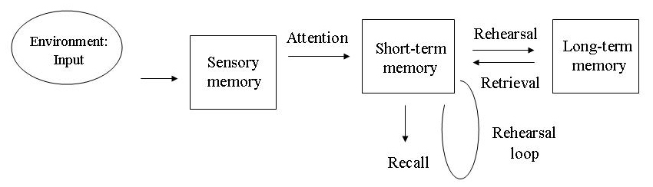

The Three Levels of Memory
After information has entered the brain via all kinds of impulses, it must be stored, maintained or removed. Many psychologists use the three-step model of Richard Atkinson and Richard Shiffrin to describe the storage process. For each memory system, the capacity, type of storage and duration are described.

Sensory Memory
Sensory memory stores information for only a moment. For example, when seeing a quickly circling flashlight in a dark space, people see a circle of light rather than separate dots of light. This is because sensory memory briefly retains these images that quickly follow each other, which means the brain sees a circle via the retina. Visual sensory memory is referred to as iconic memory, and auditory sensory memory is called echoic memory.
- Storage duration: 0.25-0.5 seconds
- Capacity: all sensory information, large capacity
- Coding: visual, auditory

Short-term Memory
A small part of the information that enters the brain via the sensory part of the brain is transferred to short-term memory. Here, it can be stored for about 18 seconds with a capacity of 7-8 items. Rehearsal or an intense event can lead to the information being sent to long-term memory, such as repeating a new phone number. The items can be large or small, depending on the individual. Where one item could be a series of ten numbers for one person, another item could be a single letter for someone else. When information has already previously entered the short-term memory, and small pieces of this information have been retained, the brain is capable of responding to these stimuli faster or to remember these more easily. This is referred to as priming.
- Storage duration: 0-18 seconds
- Capacity: 7-8 items
- Encoding: mainly auditory information

Long-term Memory
Information from short-term memory can be transferred to long-term memory by means of rehearsal, and back again to short-term memory. Long-term memory has a practical infinite capacity, which showcases the brain’s enormous potential. When the information is stored in long-term memory, it usually remains there for the rest of a person’s life. However, this doesn’t mean that this person is always able to remember the specific information. The right neurons must make the right connections to retrieve the right memories.
- Storage duration: unlimited
- Capacity: unlimited
- Encoding: mainly semantic (facts, general memory), but also visual and auditory

Retrieving Stored Information
Retrieving or remembering is the processes in which information from memory is recalled. Retrieving memories occurs by means of certain stimuli, also referred to as cues. These cues include associations, context and mood. These three components greatly influence people’s ability to retrieve the right memories.
Associations play an important role in this process. It is possible that deep-rooted memories suddenly resurface upon seeing a certain photograph, smelling a certain scent or hearing a specific sound. People can sometimes retrieve an event by envisioning themselves in the situation in which this event took place. A frequently asked question when losing your car key is:’ what did you do right after parking the car?’.
A person’s mood also directly influences one’s capability to retrieve memories. When a person’s mood is the same as it was in the situation concerned, the neurons in the brain make the right connections more easily.
That the information in long-term memory isn’t permanently lost is confirmed by the fact that people can remember specific information when they’re under hypnosis. Hypnosis makes it easier for the brain to provide the right cues without irrelevant associations getting in the way. The individual is better able to envision the context and his/her mood is largely ignored.
The Modal Model of Memory is a structural model that was developed by Richard Atkinson and Richard Shiffrin. It describes three storage systems that are linearly connected and is described as a model for information processing. Information can be detected by the senses and enters sensory memory. This is fully automatic, but when certain information is emphasised, it is transferred to short-term memory.
The Modal Model of Memory describes that, in case of sufficient rehearsal, information can be transferred to long-term memory, where it is stored forever. Whether an individual can retrieve this information, however, depends on the associations that are made, or whether the mood is comparable and whether the context in which the events took place shows similarities with the present situation.

Weaknesses
The model is oversimplified, in particular when it suggests that both short-term and long-term memory each operate in a single, uniform fashion. We now know is this not the case.
It has now become apparent that both short-term and long-term memory are more complicated that previously thought. For example, the Working Model of Memory proposed by Baddeley and Hitch (1974) showed that short term memory is more than just one simple unitary store and comprises different components (e.g. central executive, visuo-spatial etc.).
In the case of long-term memory, it is unlikely that different kinds of knowledge, such as remembering how to play a computer game, the rules of subtraction and remembering what we did yesterday are all stored within a single, long-term memory store. Indeed different types of long-term memory have been identified, namely episodic (memories of events), procedural (knowledge of how to do things) and semantic (general knowledge).
The model suggests rehearsal helps to transfer information into LTM but this is not essential. Why are we able to recall information which we did not rehearse (e.g. swimming) yet unable to recall information which we have rehearsed (e.g. reading your notes while revising). Therefore, the role of rehearsal as a means of transferring from STM to LTM is much less important than Atkinson and Shiffrin (1968) claimed in their model.
However, the models main emphasis was on structure and tends to neglect the process elements of memory (e.g. it only focuses on attention and rehearsal).
Information processing approach in the classroom
- Gain the students' attention.
- Use cues to signal when you are ready to begin.
- Move around the room and use voice inflections
- Bring to mind relevant prior learning.
- Review previous day's lesson.
- Have a discussion about previously covered content.
- Point out important information
- Provide handouts.
- Write on the board or use transparencies
- Present information in an organized manner
- Show a logical sequence to concepts and skills.
- Go from simple to complex when presenting new material
- Show students how to use coding when memorizing lists.
- Use mental imagery techniques such as the keyword method
- Make up silly sentence with first letter of each word in the list.
- Provide for repetition of learning.
- State important principles several times in different ways during presentation of information (STM).
- Have items on each day's lesson from previous lesson (LTM).
- Schedule periodic reviews of previously learned concepts and skills (LTM).
- Show students how to categorize (chunk) related information.
- Present information in categories.
- Teach inductive reasoning

Memory processes
Memory is involved in processing vast amounts of information. This information takes many different forms, e.g. images, sounds or meaning. For psychologists the term memory covers three important aspects of information processing:
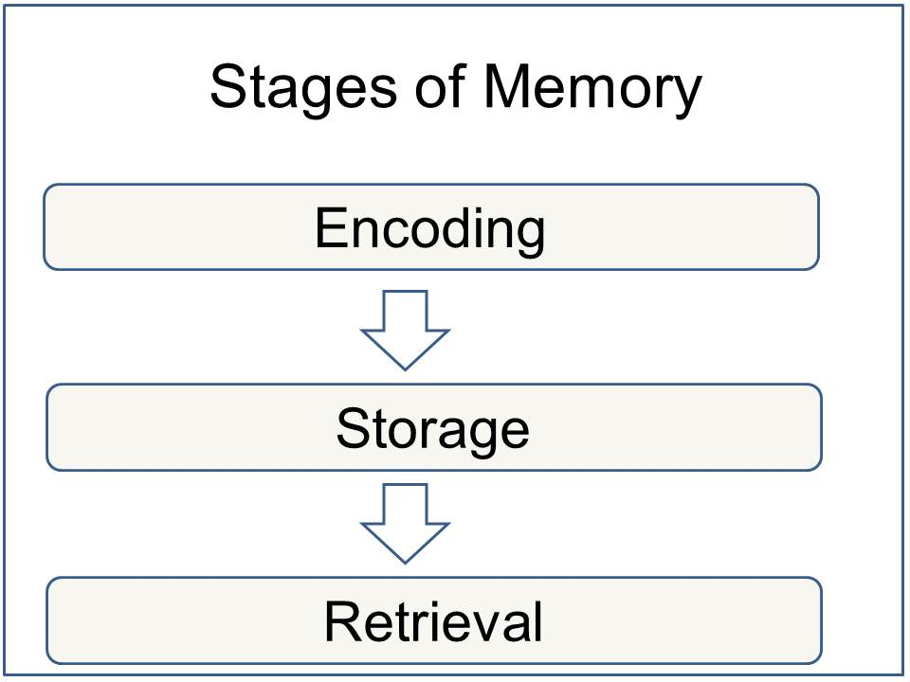

1. Memory Encoding
When information comes into our memory system (from sensory input), it needs to be changed into a form that the system can handle with, so that it can be stored. Think of this as similar to changing your money into a different currency when you travel from one country to another. For example, a word which is seen (in a book) may be stored if it is changed (encoded) into a sound or a meaning (i.e. semantic processing).
There are three main ways in which information can be encoded (changed):
1. Visual (picture)
2. Acoustic (sound)
3. Semantic (meaning)
For example, how do you remember a telephone number you have looked up in the phone book? If you can see it then you are using visual coding, but if you are repeating it to yourself you are using acoustic coding (by sound).
Evidence suggests that this is the principle coding system in short term memory (STM) is acoustic coding. When a person is presented with a list of numbers and letters, they will try to hold them in STM by rehearsing them (verbally). Rehearsal is a verbal process regardless of whether the list of items is presented acoustically (someone reads them out), or visually (on a sheet of paper).
The principle encoding system in long term memory (LTM) appears to be semantic coding (by meaning). However, information in LTM can also be coded both visually and acoustically.

2. Memory Storage
This concerns the nature of memory stores, i.e. where the information is stored, how long the memory lasts for (duration), how much can be stored at any time (capacity) and what kind of information is held. The way we store information affects the way we retrieve it. There has been a significant amount of research regarding the differences between Short Term Memory (STM ) and Long Term Memory (LTM).
Information can only be stored for a brief duration in STM (0-30 seconds), but LTM can last a lifetime.

3. Memory Retrieval
This refers to getting information out storage. If we can’t remember something, it may be because we are unable to retrieve it. When we are asked to retrieve something from memory, the differences between STM and LTM become very clear.
STM is stored and retrieved sequentially. For example, if a group of participants are given a list of words to remember, and then asked to recall the fourth word on the list, participants go through the list in the order they heard it in order to retrieve the information.
LTM is stored and retrieved by association. This is why you can remember what you went upstairs for if you go back to the room where you first thought about it.
Organizing information can help aid retrieval. You can organize information in sequences (such as alphabetically, by size or by time). Imagine a patient being discharged from hospital whose treatment involved taking various pills at various times, changing their dressing and doing exercises. If the doctor gives these instructions in the order which they must be carried out throughout the day (i.e. in sequence of time), this will help the patient remember them.

The Constructive Nature of Memory
Memory is essential to everyday life. We often reflect on our past to understand current experience or predict future events. For example, in choosing a birthday gift for a friend, we may look to past birthdays for help in deciding what gift would elicit the greatest joy for the friend this year. In this way, memory is not merely retrospective, but also intrinsically prospective. To be maximally adaptive for such future use, memories do not simply reflect individual records of directly experienced events, but also include representations built by combining knowledge across many experiences. This constructive nature of memory allows us to extract new knowledge beyond our direct experience. Such derived knowledge increases the predictive power of our memories, but may depend on our ability to fully attend to our environment.

TYPES OF MEMORY
While experts have varying definitions for short-term memory, it is generally described as the recollection of things that happened immediately up to a few days. It is generally believed that five to nine items can be stored in active short-term memory and can be readily recalled. Patients who suffer from short-term memory loss can't remember who walked into the room five minutes before, but can remember their childhood friend from 50 years ago.
Implicit memory is sometimes referred to as unconscious memory or automatic memory. Implicit memory uses past experiences to remember things without thinking about them. Musicians and professional athletes are said to have superior ability to form procedural memories.
Procedural memory, which is a subset of implicit memory, is a part of the long-term memory responsible for knowing how to do things, also known as motor skills. You don't have to look into your memory to recall how to walk each time you take a step.
Some examples of procedural memory:
- Playing piano
- Ice skating
- Playing tennis
- Swimming
- Climbing stairs
While implicit memory requires little if any effort to recall, explicit memory — sometimes referred to as declarative memory — requires a more concerted effort to bring the surface. Declarative memory involves both semantic and episodic memory.
While most people can tick off the days of the week from the time they are in grade school — which is implicit memory — it takes explicit memory to remember that your mother's birthday is next Wednesday.
Semantic memory is not connected to personal experience. Semantic memory includes things that are common knowledge, such as the names of states, the sounds of letters, the capitals of countries and other basic facts that are not in question. Some examples of semantic memory include:
- Knowledge that the sky is blue
- Knowing how to use a knife and fork
- Remembering what dog is
- Recalling that President Kennedy was assassinated on Nov. 22, 1963
Episodic memory is a person's unique recollections of a specific event or an episode. People are usually able to associate particular details with an episodic memory, such as how they felt, the time and place, and other particulars. It is not clear as to why some memories of events in our lives are committed to memory, while others don't get recorded, but researchers believe that emotions play a critical role in what we remember.
Some examples of episodic memory:
- Where you were and the people you were with when you found out about the Challenger space shuttle disaster
- Your beach vacation last summer
- The first time you traveled by plane
- Your first day at a new job
- The restaurant you went to on your first date with your spouse
AUTOBIOGRAPHICAL MEMORY
It is a memory system consisting of episodes recollected from an individual's life, based on a combination of episodic (personal experiences and specific objects, people and events experienced at particular time and place) and semantic (general knowledge and facts about the world) memory.
Conway and Pleydell-Pearce (2000) proposed that autobiographical memory is constructed within a self-memory system (SMS), a conceptual model composed of an autobiographical knowledge base and the working self.
The autobiographical knowledge base contains knowledge of the self, used to provide information on what the self is, what the self was, and what the self can be. This information is categorized into three broad areas: lifetime periods, general events, and event-specific knowledge.
Working self
The working self, often referred to as just the ‘self’, is a set of active personal goals or self-images organized into goal hierarchies. These personal goals and self-images work together to modify cognition and the resulting behaviour so an individual can operate effectively in the world.
The working self is similar to working memory: it acts as a central control process, controlling access to the autobiographical knowledge base. The working self manipulates the cues used to activate the knowledge structure of the autobiographical knowledge base and in this way can control both the encoding and recalling of specific autobiographical memories.
The relationship between the working self and the autobiographical knowledge base is reciprocal. While the working self can control the accessibility of autobiographical knowledge, the autobiographical knowledge base constrains the goals and self-images of the working self within who the individual actually is and what they can do.

Types of autobiographical memories:
There are four main categories for the types of autobiographical memories:

- Biographical or Personal: These autobiographical memories often contain biographical information pertaining to who you are, such as where one was born or the names of one's parents.
- Copies vs. Reconstructions: Autobiographical memories have different levels of authenticity. Copies are vivid autobiographical memories of an experience with a considerable amount of visual and sensory-perceptual detail. Reconstructions are autobiographical memories that are not reflections of raw experiences, but are rebuilt to incorporate new information or interpretations made in hind-sight.
- Specific vs. Generic: Autobiographical memories vary as to the level of detail. Specific autobiographical memories contain a detailed memory of a certain event (event-specific knowledge); generic autobiographical memories are vague and hold little detail other than the type of event that occurred. Repisodic autobiographical memories can also be categorized into generic memories, where one memory of an event is representative of a series of similar events.
- Field vs. Observer: Autobiographical memories can be experienced from different perspectives. Field memories are memories recollected in the original perspective, from a first-person point of view. Observer memories are memories recollected from a perspective outside ourselves, a third-person point of view. Typically, older memories are recollected through an observer perspective, and observer memories are more often reconstructions while field memories are more vivid like copies.
Autobiographical memories can also be differentiated into Remember vs. Know categories. The source of a remembered memory is attributed to personal experience. The source of a known memory is attributed to an external source, not personal memory. This can often lead to source-monitoring error, wherein a person may believe that a memory is theirs when the information actually came from an external source.

Functions
Autobiographical memory serves three broad functions:
- directive
- social and
- self-representative.
A fourth function, adaptive, was proposed by Williams, Conway and Cohen (2008).
The directive function of autobiographical memory uses past experiences as a reference for solving current problems and a guide for our actions in the present and the future. Memories of personal experiences and the rewards and losses associated with them can be used to create successful models, or schemas, of behaviour. which can be applied over many scenarios. In instances where a problem cannot be solved by a generic schema, a more specific memory of an event can be accessed in autobiographical memory to give some idea of how to confront the new challenge.
The social function of autobiographical memory develops and maintains social bonds by providing material for people to converse about. Sharing personal memories with others is a way to facilitate social interaction. Disclosing personal experiences can increase the intimacy level between people and reminiscing of shared past events strengthens pre-existing bonds. The importance of this function can easily be seen in individuals with impaired episodic or autobiographical memory, where their social relationships suffer greatly as a result.
Autobiographical memory performs a self-representative function by using personal memories to create and maintain a coherent self-identity over time. This self-continuity is the most commonly referred to self-representative function of autobiographical memory. A stable self-identity allows for evaluation of past experiences, known as life reflection, which leads to self-insight and often self-growth.
Finally, autobiographical memory serves an adaptive function. Recalling positive personal experiences can be used to maintain desirable moods or alter undesirable moods. This internal regulation of mood through autobiographical memory recall can be used to cope with negative situation and impart an emotional resilience. The effects of mood on memory are explained in better detail under the Emotion section.

Working Memory

Every day we have occasion to keep particular pieces of critical information briefly in mind, storing them until the opportunity to use them arrives. Here are some examples: remembering a phone number between the time of hearing it and dialing it (“1 646 766-6358”); holding driving directions in mind until you get to the landmarks you’ve been told to watch for (“take the first left, continue for one mile, past the school, bear right, left at the four-way intersection, then it’s the third building on the left— you can pull into the driveway”). Sometimes a problem offers multiple possible solutions, such as when you must look ahead along various possible sequences of moves in a chess game, and sometimes, as when you must untangle the structure of a complex sentence like this one, it is straightforward but nonetheless requires holding bits of information in mind until you can put it all together. In situations like these, not only do we need to keep certain bits of information accessible in mind, but also we need to perform cognitive operations on them, mulling them over, manipulating or transforming them. These short-term mental storage and manipulation operations are collectively called working memory. Think of working memory as involving a mental blackboard—that is, as a workspace that provides a temporary holding store so that relevant information is highly accessible and available for inspection and computation. When cognitive tasks are accomplished, the information can be easily erased, and the process can begin again with other information.

BADDELEY'S MODEL OF WORKING MEMORY

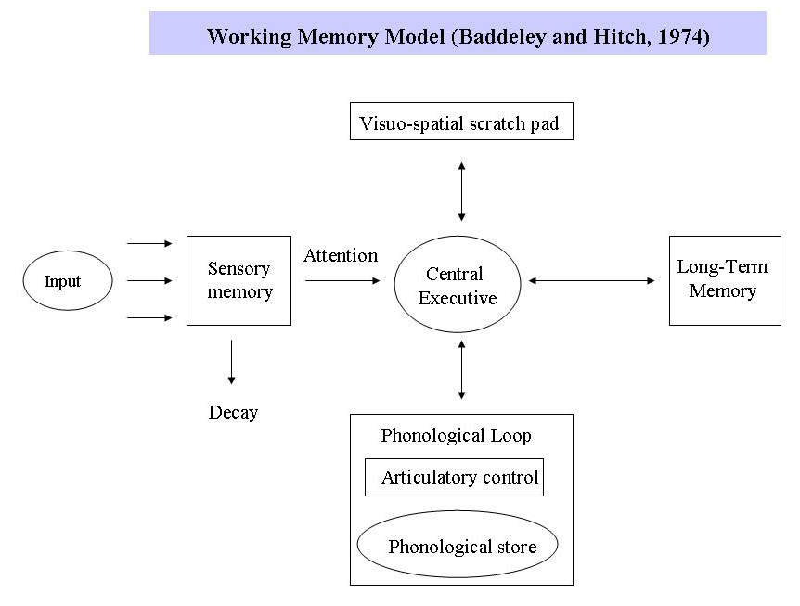
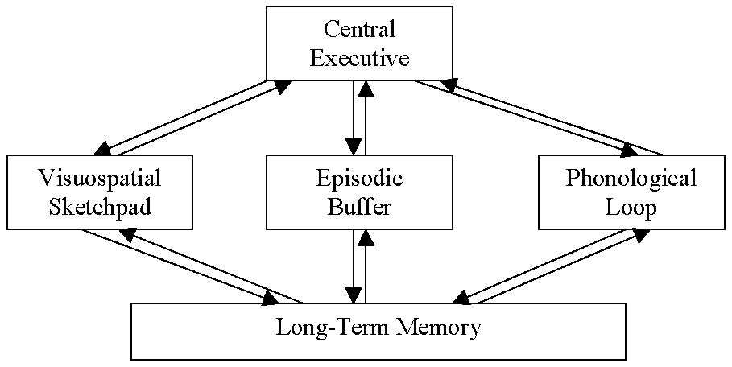
In 1974 Baddeley and Hitch proposed a "working memory model" that replaced the general concept of short-term memory with an active maintenance of information in the short-term storage. In this model, working memory consists of three basic stores: the central executive, the phonological loop and the visuo-spatial sketchpad. In 2000 this model was expanded with the multimodal episodic buffer (Baddeley's model of working memory).^{[12]}
The central executive essentially acts as an attention sensory store. It channels information to the three component processes:
- the phonological loop,
- the visuo-spatial sketchpad, and
- the episodic buffer.
The phonological loop stores auditory information by silently rehearsing sounds or words in a continuous loop: the articulatory process (for example the repetition of a telephone number over and over again). A short list of data is easier to remember.
The visuo-spatial sketchpad stores visual and spatial information. It is engaged when performing spatial tasks (such as judging distances) or visual ones (such as counting the windows on a house or imagining images).
The episodic buffer is dedicated to linking information across domains to form integrated units of visual, spatial, and verbal information and chronological ordering (e.g., the memory of a story or a movie scene). The episodic buffer is also assumed to have links to long-term memory and semantical meaning.
The working memory model explains many practical observations, such as why it is easier to do two different tasks (one verbal and one visual) than two similar tasks (e.g., two visual), and the aforementioned word-length effect. However, the concept of a central executive as noted here has been criticised as inadequate and vague . Working memory is also the premise for what allows us to do everyday activities involving thought. It is the section of memory where we carry out thought processes and use them to learn and reason about topics.
Forgetting

Why do we tend to forget the names of the people we just met? Or why do we forget the phone number we just dialed few minutes ago? We all have experienced forgetting in one’s day to day life, but what are the causes behind it? Psychologists have defined forgetting as our inability to recall already encoded and stored information from our memory system.

To understand the nature of forgetting, Hermann Ebbinghaus, a German psychologist, conducted the first systematic experiment in 1879. He created many CVC (constant vowel constant) nonsense syllabuses such as NAK or PUD and administered on himself (The method of conducting experiment on one self only and using your own experience is known as introspective method). To investigate the nature of memory and forgetting, first he memorised lists of nonsense syllabus until he had reached a pre-defined criterion and then measured the number of syllables retained by him after variable time interval. Further, he also noted the number of trials taken by him to relearn the same list of syllables again at variable time interval. Based on his observations, he came up with the following curve for explaining the nature of forgetting;

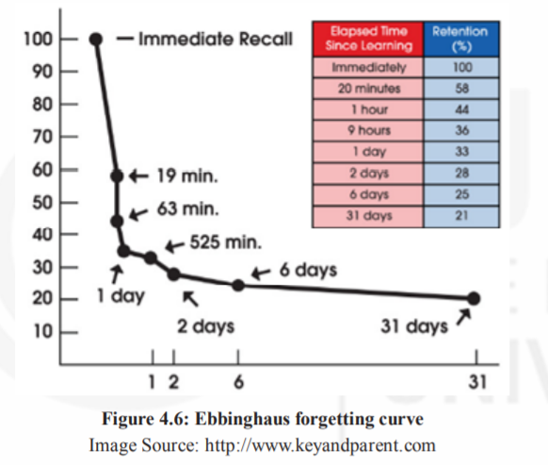

This curve is famously known as Ebbinghaus forgetting curve. You can see from the graph that the rate of forgetting is the maximum in the starting but after a few hours it becomes slow. Recent studies have reported similar results.

Types and causes of forgetting

Main theories available in the literature, explaining the causes of forgetting are as follows:
    - Theory of Interference

According to this theory, forgetting occurs due to interference with other memories. This interference can be of two types:

Proactive Interference (Pro=forward) - Forgetting of newly acquired information due to interference from previously learned information.

Retroactive Interference (Retro=backward) - Forgetting of previously stored information due to learning of new information.
    - Trace Decay Theory

It is an older theory, also known as disuse theory. Trace decay theory proposes that learning causes change in the central nervous system leading to the formation of memory traces or physical changes in the brain due to learning (Brown, 1958). When these memory traces are not used for long time, they fade away leading to forgetting. Thus, the underlying mechanism of this theory is “use it or lose it”, i.e., if you do not use your stored information at regular interval of time, then you may be at the risk of losing it.
    - Cue Dependent Forgetting Theory

According to this theory, forgetting can also occur due to the absence of an appropriate cue or presence of poor cue. Suppose you were given a list of objects to buy from the market. By mistake, you lost the list. Now, you are trying your best to recall all the items from the list, but there are good chances that you will forget many. Studies have suggested that if participants were given hint or cue about the category of those items, then it improved their recall. Studies have even suggested that the physical attributes of the environment also play a positive role in retrieval.
    - Encoding failure

As discussed in the earlier section, encoding is an important process in memory. There are many events or objects that are not encoded properly and do not go beyond sensory memory. Thus, it results in failure to process information to memory. Encoding failure is also one of the reasons why people forget things.

Techniques to improve memory

There are various techniques to improve memory. Different techniques are used for different circumstances. There are four broad principles that govern the memory techniques. They are as follows:

1) Process for meaning: As you learn new material, focus should be on the meaning of the stimuli. To achieve this, one should avoid distraction. In the presence of distraction, we loose our attention towards meaning in what we want to learn and remember.

2) Retrieval process: This is related to retrieval practice. Generate and practice the items that you need to remember from memory rather than read or restudy. Self-testing is the best retrieval practice.

3) Metamemory: It is the awareness and knowledge of our own memories. It helps in reflecting and monitoring memory. This way, it may help in strategic planning, allocation of study hours/resources, evaluation of performance, etc.

4) Distributed learning or practice: This is a superior method than massed practice.So, one should avoid cramming because it is an inefficient way of learning. Distributed practice helps in improved memory efficiency.

Mnemonics

Now, let us examine some techniques that aid in retrieving the information and also reduce the amount of forgetting. These are known as mnemonic (pronounced as ni-mo-nicks) aids.In this section, we will discuss about mnemonic methods or techniques of enhancing memory. There are basically two broad categories of mnemonics; one category of mnemonics uses images, while other uses principles of organization to memorise information.

Using Images There are many strategies which uses images to improve efficiency in retaining and retrieval of information. Following two types of mnemonics use images:
- Method of Loci: Placing images at location

Loci (pronounced as low-sye), is the plural form of “Locus”, which refers to position or place. This method uses the location of a familiar place as a cue to retrieve information. Now suppose, you want to learn a list of objects that you want to buy from a nearby grocery store. The lists contain items like, egg, tomato, pen, washing powder and salt. Now to remember these items, first, visualise each of them to be located in some separate spatial location, such as, in different rooms of your house. Then, mentally go through your house visualising each item in a separate place. After reaching the market, all you need to do is to take another mental tour of your house and recall the items you have placed in different location in a sequence.
- Keyword method:

The keyword method is considered appropriate for learning vocabulary and foreign language. In this method, any two pieces of information is linked using images. Now suppose, you want to extend your vocabulary for English language. You come across a word “scowl” which stands for “an angry or bad-tempered expression”. In order to learn its meaning, first you need to find a keyword, a familiar word that sounds similar to the target word, scowl. Now, using an image try to relate your target word with keyword. Since, the word ‘scowl’ sounds similar to owl, you can imagine a picture of owl with angry expression. Studies have suggested that this method of learning definition or vocabulary is far more superior than rote learning.

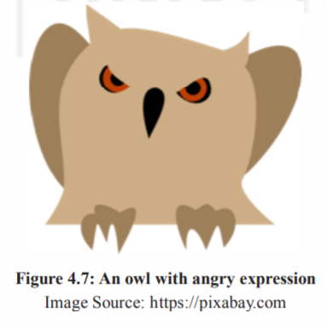

Mnemonics Using Organisation

It improves the ability to learn and retrieve information accurately by applying the principle of reorganization of the material to be learned. In this section, we will discuss two types of mnemonics:
- Chunking

It is a method of combining smaller units into meaningful larger units, such as, if you were asked to remember following series of number

1-9-3-9-1-9-4-5

If you are well versed with world history, then, you can also group these numbers in the following ways;

1939-1945

Second World War started in 1939 and ended in 1945. In this way, you can memorise as well as recall these numbers more accurately. You can also chunk information by using it in a sentences, songs or phrases. Therefore, it can be suggested that it is another way to remember large information. The items are grouped together according to some similarity or common theme at the time of encoding. So, it is easier to recall a chunk of information than individual bits.
- First Letter Technique

In this technique, first letter of each word, you want to memorise, is taken to make a meaningful word or sentence. For example, colour of the rainbow can be remembered using this technique.

Violet

Indigo

Blue

Green

Yellow

Orange

Red

The word VIBGYOR stands for all the seven colours of rainbow.This method is also known as “acronyms”, when the word is formed by taking the first letter or groups of letters from a name or phrase to be remembered. It helps in remembering the names of the events or the music notes with ease.
- Rhymes

This involves using a similar sounding word at the end of each line of a verse. This enables to encode the information acoustically.
Reference
- Pavlov, I., Watson, J., Skinner, B. F., Thorndike, E., Bandura, A., Maslow, A., … & Treisman, A. Multi Store Model of Memory.
- Atkinson, R. C., & Shiffrin, R. M. (1968). Human memory: A proposed system and its control processes. In Psychology of learning and motivation (Vol. 2, pp. 89-195). Academic Press.
- Tulving, E., & Schacter, D. L. (1990). Priming and human memory systems. Science, 247(4940), 301-306.
- Information Processing in Learning and Memory.(n.d.). Egyankosh. Retrieved from http://egyankosh.ac.in/bitstream/123456789/20694/1/Unit-2.pdf
- Memory http://www.sparknotes.com/psychology/psych101/memory/section7.rhtml

