Information processing theory by Donald A. Norman .

The information processing theory is an approach to the cognitive development of a human being, which deals with the study and the analysis of the sequence of events that occur in a persons mind while receiving some new piece of information. In short, it is the analysis of the way a human being learns something new. The information processing theory laid down by experts in psychology claims that the human mind is very similar to that of computers, as far as information processing and analysis is concerned. They also say that any new piece of information that enters the brain is first analyzed and then put through the test of several benchmarks before being stored in some vestibules of the memory. Since these actions occur at a very fast speed, we are unable to notice them in action.

Donald A. Norman first conceptualized the information processing theory. Mr. Norman was born in 1935and was an applied cognitive scientist. He was a well-established academic, who was well qualified with a MS in electrical engineering as well as a doctorate in psychology. Mr. Norman’s theory proposed that humans were information processors, with information moving from input to output via a series of processing stages.

The stages of information processing he identified are
- encoding,
- comparison,
- response,
- selection and
- response execution.

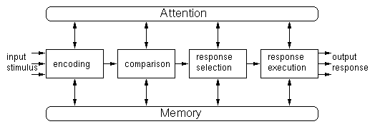
Information processing model
Mr. Norman likened human processing to that of the computer stating that the human mind takes in information, performs operations on it to change its form and context, stores it in the form of memory, locates it and generates responses to it. The information-processing model depends on encoding, retention and retrieval of information. Therefore memory is an integral aspect of information processing. So what is memory? Memory is just one of many phenomena that demonstrate the brain’s complexity.

Memory is defined as the process by which information is encoded, stored and later retrieved. Encoding refers to the first perception and registration of material. Storage refers to the retention of information and retrieval refers to the process involved in using the stored information. In other words, when a person can recall information it means that they must have encoded it, stored it and retrieved it. It is clear therefore that memory is a process. Memory, as unimportant as it may seem initially, is an integral and necessary element in the lives of all animals.

