**Forgetting**

Why do we tend to forget the names of the people we just met? Or why do we forget the phone number we just dialed few minutes ago? We all have experienced forgetting in one’s day to day life, but what are the causes behind it? Psychologists have defined forgetting as our inability to recall already encoded and stored information from our memory system.

To understand the nature of forgetting, Hermann Ebbinghaus, a German psychologist, conducted the first systematic experiment in 1879. He created many CVC (constant vowel constant) nonsense syllabuses such as NAK or PUD and administered on himself (The method of conducting experiment on one self only and using your own experience is known as introspective method). To investigate the nature of memory and forgetting, first he memorised lists of nonsense syllabus until he had reached a pre-defined criterion and then measured the number of syllables retained by him after variable time interval. Further, he also noted the number of trials taken by him to relearn the same list of syllables again at variable time interval. Based on his observations, he came up with the following curve for explaining the nature of forgetting;

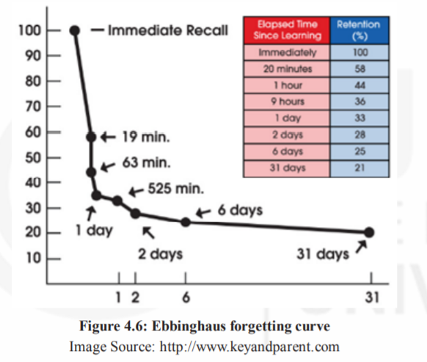

This curve is famously known as Ebbinghaus forgetting curve. You can see from the graph that the rate of forgetting is the maximum in the starting but after a few hours it becomes slow. Recent studies have reported similar results.

**Types and causes of forgetting**

Main theories available in the literature, explaining the causes of forgetting are as follows:

* + 1. **Theory of Interference**

According to this theory, forgetting occurs due to interference with other memories. This interference can be of two types:

**Proactive Interference** (Pro=forward) - Forgetting of newly acquired information due to interference from previously learned information.

**Retroactive Interference** (Retro=backward) - Forgetting of previously stored information due to learning of new information.

* + 1. **Trace Decay Theory**

It is an older theory, also known as disuse theory. Trace decay theory proposes that learning causes change in the central nervous system leading to the formation of memory traces or physical changes in the brain due to learning (Brown, 1958). When these memory traces are not used for long time, they fade away leading to forgetting. Thus, the underlying mechanism of this theory is “use it or lose it”, i.e., if you do not use your stored information at regular interval of time, then you may be at the risk of losing it.

* + 1. **Cue Dependent Forgetting Theory**

According to this theory, forgetting can also occur due to the absence of an appropriate cue or presence of poor cue. Suppose you were given a list of objects to buy from the market. By mistake, you lost the list. Now, you are trying your best to recall all the items from the list, but there are good chances that you will forget many. Studies have suggested that if participants were given hint or cue about the category of those items, then it improved their recall. Studies have even suggested that the physical attributes of the environment also play a positive role in retrieval.

* + 1. **Encoding failure**

As discussed in the earlier section, encoding is an important process in memory. There are many events or objects that are not encoded properly and do not go beyond sensory memory. Thus, it results in failure to process information to memory. Encoding failure is also one of the reasons why people forget things.